THEIR CANCER GARDEN

EDITORIAL

F E F O C: MEMBER OF EUROPE UOMO, USTOO AND MALE CARE

Directors: Professor Jordi Estapé and Doctor Tania Estapé.
© FEFOC 2022

The negative consequences of the COVID-19 pandemic, apart from many other population sectors, have a particularly negative impact on health professionals and cancer patients .

The exhaustion of the former is terrible. Spain has an enviable health system in many aspects but it cannot be denied that, pandemic aside, sharks (investment funds, some insurers with the support of political parties), stalk our system of health, with the jaws wide open, trying to devour it, that is, privatize it.

During the pandemic, which is still ongoing, insufficient support has been given to our professionals who have multiplied to nobly try to cover and plug holes, to the point of exhaustion.
We must all fight to keep our health system untouchable and recommend it to other peoples. Health is not at stake. With health should not be enriched investment funds, this serious disease of the West.

We have come a long way to make Social Security a universal good in Spain. But now the struggle is different, it is the fight against those who want to privatize our health system. When an investment fund arrives at a company, the first thing that happens is the dismissal of workers. Coincidentally, the number of health professionals in Spain employed in Social Security is decreasing.
Please read carefully the first article in this issue of "Their Cancer Garden".

There is even talk (will it be a joke?), of hospitals without

Doctors.

Patients have seen their diagnoses and treatments delayed and delayed, predicting that cancer survival will go.

(Continued on page 2)

(Comes from page 1)

Moreover, you will find two contributions to the progress of radiotherapy in prostate cancer, a succinct description of the prostate gland and its functioning. We also offer the summary of an original study of prostate cancer in Hispanics, where it is observed how the genetic acts modulated by the environmental. And other things.
We appreciate the collaboration of Dr. Mendoza with his important review of pain in cancer patients.

IMPACT OF THE COVID-19 PANDEMIC ON THE CARE OF CANCER PATIENTS

The doctors. Kainat Saleem and Diwakar Davar publish in asCO Daily News of May 2022, a major review entitled "The impact of the COVID-19 on cancer care and outcomes". Both work at the University of Pittsburgh Medical Center. The main points that stand out are the following:

- The COVID-19 pandemic has had a severe and negative impact on case presentation, treatment and cancer management.

- This has led to an emigration (advance) of stages and a foreseeable global increase in
premature mortality , with special impact on marginal populations .

- In addition, the pandemic has caused an unprecedented assault on the morale of health professionals.

Already from the start. Cancer patients were classified as a particularly vulnerable subgroup. Health professionals quickly adapted to the new situation, highlighting among others telematic communication, designing therapeutic strategies with greater intervals in their application, abbreviating radiation therapy guidelines and preferring oral administration guidelines to intravenous radiation therapy in chemotherapy.
But we're just trying to understand the multiple effects of COVID-19 on cancer incidence, on treatment outcomes, and their side effects.

We are in the midst of a wave caused by likely increases in stages at diagnosis and a predictable increase in premature mortality in various tumor types. There is already some data indicating a decrease in survival rates in breast, colon, uterine cervix, and melanoma cancers.

Global studies indicate that these negative effects will affect a third of the population due to the lack of access to treatment and almost half of the cancer centers report that 10% of the population lost at least one treatment cycle . Support strategies should be established for these groups.

As for health professionals, the rate of affectation or burnout (exhaustion) is alarming. An American study in
13,000 doctors from different specialties showed burnout in almost half of these. A third of oncologists also suffered from it. Collectively, those most affected were women, nursing assistants, attending physicians, social workers, and professionals of color.

We are in an unprecedented series and grave situation. It is up to everyone, but especially the health authorities, to urgently and responsibly seek solutions to these problems.

ADVANCES IN THE TREATMENT OF BIOCHEMICAL RECURRENCE OF PROSTATE CANCER

Alan Pollack, M.D., cedars-Sinai Medical Center (in Los Angeles, California; (founded in 1902 is a non-profit hospital that visits both insured and uninsured patients ) and international collaborators, publish in The Lancet an important comparative study on the best treatment in men than after prostatectomy experience an increase in PSA, which usually indicates that the disease is not cured. If no metastasis is found, in this situation the irradiation of the intervened prostate area is usually carried out, since, in most cases not metastatic, it is there where the problem.

But the authors show a new and more effective therapeutic by adding to the classic radiotherapy on the prostatic surgical bed, hormonal treatment plus irradiation of the patient's pelvic nodes.

To do this , they launched a phase III comparative study in which they included 1716 patients, which were randomized into three groups:

Group 1. The classic radiotherapy on the surgical bed. The median survival of this group was 71% at 5 years.

Group 2. In addition to the same modality of radiotherapy as group 1, hormonal treatment of androgenic control (of short duration). The median survival of this group at 5 years was 81% of patients.

Group 3. Radiation therapy to the surgical bed, hormonal treatment (also of short duration), and irradiation of the nodes of the pelvis. The survival of patients in this group was 87% at 5 years.
If confirmed, these results mean significant progress in the treatment of patients who, after prostatectomy, do not develop metastases but their PSA level progressively increases.

VARIATIONS IN LOCALIZED PROSTATE CANCER IN HISPANICS

Dr. Brandon A. Mahal and colleagues from sylvester Comprehensive Cancer Center, University of Miami Miller School of Medicine, Memorial Sloan Kettering Cancer Center and other groups observe, in a study published in Prostate Cancer and prostatic Disease, that Hispanics with localized prostate cancer (CPL), have significant variations in tumor aggressiveness and are less likely to be treated when they have high-risk disease.

Overall, Hispanics are more likely to have higher-risk CPLs than non-Hispanics. But if Hispanics are separated by country of origin, there is a lot of variation in the risk of developing with advanced disease.

In this regard, Mahal and collaborators subdivided the patients according to their country of origin. They gathered no less than 895,000 patients and found many variations. Thus, for example, those of Mexican origin had a higher risk of suffering from high-grade disease and with less possibility of receiving the most advanced treatment.

On the other hand, the descendants of Cubans were less at risk and closer to non-Hispanics.

For Mahal and collaborators, the variations imply of course the genetic background but also environmental, social and cultural influences such as the type of health insurance coverage, diet, physical exercise, pollution, etc.

(Continued on page 4)

(Continued on page 3)

It is interesting to observe how the indisputable genetic predisposition is modified within a broad and variable set of general conditions. Establishing subgroups that contain genetic and non-genetic aspects can have an important impact on the way we diagnose and treat our patients from different backgrounds.

ANATOMY OF THE PROSTATE

In a study we conducted, it has caught our attention that many patients treated for prostate cancer asked us "what is the prostate?" and "what is it for ?" We offer a somewhat synthetic explanation that if other readers prefer that we expand it we will gladly do so.

The prostate is a gland about the size of a chestnut or ping-pon ball. It usually weighs between 20 and 25 grams. It is located below the urinary bladder and surrounds the upper portion of the urethra, the tube that carries urine from the bladder to the outside, and in front of the last portion of the large intestine, the rectum.

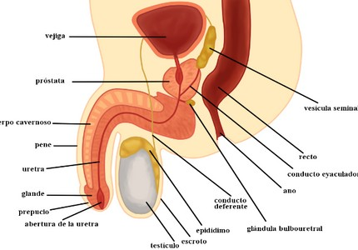

Male reproductive system

In the anatomical situation of the prostate and its relationship with the organs that surround it, the basis of the side effects of the different treatments is found.

A gland is an organ whose function is to make and secrete substances essential for the functioning of our body.

The main function of the prostate is to produce the fluid that nourishes and carries sperm ( seminal fluid). It is important for reproduction, since its fluids are essential for the survival of spermatocytes (produced in the testicles) and, in addition, it helps the exit of semen during ejaculation.

Most CPs start in the back of the prostate and near the rectum (called the peripheral area), which is accessible through the so-called digital examination or digital rectal examination of the same.

SECONDARY CANCERS AFTER RADIATION THERAPY FOR PROSTATE CANCER

Radiation therapy is both a curative and palliative treatment in prostate cancer (PC). However, it should be borne in mind that, in healthy tissues near the irradiated area, radiotherapy can somewhat increase the risk of developing a second cancer. These cancers are known as secondary cancers. These cancers include rectal cancers, urinary bladder cancers and acute myeloid leukemia.

That is why radiotherapy has become increasingly focal, reducing the risk of secondary cancer by decreasing the healthy irradiated area around. Modern radiation therapy techniques are designed to prevent this exposure.

(Continued on page. 5)

(Comes from page 4)

Dr. Kisdhan Pithadia of the National Cancer Institute in Bethesda, Maryland, presented at the last meeting of the American Society of Clinical Oncology (ASCO) a major comparative study between the two more advanced radiation therapy (three-dimensional conformal radiation therapy and intensity-modulated radiation therapy ), applied to the CP to see if the risk of secondary cancer was different with both techniques.

Three-dimensional conformal radiotherapy uses a computer that produces a three-dimensional image of the tumor, which makes it possible to identify the CP very correctly and apply the maximum possible dose, while avoiding as much as possible the irradiation of healthy tissue. surrounding.

On the other hand, intensity-modulated radiotherapy allows the dose to be concentrated in the tumor with great accuracy. It is performed by means of external radiotherapy techniques that emit beams of radiation whose intensity is variable, which allows to obtain the great objective of reducing as much as possible the irradiation in healthy tissues. around and concentrate and adapt it to the tumor. It uses photons and protons that adapt to the shape of the tumor.

According to these researchers, this second technique decreases the risk of secondary cancers of the rectum and urinary bladder. Phitadia et al . relied on a retrospective study of 45,811 men with nonmetastatic CP diagnosed between 2002 and 2010, according to data from Surveillance, Epidemiology and End Results (SEER) and Medicare. The patients' ages ranged from 66 to 84 years old.

The results showed an overall decrease in the risk of developing a secondary cancer (specifically in the rectum or urinary bladder) after CP radiotherapy in favor of intensity-modulated treatment, which they consider to be due to a more precise approach of radiotherapy on the tumor due to this modality.

PAIN IN CANCER PATIENTS: A COMPREHENSIVE APPROACH

Pain is one of the most common symptoms in cancer patients (it occurs between 4.2% and 79%) and although its initial intensity does not differ according to gender, it is considered important in clinical decision-making in the male population. It should be noted that pain is not related in all cases to advanced disease, because it can occur from diagnosis, during treatment and in patients with disease metastatic or terminal. Therefore, it is a relevant public health problem and a major cause of suffering and disability.

Pain is a complex sensation that can occur at the neurophysiological, biochemical, psychological, ethnic, cultural, religious, cognitive and environmental levels. These factors could be involved in pain perception and tolerance in the male population, however, available data on the role of gender-related factors , in patients with Cancer pain is still limited.

Symptoms are usually an indicator of disease progression in the cancer patient; for example, in patients with advanced prostate cancer, pain is recognized as an important indicator of survival. In general, however, patients are afraid to recognize it as a sign that the cancer is progressing. On the other hand, 55% of these patients feel they have to live with it daily, 45% sometimes ignore it and 39% have trouble talking about it. It should be noted that patients who have a caregiver are more likely to talk about their pain at every doctor visit compared to those who do not.

(Continued on page 6)

(Comes from page 5)

In addition, most patients with bone metastases notice it before their metastatic diagnosis, indicating the need for greater guidance on the evaluation of this symptom and the need for a better understanding of the impact. of pain in the lives of patients.

In the oncological population, its relationship with various psychological variables has been reported, such as: symptoms of anxiety, symptoms of depression and catastrophization; psychosocial as: quality of life and social support; and physical as fatigue. In the same way, the importance of the role played by gender in cancer pain has been highlighted, in this sense, it is reported that men indicate less indecision to take analgesics, lower pain intensity and a higher percentage of adequate pain management. Additionally, they have a higher probability of analgesic adherence. Meanwhile, in patients experiencing postoperative pain, males are reported to use higher doses of opioid analgesics for management.

Psychological interventions are a fundamental part of the multidisciplinary approach to pain. The evidence and efficacy of these interventions has been summarized over the past four decades within systematic reviews and meta-analyses. So there is a solid research base that establishes the efficacy of psychological interventions on adults and young people with pain.
According to recommendations from the Cochrane Review Group on Pain, Palliative and Supportive Care , it is suggested to use Cognitive Behavioural Therapy (CBT) as a standard comparison of treatment, due to its robust efficacy. In this sense, CBT has shown consistency in terms of positive effects to modulate the perception of pain in the oncological population. However, we have no knowledge about this type of evidence-based intervention specifically tailored to the needs of the male population with cancer pain, so it is a pending within this field of research.
As part of the psychological treatment within the comprehensive approach to pain management in the male oncological population, it is suggested to include:
- Psychoeducation about cancer, pain and pharmacological/non-pharmacological treatments ,
- Trainingon the specific needs of men,
- Relaxation techniques , and
- Rcognitive structuring .

In conclusion, male patients have difficulty talking about their pain, possibly believing that this makes them look weak or vulnerable. Psychological treatment is essential within multidisciplinary care in men with cancer pain; Likewise, the need to continue investigating the multifactorial characteristics of pain, the possible role of sex and the biological and psychological characteristics related to gender for thus generate new strategies to improve the management of cancer pain .

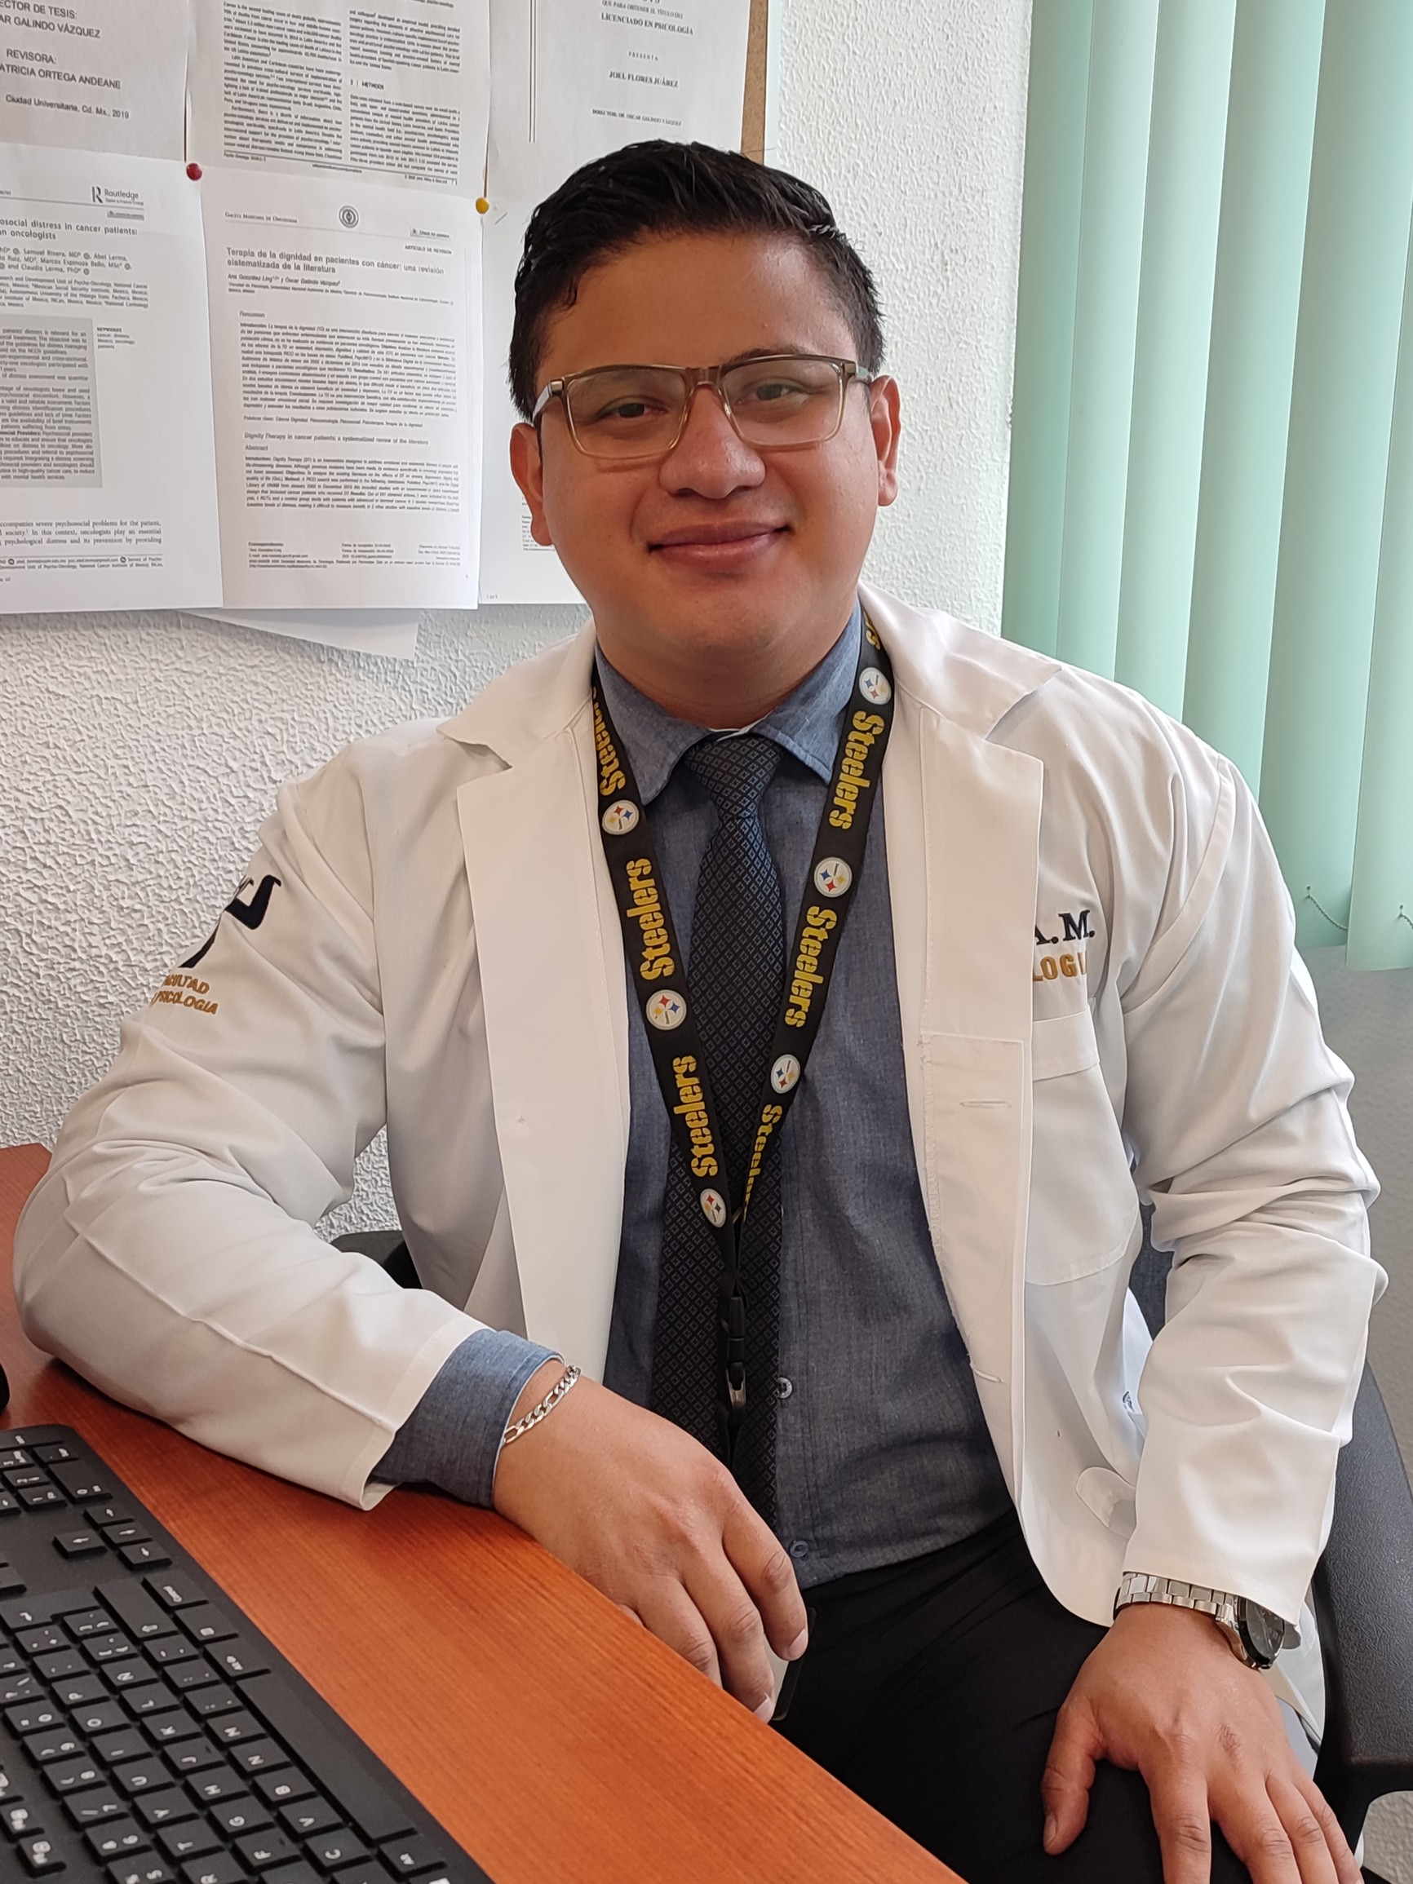
Psic. Luis Alberto Mendoza Contreras Postgraduate in Psychology, National University
Autonomous of Mexico / Psycho-Oncology Service, National Cancer Institute (INCan)

(Continued on page. 7)

(Comes from page 6)

References:

Drudge-Coates, L., Oh, W. K., Tombal, B.,
Delacruz, A., Tomlinson, B., Ripley, A. V. ,... & Shore, N.D. (2018). Recognizing symptom burden in advanced prostate cancer: a global patient and caregiver survey. Clinical Genitourinary Cancer, 16(2), e411-e419.
Eccleston, C., Keefe, F. J., & de C Williams, A.
C. (2021). Basic and applied psychology in PAIN: where we have been and where we are headed.
Williams, A. C. , Fisher, E., Hearn, L., & Eccleston, C. (2021). Evidence-based psychological interventions for adults with chronic pain: precision, control, quality, and equipoise. Pain, 162(8), 2149-2153.

To purchase the book click here

For more information about donations click here.

https://www. andoutube. com/channel/UCMOFY1FLcbVOCshefrj6mkQ/vid eos

Prostate Cancer Video Collection

Directors: J.Estapé, T.Estapé Secretary: M.Soler

Marc Aureli, 14.

08006 - Barcelona
Tel. 93 217 21 82

Email: fefoc@fefoc.org www.fefoc.org

We appreciate the collaboration of:

***************************
FEFOF belongs to EUROPA UOMO since 2004

