SCRIPT

EUomo's first online webinar on Active Surveillance:
"Active Surveillance: Looking for Quality of Life after Diagnosis of low grade Prostate Cancer"
Tuesday, April 20th, 2021 from 18:00 to 19:00 PM CET

Green = Cosimo Pieri
Blue = Prof. Van Poppel
Orange = Prof. Roobol
Purple = Anja

Introduction on the initiative (C. Pieri, IT)
Good evening to everybody. I am Cosimo Pieri from Europa Uomo Europe and also part of the Europa Uomo Italy Association.

What is active surveillance and which benefit come from active surveillance? With this webinar, and the following ones, we want to give a basic introduction of active surveillance, benefit to patients, overview of their journey, limits of application and in particular where to find indeep information. Also it could be a good idea to motivate others to create a new opportunity for communication between patient and medical staff and the Association.

Since more than 10 years, Europa Uomo Europe and their 27 affiliate member groups are committed to support men with reliable info on prostate pathologies and in specific on early diagnosis, multidisciplinary approach and Quality of Life. Active Surveillance is NOT for all PCa patients but in the cases where medical specialists confirm that is safely applicable for specific patients, it is a very logical choice. This is also what we discovered recently when Europa Uomo Europe did a big survey on Quality of Life (EUPROMS) in November 2019, where we had about 3000 answers from European PCa patients out of our 27 member countries. The average age of respondents was around 70 years, 64 years was the average age at time of diagnosis. From this survey, there were many indications for all PCa type patients and all type of treatments. You may have a clear review of this in the video presentation which is available on our website and which is called EUPROMS.
The important thing we want to say today on this specific item about active surveillance is that one of the take home messages that we got was that to ensure the best quality of life, active surveillance should be the first treatment considered if the low grade and specialist confirm applicability to this specific case. Indication confirm both quality of life in our survey.

Having said that I would like to introduce you to Prof. Hendrik (Hein) Van Poppel, who is the Adjunct Secretary General at the European Association of Urology, specific for education, co-founder of Europa Uomo and the chair of the Scientific Committee of Europa Uomo. Hendrik, how are you today?

General description of the AS treatment (Prof. Hein Van Poppel, BE)
Thank you, Cosimo. I am doing well and it's good to see so many people around that are doing well as well in this strange times and I'm very happy if Anja can allow me to share my screen.

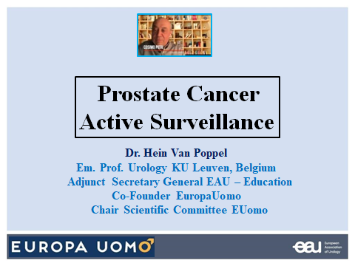

Yes, at the same time, we have prepared some questions for you. So in general, if you can explain us something about active surveillance, how this allow to delay treatments, how urologist find out if it is save for a specific patient, the impact on quality of life and the difference from watchful waiting. A lot of questions, but you will be able to explain it briefly.

Okay, by the way I just want to thank you on behalf of everybody because you have taken the initiative and you have got this off the ground to invite me and Monique. We are very happy to be able to do that today.

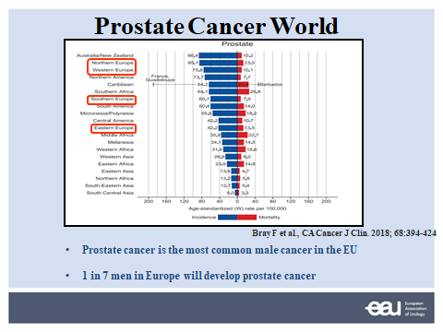

I just heard we have a couple of people from different countries throughout Europe and as you might expect there is a vast majority of prostate cancer patients in Northern and Western Europe. Mortality is here in red. If you look I would expect Southern Europe to have even less prostate cancers. You see there is less prostate cancer that as well and then there should be fewer in Eastern Europe while I doubt that there is something wrong with reporting of prostate cancer in these countries.

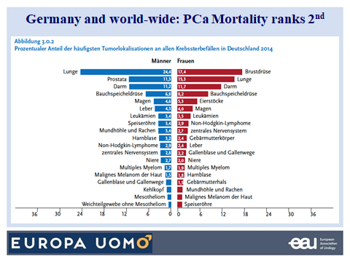

Today we know that one out of seven men in Europe will develop prostate cancer, and it's the most common male cancer in the European Union these days. I give just an example in Germany prostate cancer today kills more men then colorectal cancer does. In the UK more men die from prostate then women from breast cancer, which is not the case yet in Germany as you can see.

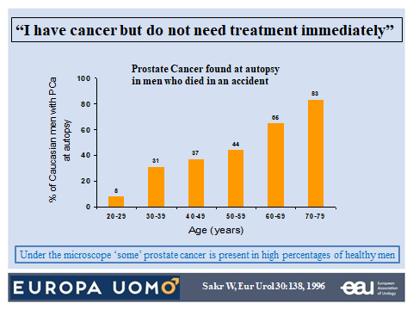

Now, when we speak about active surveillance, the issue is ‘I have cancer, but I do not need treatment immediately’. Where does the idea come from? And this is an old study from Sakr in 1993 already and they were looking at autopsies from people that died, men that died in a traffic accident, and they looked at their prostates histologically under the microscope and you see already in very young man there was a small percentage that had prostate cancer microscopically, and this is rising at the age of 72-80y up to 83%. This means that men at 100 years of age, they all have some prostate cancer present in their organ. You immediately understand if we would find all these cancers and we would treat them, we are doing far, far too much.

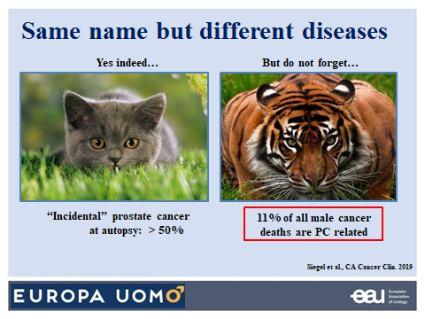

Now, do not forget that prostate cancer, although it is not killing like for instance pancreatic cancer like lung cancer, and there is incidental prostate cancer in the general male population at autopsy in more than 50%, do not forget that the Tigers, the bad ones, are responsible for 11% of all male cancer deaths. Which is enormous and we need to do something about it. But this makes also that we are feared about prostate cancer because it is still a killing disease, it is not a disease of old man that die with it instead of from it.

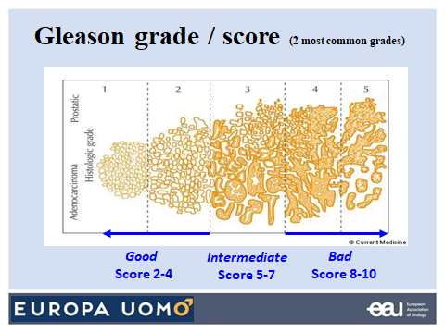

And this has to do with the differentiation of the tumour. A tumour can look very much like normal parenchyma of the prostate, or it can be very aggressive where you hardly can recognise that this is prostate and this is the different Gleason. Mr. Gleason has made this classification from one to five and a pathologist will say that the two most common grades in the specimen that he sees, in the biopsy, or in the radical prostatectomy specimen, is for instance a grade 3 plus grade 4, and this will then make a Gleason score of 7. Everything that is above 7 is bad. Gleason score 8, 9 and 10. Everything that is below 5, we do not even consider this to be cancer any longer these days, it's not even mentioned in the pathology report. And then there is an intermediate group scores 5 to 7 actually today we say 6 and 7 under condition that this is 3+4 and not 4+3. You understand the difference when the majority is Gleason 4 it is obviously worse than when the majority of the malignant tissue is Gleason 3.

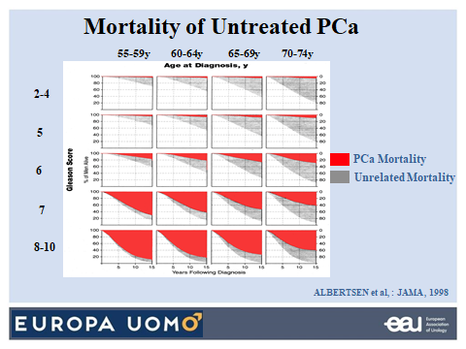

Now, if we do not treat prostate cancer and you are young and you have a Gleason 8 to 10, the likelihood that you die from prostate cancer is about 100%. If on the other hand you are older, 72-74y, and you have an intermediate Gleason, you see that the likelihood that you die from other causes is much more important. It's three times more than the likelihood that you die from prostate cancer. So you immediately understand that if we would treat all these people, we are overtreating, obviously.

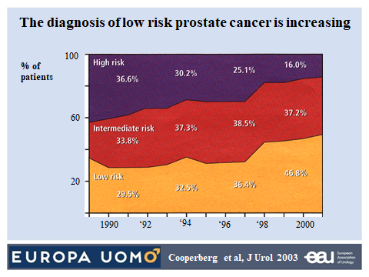

Now by time, by using different techniques for diagnosis, you see that there is an increasing incidence of low risk at diagnosis. Also for intermediate and high risk is actually decreasing by time over the years and this is a consequence of PSA.

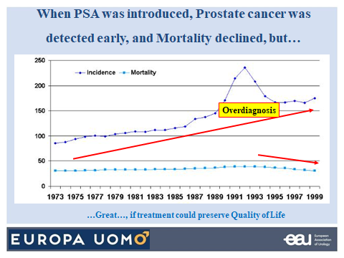

PSA was introduced in the early 80s in Europe, and you see that what was the immediate consequence by PSA testing, is a high number of more cases of prostate cancer were detected. So we have diagnosed people that some of them did not know, did not need to know that they had prostate cancer but by doing so, by doing this overdiagnosis, we have achieved something as well because you have seen the declining prostate cancer mortality a couple of years after PSA was used. You don't hear me say that this is due to PSA only. It's also due to the better treatment obviously we had. And this is great if the treatment should preserve quality of life of prostate cancer men but it impacts on quality of life and now I come to the question that Cosimo just asked me.

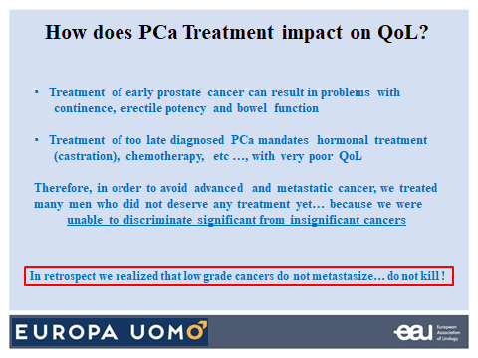

Treatment of early prostate cancer can result in problems with continence, erectile potency and bowel function in the case of irradiation. But treatment of too late diagnosed prostate cancer needs hormonal treatment, chemotherapy, castration with very poor quality of life and you understand that when I go back to my early career in the late 80s, we wanted to avoid advanced metastatic prostate cancer and we treated men who did not deserve any treatment yet. And I know from the 3000 and more radical prostatectomies in the beginning of my experience, there is 10 to 15% that did not need treatment at the moment that I took their prostate out because I and my colleagues we were unable to discriminate between significant and insignificant cancers. But in retrospect when I look back at my Gleason 6 radical prostatectomies, what did we see, they did not metastasize and they did not kill any patient. So we have had over treatment and over diagnosis.

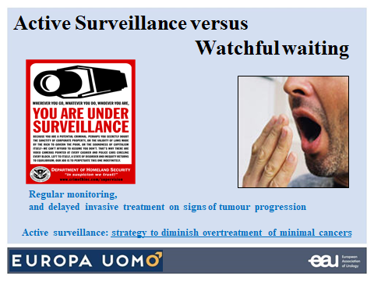

So there must be another possibility to recognise which patients could just be observed without treatment. And this is what we call active surveillance, but this indeed means you are under surveillance. This is not nothing you need regular monitoring, doctor visits, you need to have a delayed invasive treatment if there is tumour progression. But it's the only strategy to diminish the over treatment of minimal cancers that we, professionals, have been blamed for so many years. It's not Watchful Waiting. The difference is: we do not do any treatment until the patient gets symptomatic and when he becomes symptomatic we just give palliative treatment.

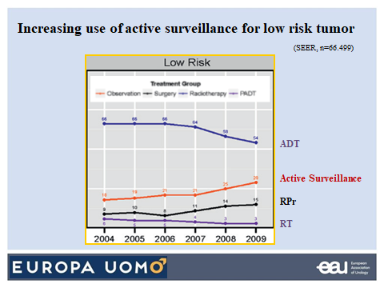

Now there is an increased use over the years of active surveillance and you see it here in red. That's increasing. Luckily for low risk tumour, ADT is less and less given. Still in 2009 far too much, this is a disease that should not be treated with hormones. There is still an increase in radical prostatectomy and radiotherapy, but active surveillance over the last 10 years has continued to increase.

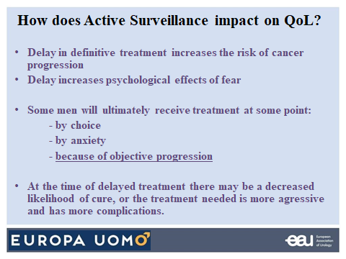

And then the question immediately is ‘does active surveillance impact on quality of life’? If you do not give treatment to a cancer patient, there is a risk that the cancer progresses and this induces fear and psychological effects and a lot of patients will at some point want to be treated by anxiety of because there is an objective progression that we need to detect on the hand of PSA, PSA increase, PSA velocity, MRI, eventually biopsies where we will then say now we stop active surveillance, your tumour is growing too fast, it's too dangerous, we will do something. At the time of this delayed treatment, after active surveillance, there may be a decreased likelihood of cure, or the treatment needed might be more aggressive leading to more incontinence or more impotence. So there is something that will play in the man's mind when he chooses or he agrees for active surveillance that these are things that can happen.

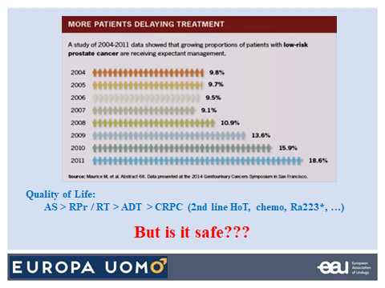

But quality of life as shown by your team in Europa Uomo is best when a patient is on active surveillance. It's better than when they have radical prostatectomy or radiotherapy. It's certainly better than when they have undergone deprivation therapy and it's absolutely much, much better than patients that become castrate refractory and that got those treatments and you see that over the years, more and more men with low risk and intermediate risk have chosen not to be treated immediately, but you're on active surveillance. But is it safe?

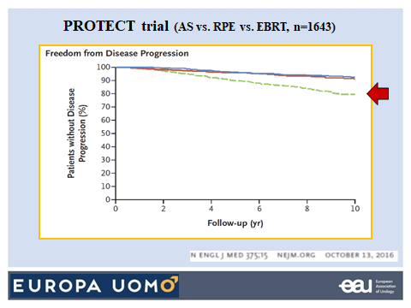

And during the coming webinars you will see more recent data, but this is from the PROTECT trial comparing surgery and radiotherapy that are around here and this is patients on active surveillance. Disease progression occurs when you do active surveillance. Obviously the tumour can progress and might become dangerous in the end.

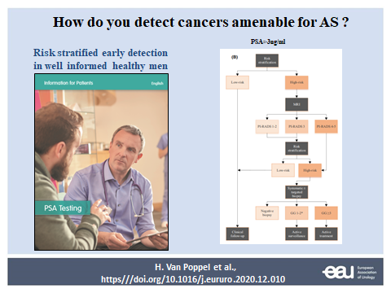

So the other question, how do we detect the cancers that might be available for active surveillance? The most important is the information of men. Men need to be informed and we have in the EAU this information: Should I have my PSA tested? And there is immediately a need in this patient information to tell the patient that what is his risk for having prostate cancer, and when he finally has prostate cancer, that it might well be that you not gonna treat him, because if the patient does not know that beforehand he will say you detected cancer in my case, and I want to have treatment, I want to get rid of it, but he must understand from the beginning from the initial information that there is a likelihood that he can go on active surveillance and I will not go in detail on the rest of this nomogram but there are risk stratifications possible. We have MRI. But a group of people will have cancer and will not need treatment and that is the important point.

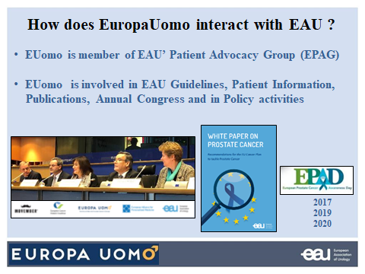

I know that Cosimo wants to know that I would highlight on how do patient organisations interact with the EAU? Well, we interact very very much and the Europa Uomo board and the executive people know that we support their activities in a substantial way. Europa Uomo is a member of actually all the cenacles we have. There is the patient advocacy group, patients are involved in the EAU guidelines, I just saw Erik Briers participating in the Patient Information, in our publications, in the Annual Congress and in the policy activities. We are not good to talk to politicians. We need you to talk to politicians and say we want you to make that our urologists and our experts do what is correct, and this will be active surveillance in a number of cases. And so we have made this White Paper on prostate cancer with the help of Europa Uomo, EAPM and Movember. We have had this European Prostate cancer Awareness Days (EPAD) that were initially also put together by Europa Uomo and the help of the EAU while we are now working together on this.

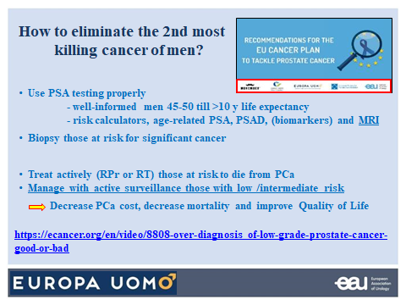

So how can we eliminate the second most killing cancer without having any problem and not forgetting that there is active surveillance. We need to use PSA properly and we should treat actively with radical prostatectomy or radiotherapy those at risk to die from prostate cancer. And manage with active surveillance, those with low and part of those with intermediate risk and this will decrease the costs of prostate cancer, decrease the mortality and improve the quality of life.

So I hope I didn't make it too long. Thank you Cosimo and thank you all for your attention.

Thank you very much Hendrik. For me it was very good. In any case I want to say that we are able to answer to question, if you want to put something in chat at the end of the webinar. As we said at the beginning, the idea is to establish more communication between all of us. So if we want, we can answer later, we can discuss later.

Now as we agreed to make something effective, I will give my testimonial.

Patient testimonial (C. Pieri, IT)
I have been an on active surveillance prostate cancer patient and so what is my experience now that I am 69 as a PC patient. At 55y I had frequent urinary issue symptoms that gave me a reason to meet a urologist. After some examination, the diagnose was benign hyperplasia so no cancer but the prostate was too big. So then there were four years of pharmaceutical treatments which could not avoid a surgical intervention to reduce the dimension of the prostate. And after this surgical intervention, the symptoms disappeared and everything was fine. But the urologist advised to continue to have yearly controls of the prostate situation. In effect five years after the surgical intervention, the urologist find a suspect nodule and doubled the PSA without any symptoms. So it was something to be taken care of. There was immediately, reasonably fast, magnetic resonance and after that there was a fusion biopsy. Then came out, the diagnosis of carcinoma, my prostate cancer, low grade with a Gleason score 3+3. So what we can say, it was a real early diagnosis because there were no symptoms in this part and an asymptomatic situation.

I want to present what happened so the urologist presented three choices. Two were treatments and one was a strategy method. So the treatments were the surgical prostate removal or the radiotherapy. And one was the strategic method of control, as we say and as I knew at that moment called active surveillance. It was suggested as a logic choice. There was no push for one or the other treatments, but together with the urologist we find out that due to the general situation of the age and the grade which was low grade of prostate cancer, active surveillance could be the most logical choice. Also, the urologist alerted me immediately that there are possible psychological issues because many patients do not want to keep the cancer inside their body. Here what I want to say is that in this approach, even if it was only one doctor, only one urologist, the approach was multi-disciplinary. So this was a very good approach in my opinion from the urologist, because he didn't push in one direction or the other. Now five years after the diagnosis, the yearly controls go on with PSA, magnetic resonance and biopsies not every year. The good point is that the prostate cancer did not grow so I may continue the active surveillance for the next year. Regarding the psychological effects, in effect there are certainly psychological effects and it could push the patients to take decisions or treatments. Especially when you wait for the yearly controls, especially the first year, because you are surprised by the badly surprise from the diagnoses and you have one year, more or less, for the control PSA, but you don’t know exactly what will happen with the magnetic resonance or the biopsies at the end of the first year.
In this case I think I was lucky to find an association like Europa Uomo in Italy. Because it gave me two possibilities. One to understand more about my choice because when you have a urologic visit it is 5 to 20 minutes so you don't have a lot of time to know to understand something that you have ever had or never knew before. And the second point is the auto-help groups because in our association we strongly support the auto-help groups. Every week, every 15 days, there is an auto-help group where patients meet together, they speak together and exchange experience. There are all types of patients, patients with low grade cancer and patients with more advanced cancer but it's very good to do this way to share experiences and suggestions with psychological support.

Before we proceed with another presentation of the next speaker, I want to suggest that it's important to have a urological visit after 50 years, more or less, because as you see from my experience and many others, I had symptoms, it was not cancer and when I didn’t have symptoms, it was cancer. So it is important to have the visit because you cannot understand from this observation what is the situation. And the other point is, is important for patient to be associated, to work and to speak together, and to do some action together because this will help everything to be better for themselves and for such a group in any case.

Having said this, I am pleased to introduce Monique Roobol who is professor decision making urology in Erasmus and epidemiologist. Monique, we saw you already but how are you today? Are you doing fine? Yes, of course. Good evening everyone.
We see a really nice picture of your institute. We tried to put together some question for you because there are many things to discuss but we wanted to focus on something. So why and how are you planning statistical work on active surveillance in Europe? What is important to put in evidence from the set of data that you have on active surveillance effectiveness which are an indication for the patient and medical communities? And specifically also patients journey planning? What is the anxiety, or possible users issues? So we have any questions, but obviously you will give us an overview and we will have all the time later to discuss more with other patients and between us.

Clinical data overview of AS effectiveness in last years (Prof. Monique Roobol, NL)
Then I will start to share my screen first, right? So I hope that everyone now sees the first slide of my presentation.

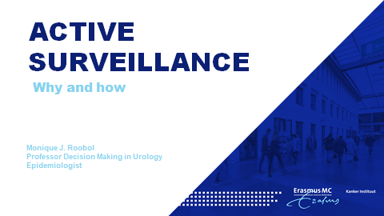

Thank you, well good evening all and thank you for giving me the opportunity to present my work here for you. I will talk about active surveillance as Cosimo already told you.

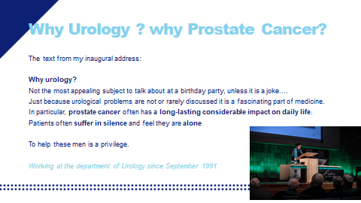

He asked me in particular why I work, I am an epidemiologist not a urologist, in urology and why I focus on prostate cancer. This is something I particularly addressed some years ago at my inaugural address. And there you see the text on this slide. I told the people why I work in this field, why I work in urology. And it is just because it is something that is not discussed openly. Even today it is something that people prefer not to talk about urological problems, and in particular prostate cancer often has a long listing considerable impact on daily life so this is one of the main reasons why I work for your urology and in particular on prostate cancer, and I feel that it is a privilege to help men to cope with this disease. I work at the Department of Urology since 1991 so I know everything about watchful waiting and active surveillance..

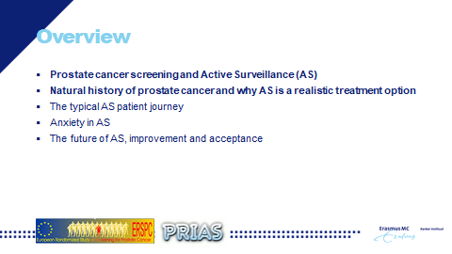

So what I would like to address today this evening are a few topics; obviously about the relation between prostate cancer screening and active surveillance, the natural history of prostate cancer and why active surveillance is a realistic treatment option, the patient journey, the anxiety like Cosimo already told you about and a little bit peeking into the future of active surveillance. Because there are a lot of things happening in active surveillance as it is a still a relatively new treatment option so there is a lot of research going on.

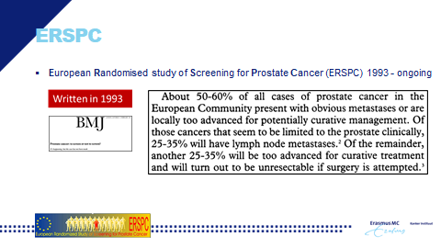

So I would like to go back to 1993 and there was already at that point in time a publication about prostate cancer and the problems that were relevant at that time, and if you can read this text there, you see that prostate cancer was a serious disease. More than half of the men that were diagnosed with prostate cancer already had metastases, and for those that were deemed to have limited prostate cancer (limited to the prostate) there was already lymph node metastases and the cure rate was extremely low. So this was the picture of prostate cancer in 1993 and obviously also before that. And this is to reason why we considered: wouldn't it be worthwhile to start early detection? Because obviously we are too late here and we cannot treat this man anymore. We cannot cure them.

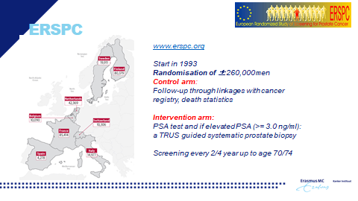

So this is the reason why we started the European Randomised study or Screening for Prostate Cancer. It started in 1991, the year that I started to work in urology and you can see that over time approximately 260,000 men have been randomised in Europe in eight countries to a control arm where we do nothing, only follow up. We see what happens to these men in daily clinical practices. In addition we had an intervention arm where we actively screen these men with the use of the PSA test and the TRUS-guided systematic prostate biopsies. Screening was done every two to four years up to the age 70, in some countries 74. So this is what we did. Active screening stopped approximately 8 years ago and I think we have all read and heard about the results of this trial.

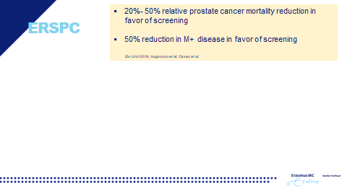

And these were extremely favourable. Please note we did not know this upfront. We started this trial and we were curious whether early detection indeed could have an effect on metastatic disease and prostate cancer mortality. And it turns out with a long follow up we have now shown that it has a very favourable effect on both. So we can reduce prostate cancer mortality and we certainly can reduce metastatic disease in favour of screening. But there is always a second picture and a second sentence following after this very favourable messages.

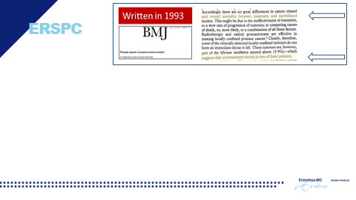

And that is that also in 1993 we already knew at that time that there was a lot of prostate cancer around, and then there was prostate cancer that never causes any problems and that there was no difference between treatment and surveillance. So already at that time we realised that when we started active searching for prostate cancer it could very well be so that we would detect a lot of prostate cancer that would not harm the patient if left undetected and untreated and that it even might be in two out of three patients. So this was on our radar already from the very start of the trial that we should watch this very closely.

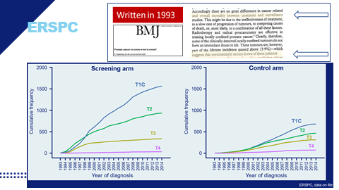

And now I would like to show you what happens when you actively start screening for prostate cancer. Please be reminded it has very favourable results with respect to mortality reduction and metastatic disease reduction, but this is what happens when you start screening with a PSA test and the systematic prostate biopsy. I will come back to that later. You see here a screening arm and a control arm, and both are the same size. In this case, 20,000 men in each arm, and you see that if you start actively screening you will detect a lot of predominantly T1c grade prostate cancers, which are in fact for the majority overdiagnosed prostate cancers. This is a fact, we knew this already and you can see that it happens relatively quickly here, and on the right you see data from the control arm, where obviously there's also active screening in the control arm. So this is something we have to deal with.

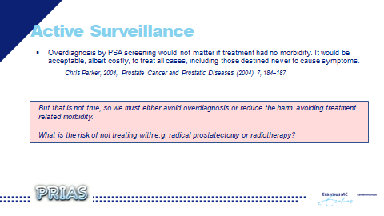

In 2004, there was a very sensible article by Chris Parker, an oncologists in the UK, and he admitted obviously as we all knew there was over diagnosis by PSA screening, that it actually would not matter that there was overdiagnosis if the treatment had no morbidity. It would be acceptable to treat all cases included those destined to never cause symptoms, but we all know that that isn't true, right? We must do something about it so the best option, at least in my view, would be that we avoid over diagnosis. But that is very hard, still today that is very hard. Another approach is to reduce the harm by avoiding treatment related morbidity. And that is something that obviously refers to active surveillance. But then immediately comes the question what is the risk if we do not treat actively, with for instance radical prostatectomy or radiotherapy?. Because it's a very strange message for recently diagnosed men. You tell them in one consultation ‘Okay, I'm sorry to say this, but you have prostate cancer’ and the next sentence is ‘but we will not treat you actively’. That is a strange message and people will start worrying and thinking: OK, what's going on here and then immediately obviously the good messages of active surveillance must be there.

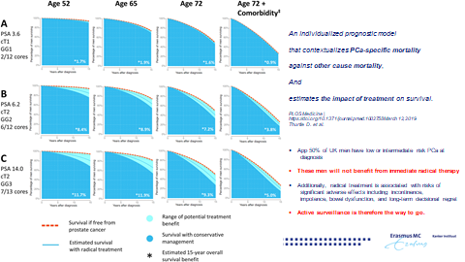

And I would like to explain to you why active surveillance is a perfect solution for these low-risk cancers, by looking to this graph which put into context: mortality, survival, prostate cancer specific mortality and the impact of treatment on certain cancers.

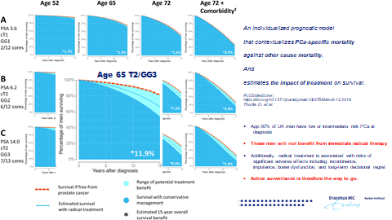

And I want to focus, for instance, starting below in row C as you can see here. Here you see the age, and here you see the type of cancer, the time of diagnosis but we will now focus on this particular example. You see here the example of a man aged 65, he has been diagnosed with a cancer with a relatively high PSA value, a T2 cancer with a grade group of 3 that is a Gleason 4+3 and of the 13 cores that have been taken at the systematic biopsy 7 were positive. So this is not a very favourable picture for this man and you can see here the orange line is survival without prostate cancer which declines over time. This is as expected since not all men will reach the age of 80 So this is the survival curve if there is no prostate cancer. The dark blue represents the survival curve if you have this type of prostate cancer and it is not treated. So what we have here in between, the light blue part, is the potential benefit of active treatment effect. The line in the light blue part of the graph is the potential treatment gain, since we all know that treatment is not 100% effective in all cases. As you can see in this picture there is a considerable difference between doing nothing and treating this man. So in this example it is certainly worthwhile to treat this man.

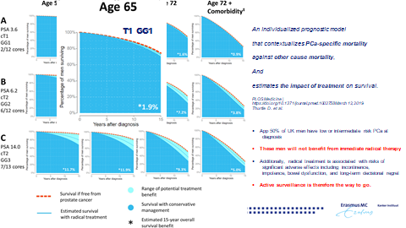

If you now focus on another picture, on the upper part. . This is a man also aged 65, but now he has a prostate cancer with these characteristics: a lower PSA, a T1C prostate cancer, a Gleason grade 1 so a Gleason 6 and only 2 of the 12 cores were positive. And now you see again the orange line similar, this is survival without prostate cancer, and the dark blue area is survival with this prostate cancer not being treated. Now it is obvious that there is a very, very narrow difference between those lines. So the benefit of active treatment with all comorbidities is extremely small. So then we touch upon the question of harm versus benefit. And if you then take into account all the harm being done with active treatment, it is not a good thing to start active treatment in these type of cancers.

So to conclude, this is a study based on more than 10,000 men with prostate cancer in the UK. And please note that approximately 50% of men when being screened, like I just said, have these kind of type A cancers ( see the figure) and all these men will not benefit from immediate radical therapy. And for these men active surveillance is therefore the way to go. Preferably we would like to avoid the diagnosis but if it is diagnosed , active surveillance is the way to go cause there’s simply only harm what can be done and no benefit.

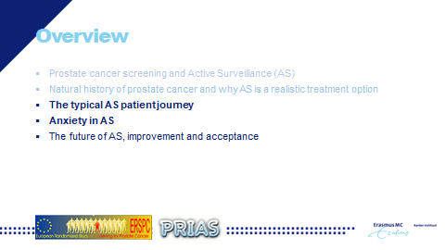

So what does it then mean if you have been diagnosed with a prostate cancer that is in principle initially suitable for an active surveillance approach. What does it mean for the patient?, what does it mean with respect to anxiety? Because it is perhaps a little bit counter intuitive to not have active treatment.

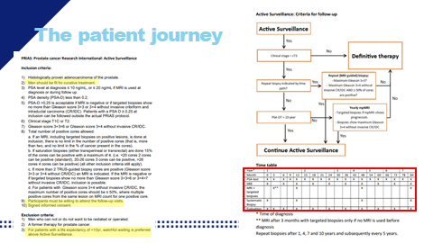

I take this example of the PRIAS study. Perhaps you have heard of this. PRIAS is a global study which actually is an interactive website open for all urologists worldwide who can have a login and use this interactive website to follow their patients, which have opted for active surveillance. It is very nice to work the website since it generates graphs for the urologists and is also very informative for the patients. For a patient it means that if he opts for active surveillance, that he must and should be fit for curative treatment, because this is always an option when you initially opt for active surveillance. There should always be the possibility for whatever reason to switch to active treatment. So you must be fit for active treatment. And for the rest, it’s very important that if you consider active surveillance, you must be willing to attend follow up visits because it is after all called active, with the emphasis on active, surveillance. So you must be willing to attend follow up visits. Let’s have a closer look what follow-up visits actually mean

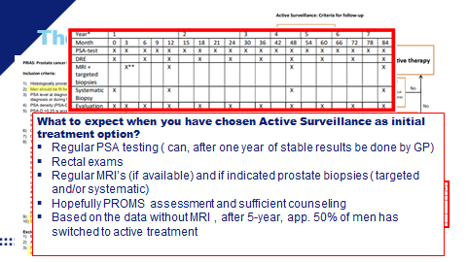

This is the PRIAS protocol. This is something that is used very often in the world. What does it entail when you have chosen active surveillance as initial treatment option? It means regular PSA testing, and at least in the Netherlands I know that after one year or after two year of stable PSA results often this regular testing of the PSA value can and is done by the GP. So that means that you do not have to visit the hospital that often, which is most likely a patient rather avoids. In addition, active surveillance means rectal exams at certain points in time. Nowadays it also means regular MRI‘s if they are available and if indicated prostate biopsies. This can be either systematic biopsies or targeted biopsies, or both depending on the situation you are in. And I sincerely hope that it also means that the PROMS are being collected from the patients that are on active surveillance because they proof to be valuable in assessing how everything is experienced by the patients. Important data, as we just heard from the EUPROMS study. Sufficient counselling , this is something that is definitely needed on active surveillance because this treatment option needs a lot of talking. At the frequent visits to the hospital or GP a patient needs to have reassurance that everything is OK. So, I have learned from urologists that having patients on active surveillance actually means more time needed during clinic as compared to other initial treatment options. But that is something that is definitely needed. Based on the data without the MRI being used, so let's say the active surveillance data from five years ago, approximately 50% of men, after five years, have switched to active treatment and this is one of the reasons why there research is so needed in the field of active surveillance. Not so much because it's an unsafe treatment option, no far from that, it is a very safe treatment option, I hope that I’ve just showed you discussing the survival graphs, that it is safe treatment option. But many men switch to active treatment based on triggers that are actually invalid and we need to work on that to make sure that active surveillance indeed can reduce the harm of over diagnosis.

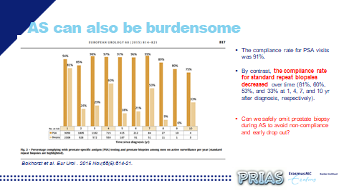

Active surveillance is obviously all about avoiding the complications of active treatment, like urinary incontinence and impotence. However, also active surveillance can at some point be burdensome. I just showed you the table with all the visits you need to follow to be sure that we adequately monitor the cancer. And what we know now from the PRIAS study, is that the compliance rate for PSA visits, as expected, is very high because that is of less burden for a patient as compared to e.g. the prostate biopsies. And this is confirmed by this graph where you see a decline in compliance over time for prostate biopsy. Good compliance is however important. Not so much because we are afraid that the cancer progresses but more that there is reclassification. This is something what occurs if at time of diagnosis the grading and staging of the cancer has not been optimal. . That is the main reason why we do need to repeat tests over time and that brings us to the question: what could we do to reduce this burden from active surveillance? Can we reduce or omit the repeated prostate biopsies and with that reduce or even avoid non-compliance and early drop out of active surveillance?

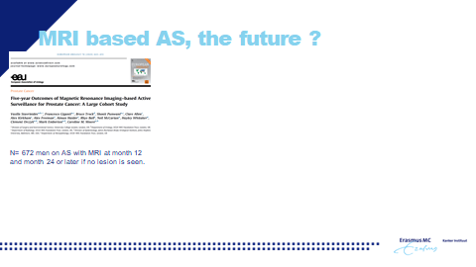

Of course we have all heard about MRI. And the MRI is certainly of high value in prostate cancer diagnosis, I say this without doubt. It has changed the whole picture of prostate cancer diagnosis. And I can tell you and I will show you later that it has also plays an important role in reducing unnecessary testing and overdiagnosis in the screening pathway. But what about MRI in Active Surveillance? Can we do active surveillance purely based on imaging? So no burdensome of prostate biopsies anymore? Obviously these trials are ongoing. In this slide you see data of a study where researchers have analysed the five year outcome of MRI-based prostate cancer of 672 men. There was an MRI done at time of diagnosis, at 12 months and one at 24 months or even later if nothing was seen in the earlier MRI’s.

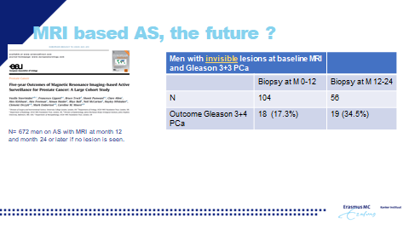

And it looks all very promising with respect to compliance and 5 year outcome, but if we look in more detail we see that in men with invisible lesions, so with a normal MRI, who in this study were biopsied we see that some cancers are still missed on these MRI’s over time. And we need to learn more about the consequences to be able to fully recommend and trust a purely MRI based active surveillance protocol. .

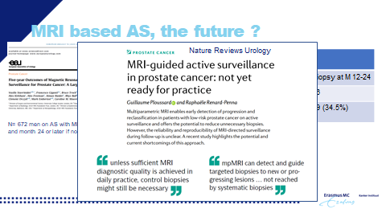

And that’s also what's being said in the literature now. It has without doubt much potential and I think it is really a lifesaver for men on active surveillance that they do not have to have the burdensome prostate biopsies at regular intervals, but we need some more data here.

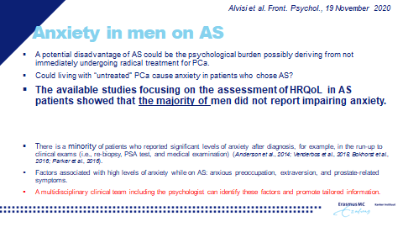

Then about anxiety. And I just want to stress that based on the survival graphs I just showed you, you should not be too anxious that your cancer is progressing over time. It is more that we worry that we have to correct picture at time of diagnosis. So what about anxiety in men on active surveillance. Because as Cosimo already said, it might have a psychological burden because you are not going to be treated for a cancer that has been diagnosed. And that might be very strange. Indeed living with untreated prostate cancer can cause anxiety in patients who have opted for active surveillance. And we have done a lot of research on this with PROMS and that’s why I stress so much on collecting PROMS because they are invaluable to do these type of research. And as can be seen on the slide the majority of men undergoing active surveillance did not report any impairing anxiety. But it is the majority, it is not all men.
So there are still patients on active surveillance who reported significant levels of anxiety, either after diagnosis, but also , e.g. during active surveillance. Since, like I just showed you, a patient has to come for PSA testing, has to wait for the test result, has to undergo a biopsy, and has to wait for the test result. All this can cause anxiety, and needs to be dealt with. To be able to do this it would help enormously if we know upfront whether you belong to the group of patients who will experience anxiety. This is why we do a lot of research on this subject and why we need the PROMS. We learned already that some men with certain characteristics are extremely sensitive for experiencing this anxiety and obviously especially for those men it is preferable that we have a multidisciplinary team and that we can promote tailored information for these men. The goal is to avoid that these men switch to active treatment unnecessarily, that would be harm, since active surveillance is the right choice and it is safe.

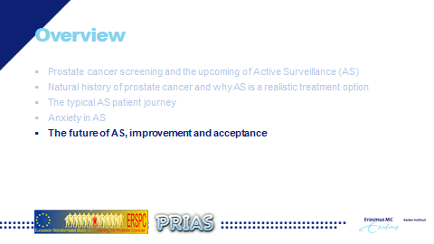

So to conclude my presentation I would quickly go to the future of active surveillance, the improvement and the acceptance of active surveillance

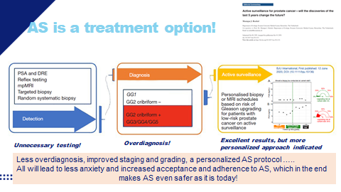

And I would like to show you this figure. First, how we did it, screening, diagnosis and treatment. . We had PSA, sometimes a rectal exam, we did a random systematic biopsy. A lot of men were biopsied, a lot of cancers were diagnosed. You see the difference in the amount, a lot of biopsies, not all men had cancer so a lot of unnecessary biopsies. The cancers we detected were for more than half Gleason 6 prostate cancers which we prefer avoid to detect. These men were hopefully offered active surveillance, but certainly not all opted for this. Active surveillance is currently still a one size fits all protocol. So every man undergoes the similar testing schedule while this might not be necessary in a lot of men and we know it is related to dropout rates. But please do not forget, Active Surveillance has excellent outcome results.
So how can we change this? First of all, and that’s already luckily ongoing. We have reflex testing, nomograms, risk calculators, we have MRI with targeted biopsy. So less men are being biopsied, and those men that are being biopsied are at high risk of having prostate cancer so less unnecessary biopsies. We have a different balance now in overdiagnosis and detecting those cancers that need treatment to avoid further harm. We have better insight with respect to growth patterns, i.e. which men are especially suitable for an active surveillance protocol which enables more men to follow an active surveillance protocol.
And active surveillance is about to be change into a tailored individual program. The test frequency will be based on his individual risk which we can calculate on the basis of, not only PSA but also e.g. MRI results. With that we can avoid biopsies in those men at very low risk of reclassification and we can do a biopsy in those men at higher risk of reclassification. And if this all works and is implemented at a large scale, then without doubt we will reach a stage where we have less overdiagnosis, improved staging and grading and a personalised active surveillance protocol. And this will all lead to less anxiety and increased acceptance and adherence to active surveillance, which in the end makes active surveillance even safer as it is today.

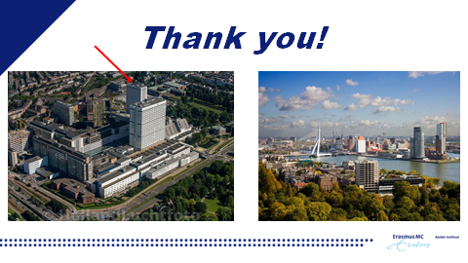

And with that I would like to thank you and show you where I work in Erasmus. I moved a few years ago from an old building to this very new building to one of the higher floors and at the right you see my view from my office, which unfortunately I have be able to visit a year now, but hopefully I can go back pretty soon. Thank you for your attention.

Thank you very much, Monique. It was a very good presentation we see a nice picture of your view from the office and a nice blue sky.
Okay, so I thank you everyone for the participation I don't know if Anja has online questions.

Yes, I received some Cosimo.

Q&A

* Should Gleason 6 even be considered cancer?
You have seen it in the slides that I have presented we are speaking about grade 1 and 2 and scored 2 and 4. These are not considered cancer any longer as I said and they are not mentioned in the pathology report any longer. They were so many years ago and this is when we had the diagnosis of cancer on the biopsy in the late 80s, prostate cancer was a killer, so we treated them. These we do not consider to be cancer. Gleason 6 we have extensive research done in Europe, also done in the United States. There are some patients that were operated for Gleason 6 that so called subsequently developed progression and had a risk of dying from prostate cancer. But you need to go back then to the pathologist that has made the initial diagnosis. We are now with the international guidelines on classification of Gleason score much better and when today a pathologist tells us this is a Gleason 6, it will be a Gleason 6 but you understand what is the difference between a 3+3 and a 3 + a little bit of 4 or what is missed on biopsies. You have always a likelihood that you miss something on biopsy because there is even more aggressive tumour that is not seen on MRI that is not targeted and not picked up with systematic biopsies. So the man who has a Gleason 6 to say that he has no prostate cancer because when it's only this what we see under the microscope will not kill him, it’s probably a bridge too far because the likelihood that he has some more cancer elsewhere. So this is why we need this safety net in all active surveillance patients with a Gleason 6 that this is checked by regular PSA testing, that this is checked eventually in case of PSA rise or short PSA velocity by multiparametric MRI and eventually we biopsy to see that he does not need to be reclassified.

* What is the European view of genomic testing used to the determine with other factors whether a man goes on active surveillance?
I'm not, I'm not particularly aware of the European view, but in my view genomic testing is indicated in a certain sub group of men, those with a BRCA mutation and also those men with family members who have been diagnosed with prostate cancer at a young age. So really, those men that have a high risk for having aggressive cancer at a younger age. But in my view at the moment, genomic testing is certainly not something that should be used in every man that is being considered at risk of having prostate cancer that is one step too much in my view but Hein, I'm please go ahead.

I think I should add something! There is just a recent paper. I think I saw it just a couple of weeks ago. It's a large analysis and they have seen that the application of active surveillance in this group of patients of genomic testing or without genomic testing to see whether they were safe to continue on active surveillance. We must realise that more men choose to stop active surveillance because of the result of genomic testing. So this will have disadvantages as well. By the way, they are not easily accessible today. They are not available everywhere. I do not want to include genomic testing just besides the BRCA 1 & 2 mutations. This is different because this is really young men 45 years of age that are at risk to develop significant cancer. But the real genomic testing to know, am I a safe, active surveillance patient that can continue? I think we do not have enough data today. It might impact negatively on the number of patients that want to continue active surveillance, and I think the science is not there yet that this is the correct way to go.

Thank you. Other questions, Anja?
Questions are running in. Let me ask another one.

* What happens with high grade PIN, does it turn cancer or can it regress?
Does it turn cancer or can it regress? Well, interesting. I think it can remain high grade pin and it is considered to be a stage before prostate cancer. But whether it can regress, I'm not sure. Perhaps Hein knows that.

We have studied high grade PIN very intensively in the past, and we have today agreed not to mention high grade PIN in biopsies any longer. Because there is no real roadway from high grade PIN to cancer. So this means that many men can have a high grade PIN and continue to have high grade PIN, and we have seen by giving dietary measures and supplements that high grade PIN can even disappear. So I think the question is very relevant. I do not consider high grade PIN to be cancer. We are not sure that it is a precursor of cancer in every patient. So I would try to convince all the pathologists that look at biopsies not to mention high grade PIN, because it's just a factor of fear. On the other hand, if you are on active surveillance, can you do something to maybe not have your cancer grow too fast and then we are thinking about prevention of prostate cancer? The only data we have is epidemiologic data. If I have a young man who comes to me and says my father I saw him dying from prostate cancer. I do not want to have prostate cancer, but can we prevent it? No, we can certainly not tell you black and white that you can prevent it, but you can adapt your diet and your lifestyle. You can do more like Southern Europe. You can you do more like the Asians. There is supplements that you can take. We know that processed meat and red meat probably are a co-factor to get prostate cancer. So there's a lot of things that you can do and we have in high grade PIN patients administered Prevalon a couple of years ago which was soy-supplement with vitamin E and what we saw is that they were not less patients developing prostate cancer than in those that did not get it. The only thing we saw that there was a response in PSA and those who responded with a lower PSA by taking these food supplements, they indeed showed to have less prostate cancer in subsequent biopsies. So there is something that could be done, but I say it's all very floppy here. Not too strong evidence. But we also did a randomised trial and we saw the same that it affects your PSA doubling time. So that will be longer, right? So it affects your arising of your PSA and that we assume also affects your tumour growth but that is something that still needs to be proven. But yes, and in the end it doesn't harm to have a healthy diet, to exercise a lot for many, many other reasons.

Other questions?
I have another meeting already started. If there is a question for me then I would like to have it.

* You told us that 50% drops out after five years. What can those figures be with all the changes?
I think it hopefully will be much, much lower since the diagnosis we already been much more accurate in the future as I hopefully have shown you with the MRI’s, with the more pathological knowledge we have so the fear of reclassification especially in the first year on active surveillance, there is a drop out of approximately 25% already, which drops out after one year and that is not because of progression, but because of reclassification and that will disappear in time. I'm sure of that because we will do a time of diagnosis and much better staging and grading. Then the anxiety is a main reason for overtime that men or the urologist. It is not always the patient, it can also be urologist who is anxious to follow up with the protocol. And I hope that we can address that further with the PROMS and with the counselling that we need to do and also urologists need to be counselled how to best provide active surveillance treatments to the patients. But in the end I will hope it will drop down to less than 20% and that is what I just sent to André but now for the whole group.

Okay, thank you Monique. You can you can leave.
Thank you sorry but I have a pioneer meeting starting at 7pm and I need to be there.
So we will keep in touch and in case we will send you other questions.
No problem, please send me the questions. Bye bye.
Any other questions?
Let me just ask one question to Prof. Van Poppel.

* Is there research indicating young boys should be monitored when PSA is no higher than 1.0?
Yeah, there is an age-related PSA. You know that what we consider to be too high in young man the fluctuations of PSA by intercurrent diseases like prostatitis, like biking, like ejaculation. A young man who goes on holiday for the weekend to the Ardennes in Belgium and he’s biking for 6 or 7 hours and they had sex three or four times. He will have a higher PSA on Monday morning, so there's so many different things that can happen. I think there is an age to take a PSA which should not be lowered below 40 years of age. For the EAU it’s 45 when you have either an African origin, if you have a family history, that's the first or second degree family member who has had prostate cancer, and third is the BRCA 2 mutation. BRCA 1 is still not so closely related to prostate then to breast cancer, and this is 45. I know that younger man sometimes they have a PSA determined and it gives very difficult stories because they have a PSA 1.7. Then they go forward and I agree it is not done always in a proper way. They are anxious to have prostate cancer. On the MRI you see something that is then misinterpreted. They could even have biopsies which I believe if you look at the incidence of significant prostate cancer, we should stick to these ages that I just mentioned and not do PSA testing in younger man. Prostatitis can give PSA’s up to 70, to 80. Benign prostatic hyperplasia. The big prostates, obviously they have a higher PSA as well and therefore why do we start at 40-45? Because these men do not yet have significant prostate enlargement. Because once you have prostate enlargement, just the size of your prostate will make that you have more PSA in your blood, so therefore 40-45. If a man does not want to die from prostate cancer today, he can do it, and then he should follow what we have said. Have his first PSA at 45 or 50.

Okay, thank you professor Van Poppel. I have just one last question and then we can finish.

* Can Prof. Van Poppel comment on having a confirmatory MRI in addition to a confirmatory biopsy to act as a double confirmation for a Gleason 6 considering Active Surveillance?
Well, again this all depends and we are working in, Monique and I are working in tertiary referral centres and it happens that the patient has had an MRI, even in private somewhere in Antwerp or in Brussels, that he had one or two biopsies from his prostate and he is then considered a PIRADs three or four, let's say, but he has only one core that is involved for less than 50% and he is considered suitable for active surveillance. I think this is correct, but you need to be sure about the initial status of the patient. Is this MRI well done? Is the biopsy well done? And if it isn't? Then I think it is wise as a man confronted with the so called active surveillance candidate to have a confirmation in the centre of excellence with a decent multiparametric MRI and eventually re biopsy. And this is unfortunately what happens if we see people that are worried and that have been seen in a peripheral or in a small hospital, candidates for active service, “am I safe to do so” then often we have to propose a new MRI and to do new biopsies. Actually, if you start active surveillance and you plan to only check the situation and the evolution two to four years later, with a MRI or a biopsy, you need to be sure from the beginning that you're not on the wrong track.

Okay, thank you. Thank you very much for your answers. And I think we can take the commitment to answer to the remaining answers the next webinars. We will have a next one on May 20. It would be another testimonial and other two medical specialists. The idea is to have more and more opinion and to continue exchanging ideas and the indication on this information on this evolving items. So thank you very much Hendrik for your support.

* How big portion of men should be under active surveillance compared to men under active treatment?
Well you understand what we are trying to do at the European Parliament and at the Europe's beating cancer plan and what Ekke has been achieving in Austria is wonderful. We tried to do the same in Belgium but we know that if we will do early detection the way we are proposing it, there will be overdiagnosis and we than need to be sure not to do overtreatment. Asking me what percentages of men will be on the one or on the other side is very difficult to say because today there is no population-based screening done. What we propose to do with the EAU and at the Parliament and in European Union is to have a population-based information campaign after which the man chooses to have a PSA test. And starting with the PSA test, then we will do the next steps as we have described. But I do not have the slightest idea how many will still be overdiagnosed, but there will be. So the better we can have active surveillance secured and the better it will be for the early detection programmes because men will be less reluctant to have a PSA test if they know maybe I have prostate cancer, but it might even be that I do not need to be treated. So I think that Cosimo has had this idea from the very beginning to support why did he come and talk to me? Because I'm mostly busy with this early detection programme. He was busy with active surveillance with ASPI and with his friends over there. And he has said I can help you in making early detection more acceptable. I am just stating that active surveillance is a good management for a certain amount of patients that are diagnosed with prostate cancer.

I think we will have to go on, on this in the webinars because it is a very interesting subject. So I'm sorry but we have to end now. But I want to thank everyone for taking part of this webinar. We will try to go on with the next one on May 20. Thank you very much and in any case you have our email address if you want to send other questions. Thank you very much and good evening to everyone.

Thank you very much.

