SCRIPT

EUomo's third online webinar on Active Surveillance:
“Early diagnosis and Active Surveillance, how to balance under/over treatment?"
Thursday, June 10th, 2021 from 5:45 to 6:45 PM CET

Cosimo Pieri = CP
Thrainn Thorvaldsson = TT
Prof. Chris Bangma = CB
Anja Vancauwenbergh = AV
Questioner Steven (USA) = QS

CP:
So good evening everyone, I am Cosimo Pieri and I am from the Board of Europa Uomo and also part of the Europa Uomo Italy association. Early diagnosis, active surveillance and how to balance under-/overtreatment with this third webinar, we want to give a basic introduction on active surveillance and especially today is focusing on this argument of under-/overtreatment. So the idea today is just to give an overview of the benefit of active surveillance and also give an overview of how it is useful to apply the multidisciplinary approach in general to reduce overdiagnosis which may lead to the use of active surveillance in all ways that are possible. Today we have organised two testimonials and then we will have professor Chris Bangma giving us an overview of the arguments which are related to what I was saying.
Now the first testimonial is Thrainn Thorvaldsson from Iceland, and Thrainn is the chairman of the board of the local Iceland prostate cancer association and is also cofounder of the first independent active surveillance support group. So Thrainn we have already spoken before so we see that you are fine even if you are near a volcano. We hope that you won’t be covered by lava. Okay. We have a still a few questions and obviously you can give your review more or less what is important to understand this, what was your experience, in this circumstance the important of a second opinion and if you had to cope with anxiety during the journey, so more or less these are some questions, but you certainly will give us a good overview, so Thrainn please go on.

TT:
Thank you. Cosimo this is a great honour to have the opportunity to addresses this webinar. You gave me three questions to answer. How was my experience on active surveillance? And the importance of a second opinion. And how to cope with anxiety during the journey? I have decided to write my presentation as we are restricted in time. I hope you understand my English with the Viking accent. Because, as you probably know Icelandic, we speak the same way as the Vikings did 1100 years ago.

1. How was my experience of AS?
Well the first question: How was my experience on active surveillance? Active surveillance has made a huge impact on my life. If I had not thought of active surveillance in 2005, my life would most likely have been different, and I would have missed considerable quality of life. My active surveillance story is a little bit special. I started PSA testing over 20 years ago in the year 2000 when I was 56 years old. No reason for starting, I just read in a newspaper that PSA blood test could be of importance. My PSA value proved to be 5 when I started. Once a year I had the PSA test and the value increased every year. The doctor didn't tell me that PSA level over than four was a sign to be watched. I did not seek any information about prostate cancer matters I just trusted what the doctor told me after each PSA test every year and that I was in a good shape. After a PSA test in January 2005, the doctor called me, so happens I was in Norway at that time. I asked if I was not OK as usual, but he said no. I would need to have further tests. We should discuss the issues when I returned to Iceland. He didn’t want to give me more information at that time. I have sent rarely ever felt as badly as during the rest of the days in Norway. I became very anxious and depressed. What was this about? Did I have cancer and was my death around the corner? I didn't know anything about the disease. Then I returned to Iceland, I met with the doctor who told me that my PSA value had reached 10 and I needed to have a biopsy. The result was that I was diagnosed with prostate cancer, Gleason score 6 (3+3). Second opinion showed the Gleason score 7 (3+4). I asked the doctor what to do. I’ve booked you for a surgery next month was the reply. At that time, almost all men diagnosed with prostate cancer went into treatment. I met the doctor again and had a number of questions, but received limited answers. I searched information online and learned about the theories of Dr Laurence Klotz in Sunnybrook in Toronto, Canada which in 2005 were receiving attention and recognition. My doctor predicted a very uncertain future for me if I didn’t go for a treatment. My wife and I decided that I should not have a treatment until further studies. At the age of 61, I was not ready to take the risk of possible side-effects as impotence and urinary continence. I also believe that I could postpone treatments, prostate cancer treatments would advance. I had no idea at that time that my PSA and other biomarkers later turned out to be satisfactory condition for being able to choose active surveillance treatment. My wife and I decided not to tell anyone outside our closest family about my prostate cancer diagnosis if I was to die. After two years we thought it would be safe to tell and I started my current journey as a lecturer on prostate cancer in men’s clubs and supporting men who were being diagnosed with prostate cancer. Yes, I was on active surveillance for 14 and I enjoyed full quality of life. Two years ago, it was found that a part of one biopsy sample taken in Germany was Gleason 8 (4+4) and the lesson was close to the surface of the gland. I could have waited and watched the development instead of having a treatment. I thought it was different case to be treated after 14 years of active surveillance, being 75 years old and not 61 years old, I then undertook radiation therapy which ended in February last year and underwent androgen deprivation therapy. My PSA is now 0.04. There has been a great progress in prostate cancer treatment during those 14 years, not least in the radiotherapy. It should be noted that the sexual desire disappeared during the treatment and has not yet returned. My wife and I think with gratitude of the 14 years I enjoyed full quality or life.

2. What is the importance of second opinion?
The second question is the importance of second opinion. I think it's most important to get different opinions in diagnosis not least when decision has to be made that can affect quality of life or the person in question. This also applies in the case of institutes where few samples are taken for analyses and relevant analysts received limited training in analysing. I read once that it is wise that when seeking for a place to be diagnosed, we should choose places or a place where number of samples are taken. It was stated that an analyst needs to analyse at least 1000 samples before they are fully qualified to arrive to the correct results. I have chosen to have a second opinion by foreign experts. I have visited doctor Barentsz at the University Hospital in Nijmegen in the Netherlands a few times. And in connection with Europa Uomo meeting in Frankfurt in 2019 I went for a targeted biopsy with doctor Vogl at the University Hospital in Frankfurt. The results were different from what I had received in Iceland and changed my decision making. So, I recommend second opinion.

3. How to cope with anxiety during the journey?
And the third and last question is how to cope with anxiety during the journey. Personally, I have mostly been free from worries on my prostate cancer journey, except in the beginning as reported earlier. However, I know that many prostate cancer men have great anxiety after being diagnosed and also after choosing active surveillance and also after undergoing treatment. The fear when being diagnosed with prostate cancer is due to ignorance. To be diagnosed with prostate cancer is not as deadly as many men expect. In fact if detected early, the life expectancy is over 90%. It’s difficult for men to get the grip with the complex prostate cancer issues under the strain of diagnosis and to evaluate the treatment options. Many men want their doctor to decide for them if they should be treated or not. I have pointed out to men together with their spouses should make decision themselves and therefore it is important to acquire knowledge about prostate cancer on their own. Urologists cannot make decisions for the individual. They can review the choice of decision making options but decision makers should always be the individuals. I once asked a urologist why he didn't advice men who have low scores to choose for active surveillance, and he answered: I cannot, if I do so and a few years later the evolution of prostate cancer has gotten worse, then men will ask me ‘why did you not lead me into treatment?’ I naturally list active surveillance as one of the options. I have the feeling that doctors in some cases have the tendency to recommend treatment, especially in the intermediate risk, Gleason category 7 (3+4), to be on the safe side and then choose to go for a treatment immediately after being diagnosed become very regretful. The men are shocked when they are being diagnosed and ask the doctor to remove the cancer immediately. After a few months, when the side-effects appear, they have reservations about the decision. Many men in this situation have told me that they should have taken more time to look more closely at the situation and options before making a decision about the treatment. The big question is how to reduce anxiety post active surveillance and after treatment. When I was first diagnosed in 2005, I was very lonely. I didn't know anyone who had not been treated and I could talk to. The doctors strongly encouraged me to go for a treatment. There was little information available in Iceland and I was lucky to come across the Prostate problem mailing list, chat site, in the USA where I receive the information and I could ask questions. Many people were incredibly diligent in providing information. The information and support I received from this site proved invaluable to me. There is plenty full of information about prostate cancer centres in English. In Iceland, prostate cancer information is to be found on the Icelandic cancer society website in a compartment called Men's chamber. We at Framfor (organization of prostate cancer men in Iceland) have our own website where we share information about prostate cancer. Our experience, however, is that most men who are diagnosed or are on active surveillance are not very active in reading this information. Many men do not even know their PSA or Gleason value or what they mean. My long experience in dealing with men who had been diagnosed is that information will be important, but even more important is what I have called nearness that means close communication with others who are on the same prostate cancer level as themselves. People who have chosen active surveillance need to be in contact with other people who have longer experience on active surveillance. Those who have undergone treatment need to be in contact with people who have more treatment experience. We at Framfor are experimenting with a new organisational approach. Our association will be working as an umbrella organisation for three types of support groups. One is the support group of men who had been diagnosed with prostate cancer. Another for men who have not undergone treatment and chosen for active surveillance. And we are preparing to establish a support group for spouses. When it comes to educational meetings, the type of group needs to be taken into account. Men in the support group who have already undergone treatment have limited interest in learning about new methods for treatment, men in the active surveillance group do. Men who had undergone treatment are interested to know how to improve their quality of life, like sex life, and how to monitor it after being treated. It is regrettable for men who have undergone treatment to listen to discussion about active surveillance. This work of us in Iceland is in progress and this is not the time to tell more details and at the end. My friend and I took the initiative in 2014 to establish the first independent active surveillance support group in Iceland and probably elsewhere. After we started the group, the members claimed that they would have liked this support group to have existed when they were diagnosed with prostate cancer and choose active surveillance. It would have relieved them from great worries and anxiety. The closeness and connection with others at the same PC cancer stage seems to me to be the key to reducing anxiety and fear with the support of good information. Thank you for the attention and warm greetings from volcanic Iceland. Thank you.

CP:
Thank you very much Thrainn. For me, and I think also for the other your testimonial of active surveillance is a good example and in certain sense positive and now I will bring the other testimonial which is from Ettore Fumagalli who has been the President of Europa Uomo Italy for nine years. Ettore asked me to read his presentation as he could not join us. In this case, and this is a different case and unlucky for him, Ettore did not have the opportunity to choose active surveillance back in 2004. So let's go through his testimonial. Ettore is very active till now in the financial investment market. So now over the age around eighty years. He had a radical prostate cancer operation in 2004 after suffering from benign prostate swelling for many years. In his case, after a pharmaceutical treatment, he discovered the PSA around 6. He had 4 biopsies and at that time without any anaesthesia, so not even very nice. Everything was with negative results until he got the results from the screening which he asked from an urologist in the United States. He wanted to be at the highest possible level of decision but unlucky the diagnosis was 3+3, so it was a diagnosis that now is able for active surveillance. But at that time, what happened is, obviously they decided it was not able to continue to participate, to take part to, the pharmaceutical proforma study on finasteride. And he was contacted and he went on in contact with an important Italian urologist which has suggested him an operation without giving him many, many choices. The pressure was high, the news was really shocking for him. And even if he had, let’s say the technical study was also university background, he didn’t had the faintest idea what he had to do. He decided, let’s say he was pushed, he decided to do the operation didn't had the good choice and what happened is that obviously he got some side-effects which were not expected at all. But during his convenisis he had the television of the regulation of the Europa Uomo association by important doctor in Italy, Veronesi. He decided to join in 2007, participate to the first encounters and began to understand about the prostate cancer. He became aware of the problem that he had when he went in the operation. He didn't had the idea and he saw at the same time that most men in Italy didn't want to
talk about prostate cancer and did not had the idea where to go to get the side effect with like for instance the most relevant for Ettore was a sexual consequence. On the other hand, the urologist at that time and even later tended to appear to the main patient with the surgery tools in their hands even before examining and the wrightly patient. So it was really for him a mission, because he was already working in voluntary work giving blood donation and activity. And decided to push a lot and give a lot of attention and create this association which now we are going on with the idea to give information setsitary institution represent the right of the prostate cancer supporting frame. It was really for him, he did a really fantastic work because now a lot of patients, like for instance me, were standing in a situation where they could choose active surveillance without going in that direction, that for him was not good. In particularly, the doctors logic. Ettore is caught in an example, which is the different situation that is one of his cousins had after a Greek diagnosis of the same type Gleason 3+3 in 2010. His cousin was, in 2010, suggested to start active surveillance and the result was that he had better quality of life. During the work that Ettore did in the years, the idea was especially to push for the multidisciplinary approach and create more care instead of using surgical operation without many, many support. Obviously this progress were coming also because in Italy we started a programme of prostate cancer programmes of Prof. Valdagni which you saw in our last conference. The creative culture, there was the arrival of the DaVinci-robot. The active surveillance became more known and the experience of Ettore was bad for himself but we have to admit that he did a very fantastic work to support the other people in Italy to have a better quality of life what we are experiencing. So more or less, this is the experience of Ettore. And the idea we had is to show what has been done in the difference cases between one case of active surveillance and one without active surveillance. Ettore is at disposal in any case for questions when we want and he is giving/providing us compliments to do these actions and this action was also supported by Malcolm Duncan which was his support person in helping me to create this testimony.

Okay so thank you. I hope that was clear, we will have questions and answers later. Now we go to the third part where we want to give the speech to Professor Chris Bangma, who has a very important role in Europe as a professional chairman of the Urology department of Erasmus Rotterdam. I have sent to Chris a lot of questions but he will give us an overview on his best experience. The idea is to talk about benefits of active surveillance treatment, which two cancers are more amenable for active surveillance, what is happening with early detection and early diagnosis all over Europe, and the benefit that early diagnosis and active surveillance are bringing to the world to the men in Europe and will probably bring more in the future. I asked him also to give an idea of the PRIAS study. Chris how are you today? I hope you're fine.

CB:
Thank you very much Cosimo, I'm perfectly fine and I hope that you can hear me well and I'm very thankful that you give me the audience today. And let's talk about this active surveillance. I'm very much impressed about the testimonials because they reflect, I think, the lives of hundreds, thousands of men in Europe struggling with prostate cancer and struggling with making decisions on their own, with others, with their physicians and I can only say just like Thrainn was telling us, although the suggestion of his background with the volcano and being cool on Iceland, it heights a little bit that anxiety might play a big role in the daily life of prostate cancer patients. So we can be sturdy about it but please communicate with each other the best you can. Now we can probably talk for many hours about active surveillance and just see my presentation as something that is a reach out for questions to pose within this setting or around it but I'm very happy that Europa Uomo for many, many, many years already facilitated this pendure being discussion between patients and physicians in this field. Now what I want to highlight is, at least by this two testimonials, that there is some kind of attention between the one and the other. The early detection of prostate cancer being in time for curative treatments and then on the other hands being diagnosed with so called harmless or irrelevant cancer as suffering from death presents all your life, suffering from the anxiety that it might change into something realistic that needs to be treated. These two items are fighting each other and I will show you a little bit why. Anja is helping me with the slides, as usual the women pushes forward. So Anja please do and give us the next slide.

AV:
Can you see the slides?

CB:
We’d like you to proceed because I'm limited by my university making use of Zoom, so I'm asking you to go to the next slide. Anyway while busy looking for the correct button, I can only start with telling you the story of screening and prostate cancer, because in the 90s we started with PSA.

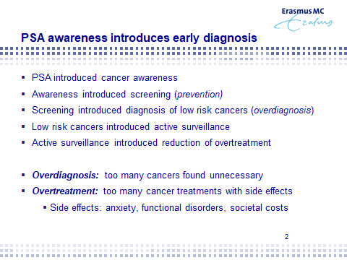

PSA was an easy test, it was a blood test and everybody could get their PSA from the GP or from any physician. It was cheap so from that moment onwards there has started some kind of awareness that you could find prostate cancer by means of PSA triggering biopsies in the general population. And that's what people did, so more or less PSA started the anxiety. And so we introduced screening, there was an enormous screening activity amongst Europe. A large randomised study and that showed in the end that screening could reduce mortality. So the mortality due to prostate cancer could be reduced by the screening, and fortunately it also introduced an enormous amount of recognition diagnosis of these harmless and slow growing tumours that Thrainn was telling us about. And that’s what we call overdiagnosis. Actually, you're being diagnosed with the cancer, however this cancer is harmless for you because it never gives you symptoms and therefore you live with the anxiety. Because it has to be checked again and again and again. So what we did we do in the early 20s. So Prof. Klotz and others and also in Europe, people started with programmes taking care of active surveillance, not doing anything, not treating immediately like Cosimo told us about the Ettore’s story. But keeping an eye on it and looking whether things would change, whether the risk would change. And therefore active surveillance was invented and it had to be done in protocols because we did not know the behaviour of all these tumours that were diagnosed but were Gleason 6, they did not seem to be aggressive. So this was overdiagnosis with this overdiagnosis also introduced overtreatment and that is a little bit the Ettore story. There was a Gleason 6 tumour and it was operated upon with side-effects for many, many many years and the same goes for radiotherapy. And these side-effects, of course, were unnecessary if you looked at the biology of the tumour because you could have lived a very long time and maybe forever without an operation. So the side effects of all of these screening and PSA were anxiety, there were functional disorders like erectile dysfunction and incontinence and there are of course also societal costs, and therefore these were the side effects of overtreatment.

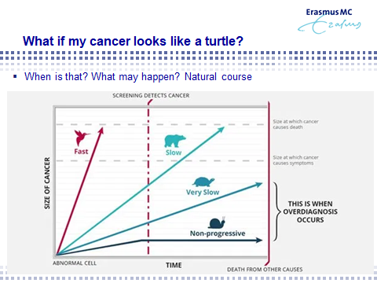

Now the story goes on, although the slides will be taken later, but everybody is familiar with the fact that there are multiple, let's say aggressiveness, levels of these cancers. And some of them they act like slow turtles and others acts like birds, you cannot catch them, they are very aggressive and whatever you do, even if you try to screen them early, they will results in metastatic disease and you will die of it. And then there is a large part of towards in between that grow, they need to be treated because they will become symptomatic before the end of your life, but unfortunately you will suffer the side-effects of that. We are talking about the turtles, very slow and non-progressive cancers in prostate cancer. And when you have such a cancer because you're starting to bother what to do and here we see the slides. We go to the next slide, Anja, thank you very much.

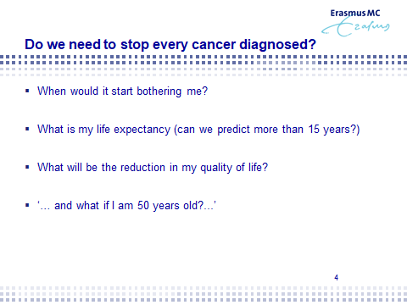

And so there are four questions for patients in the next side, and it is when would it start bothering me. What is the point? I'm anxious from visit to visits to the physician, what is happening. What is my life expectancy? Is my cancer going to survive me or am I going to survive my cancer? Who is the more aggressive one? And what will be in case of treatment the reduction of my quality of life as we heard from the Ettore story and maybe more precise, what happens if this is being diagnosed because of an early diagnosis for whatever reasons. If I'm 50 years old, what can I predict? Can I predict it until the end of my life? That would be something if we could predict the end of life and then also know what the biology of the tumour will be. Well these things are suffering for patients.

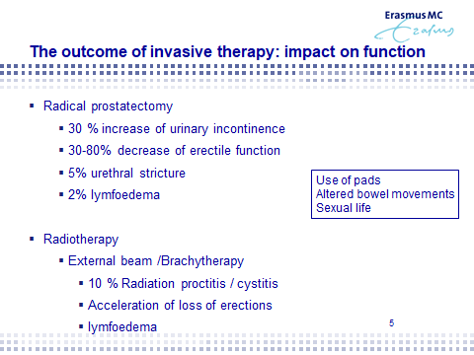

And then here you see of course the summary of all the side-effects with what you can appreciate. whether you get treatments radical prostatectomy or whether you get radiotherapy, a large amount of patients over 10%, maybe up to 30% will suffer from severe side effects that will affect their quality of life. And of course and that’s a psychological mechanism, after two years that you have been incontinent, you learn to live with your diapers. And you get in peace with your diapers, and you say my quality of life is good, but it was unnecessary, unfortunately. Next slide please.

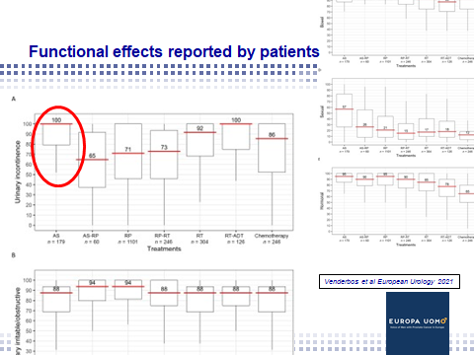

Now Europa Uomo made an inventarisation, a questionnaire, for all of these side-effects. We are very grateful that Europa Uomo took the activity, asking so many patients how do you suffer? And so it shows real lives, people suffer from incontinence and you see the graph on the top left and then you see the least incontinence sufferance is when you follow active surveillance. Of course, because that is the situation in which nothing alters and the worst is when you do a radical prostatectomy because then early on maybe 30-35% of men are suffering some form of incontinence, which in case of harmless tumours would be unnecessary. Next slide please.

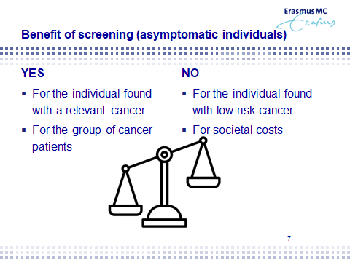

So here we have it, the benefit of early detection. A large study being done. It can give less mortality. Moreover, it can reduced in number of patients with metastasis, painful metastasis and there are a lot of medications. But it has a side-effect, it can be beneficial for the patient that has been treated with success and cured without the side effects but it will cost for the individual with a low risk cancer being treated or being diagnosed because of screening and of course there are costs around it. Next slide.
: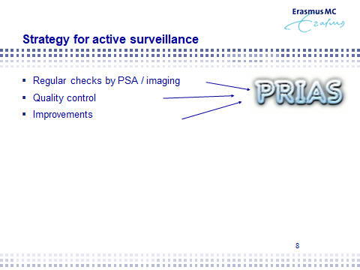

So what I want to say, active surveillances is only, let's say, an invention in order to compensate for the screening efforts. So when you decide to get screening for whatever reason, because it is in your family or that you're just anxious or be impressed by your surroundings to go for screening, just realised that you can end up in a situation in which you have to act in active surveillance. Now active surveillance is safe. We know, we now know it and we have the experience for over 10-15 years, how to manage active surveillance and I will show you the outcome results after 15 years. But these programmes, and especially in Europe everywhere accepted, programmes like PRIAS gives you some support in how to do it together with your physician because it gives a protocol of regular checks by PSA and by imaging that has been introduced during the last couple of years. It gives quality control because all physicians and technicians and doctors and whatever can look over our shoulders at the programme. So they can check it, never too many people will check the programmes and over the years we have improved. Next slides please.

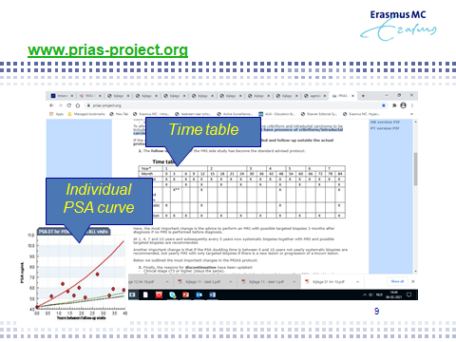

So this PRIAS programme is on the internet and it can show you the support, for example you see a timetable over here. It shows you when to check, when to go for a PSA or for a biopsy, or for imaging. And it also gives you an overview, for example, see the left hand side, of the individual PSA curves. PSA is a support, it does not always gives a realistic situation of the biology of the tumour. But it supports you in order to make a decision to take, for example, a biopsy or to take an image, a MRI, in order to check your tumour. Next slide please.

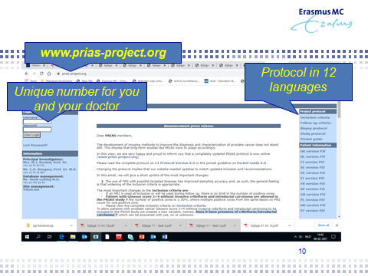

And this is an international programme accepted everywhere around the world. It has support in very many European languages. It gives you the exact protocol to read by yourself, by your spouses, by your physicians. It gives you contacts addresses. It has passed the quality control everywhere in every hospital you are being offered this programme. Which you can follow it also on the internet. Next slide please.

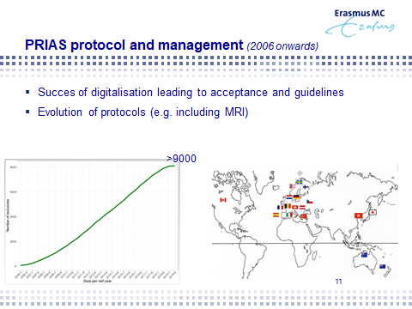

And here you see the acceptance over now more than 12 thousands in 2021 patients in Europe and in Canada and in Australia are supporting with their data, the research (I'm sorry) about prostate cancer active surveillance. And with all these experiences we can improve. And we did over the last few years by introducing, for example, MRI or perineal biopsies, or new Gleason scores, or new markers or the incorporation of genetic markers by BRACKA2, etc. Next slide please.

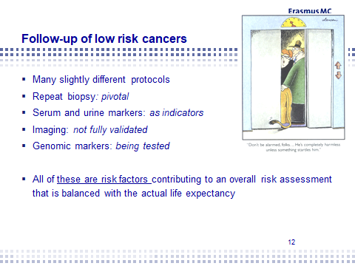

It is not the single protocol around the world. Yes, many institutes around the world who have slightly different protocols. But because we are fully together in one consortium that is called the Movember Global Action Plan, which I'm the coordinator of, we have merged all this information from around the world in over 25.000 pieces of information about patients. So we are going together emerging but you have to realise that an active surveillance programme in Japan is different from that in Europe, is different from that in the United States. We see the serum and urine markers that have been invented overtime as indicators, so they're not the proof of cancer of progression. They are the traffic lights for especially looking right and looking to the left in order to proceed. The imaging has not been fully validated yet. Lot of efforts in order to recognise and to biopsy correctly, but at this moment we are looking for the follow-up. Can imaging replace, for example, a biopsy? But we do not know yet. So anybody who claims that imaging can replace a biopsy, has discussed that with you as a patient very intensively because there is not scientific proof yet. But we're going to have it because we are collaborating with so many patients, with so many institutes. And genomic markers, as we talk, are being tested and we have found it in a consortium from the United States and from Australia together with PRIAS. In order to test new markers that will support whether your tumour is aggressive yes or no. So all of these are risk factors that contribute to your risk classification while you are on active surveillance you have to redo and reassess your risk just like a fire insurance of your house, you have to reinvest into a risk assessment every year, or every two years, or every three years in order to see whether things have changed. Next slide please.

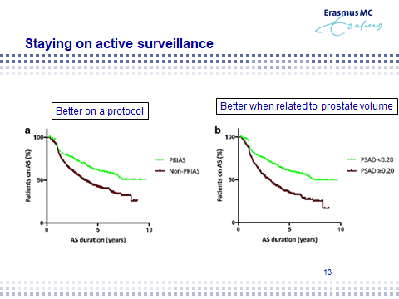

And what we know is that people are doing better if they are on a protocol because they are being checked more regularly and there are many people looking at you. So you see here a curve, in green, that people that are on a protocol remain more often on active surveillance because they feel supported, they have less anxiety and they know that when the protocols shows any change in progression, then they have to act and not before that. The other thing that we've learned, for example, that the size of your prostate is extremely important. And you can understand it, more PSA means a bigger prostate. It does not mean always more cancer. So therefore in all of the protocols nowadays, the size of your prostate is important to correct the level of the PSA as an indicator of your risk. And so we learn. Next slide please.

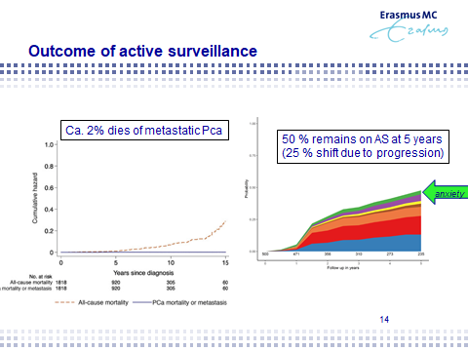

And here you see the long-term results. And the long term results are like in Canada, like in the United States, it shows you in as the main message that yes, there is a small chance that while on active surveillance we miss things. The MRI doesn't see everything. The biology of the tumour is not being recognised because we do not know the genetic landscape of every tumour as yet. So the risk is very low that in the end you might be diagnosed too late this progression, but this risk is very low. 98% of men are safe on active surveillance. And that is over the time period of 15 years. So when you are 50, we cannot predict how you will be when you're 80. We can look forward 10-15 years, but that is it. That is also reasonable. But in 10-15 years we know far more and many things, and so we might be better being able to handle your active surveillance cancer. And then the other graph shows reasons why people shift to curative treatment. And all of the colours can be explained, but it was also about anxiety and this graph shows that the minority of men on a protocol, well balanced with discussions with their physician, is shifting because of anxiety, so it supports not only communication with other people and patients supports, but also these kinds of protocols. Next slide please.

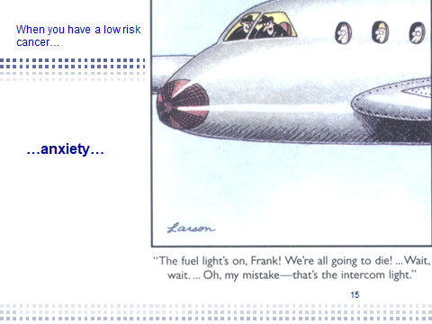

So anxiety. Anxiety is something horrible and you can live with it, but it can be sometimes a big mistake and it means that anxiety is very much a threat to our lives and to the quality of our lives. Next slide.

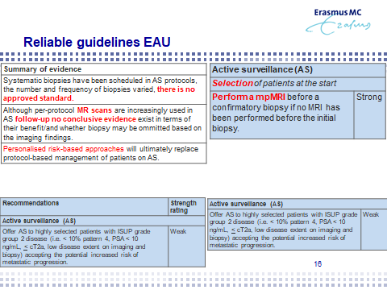

We try with the professionals, together with Europa Uomo and the European Association for Urology (EAU) to provide you with guidelines. Guidelines are the results of metological studies, scientific studies on the behaviour of cancer. So these are the evidences you can rely up on when looking at active surveillance. And actually what this slide shows you, is more or less support because you can read it and you can see what is certain and was has a strong evidence and what has a weak evidence? And we still have to learn from but anyway it gives you the impression that many, many people are supporting this research and therefore the outcome of active surveillance and giving you their reliability of the profession to support you. Next slide.

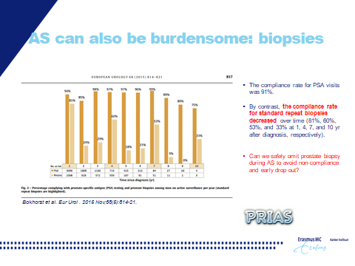

And we know of course that biopsies, and repeated biopsies, are so horrible. This side shows you overtime that although people in the protocol should have a biopsy, the following of PSA is quite good, that's the dark brown bar, over let’s say in time in 5 or 10 years times more than 80%. But there is some kind of a reluctance of repeating the biopsies. Many people feel that an annual biopsy is awful. A three year biopsy, like in PRIAS, is followed well as you can see here in the bar with 60%. But over longer term the enthusiasms to repeat the biopsy is declining and of course, that is a natural reaction of a man who feels that after 10 years and nothing has been found so far, he can relax a little bit and say, okay, my tour is not that bad so please let's skip the biopsy. We as doctors have to rely on the scientific methods and therefore the protocol prescribes us that we have to do a biopsy but of course we would like to change that to, for example, imaging with MRI. So we are busy with that and we understand that the protocol is something different than the patient’s feelings and that is exactly what you have to discuss with your doctor in the clinical room. Next slide, please.

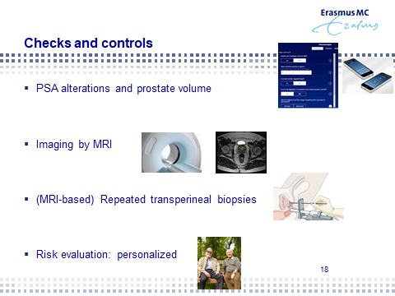

We’ll come to the end of this presentation. We have checks and controls. We have risk evaluators. We have imaging. We have now improved towards transperineal biopsies that means less antibiotics, better performance of the biopsies and therefore also far less infection. So please ask for transperineal biopsies at your doctor's place and we're getting into risk evaluation that is personalised. Next slide.

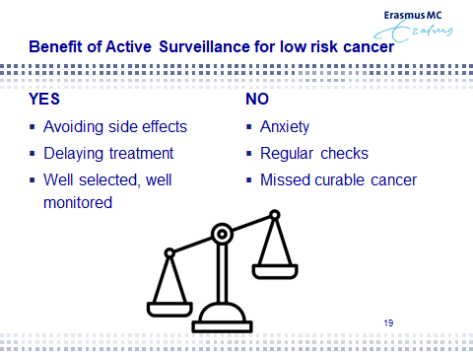

The next slide is probably shows you the summary of it. Active surveillance can avoid side-effects, it’s delaying treatments or even abolishing it. It can be well selected and well monitored. But the side-effect is anxiety, regular checks and missed curable cancers in very tiny amounts of patients. Next slide.

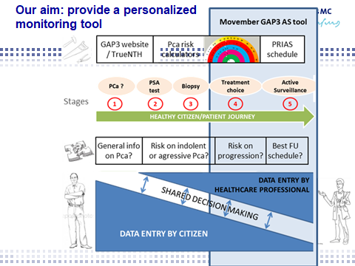

This is what we are working at in Europe at this moment. That is a personal risk assessment as you can understand the MRI in one person is not the same as in the other person and the PSA decline or improved increase is last the same. We are not the same people like we're sitting here, we all have our individual stories. These individual stories are full of individual risk elements and we would like to see to say to the one patient OK you need a biopsy next year but to the other patients you can wait five years with your biopsy. And that is exactly what we want to accomplish with a personalised risk strategy. Next slide.

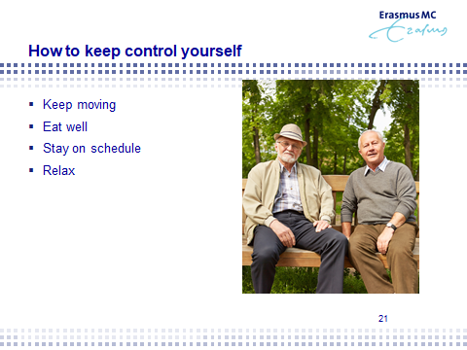

So how to be on active surveillance? Some general lifestyle things: keep moving, keep active it's the best you can do, eat well not too much meat, you know, more fish, more vegetarian, more fresh foods. You can handle your disease, you can support handling your disease by doing these things. Message is stay on a schedule, be in a good communication also with your physician and relax. It's safe. It's good. It's been checked, It’s been controlled.

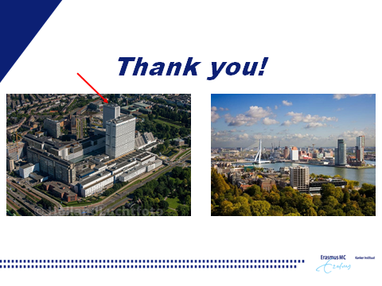

So next slide shows who the end of my presentation, the show from Rotterdam. But we are as much as anybody else collaborating with all over Europe and are very thankful of Europa Uomo supporting our work, the work that is dedicated to you as patients on active surveillance. Thank you very much Cosimo.

CP:
Thank you very much, Chris. I think you gave us very important elements and gave us a very clear idea of all the activities that are done. Just before starting with the possible question answers, I want just to conclude a few words about what our association could do and the most important thing is that I say a lot of important things have been done in progress now are clearly evident from what you see from this testimony of 2004, when everything was little confused. Now we have PRIAS, we have strategies, we have active surveillance, we have activities. But obviously as usual a lot of things still have to do because the activity in the European countries is different. There is a big variation between European countries and within the counties. We are trying to work on three sides as Europa Uomo in the central branch say and in the local association. The important thing I think is to have a good communication to exchange communication like we will do in the next General Assembly on 19 of June. And we are working on awareness and that is important and we are picking in general locally or centrally with politicians to trace the awareness. We are working on actions before diagnoses because with for instance the European Association Urology, we are campaigning for screening programmes as Chris was saying, with all the guidelines that need to be considered for prostate cancer which are not the same at other type of cancers. We are cooperating with the European Commission/Parliament to recommend early detection. And after diagnosis, we are trying to work centrally and locally in order to be very important, to be effective and to be updated with latest data and activities related to the developments including the active surveillance strategy. And also with a lot of actions with patients, which can have anxiety from active surveillance or from the other treatments. What is the object? The object is clear. We, and was also shown by our survey of Europa Uomo on quality of life, we want to give the people the best quality of life possible consistent with their status. Everyone is different in case of prostate cancer. But the idea is to work on this so a lot of work may be done and a lot of work may be done centrally like we are doing with the survey questions on life which has been the first one being done by patients. And so we grieving to the European community, to the doctor community, medical politics, politicians, the importance of something that is coming from patients to really quality of life appreciation. Every country is different, so I think it's more important to communicate that then always, then, then never. Having said that, I don’t want to go on and explain things. So I want to give a start to questions and answers. There is a question from Peter Dzuppa from Slovakia, who could not be here today, so he asked me to present his question. So he was saying what is the family role in active surveillance? And if there is any prostate cancer screening best practise which could be adopted in the European states? These are not easy questions, we can just give an overview. But maybe Chris you can give your personal view on this.

CB:
Yep, these are important questions of course, thank you very much. I think that we have to realise that there is not 1 pan-European view on screening because the screening results are also different amongst European countries. We do see that the incidence and also the incidence of relevant cancers is higher in the Scandinavian countries compared for example to Italy. And we see the southern European countries with more sun but also with a different diet do express, do grow, less relevant cancers than in the north. We do not know exact the biologic mechanism but it seems to be an epidemiological truth and therefore screening or population-based screening, the activity around it in Scandinavian countries, is much higher compared to ,for example, the southern European countries.
The family support or family act. Now I do not know exactly Cosimo what the question is, but it can be to two-foiled. Of course the support of the family is of pivotal importance and I think that strange history about keeping the information for two years secret is exactly as most men do. That we experience it's to be harmful to give this kind of also information to other surrenders, but at the same time we are shooting ourselves in the foot because we also see that talking about this and communication and support, family support, is pivotal in order to get to keep on a protocol or to keep fighting your prostate cancer. It is best being done by a team and not by yourself alone. The other aspect might be the genetic elements and we know, by now, since 1-2-3 years that breast cancer genes when it runs in your family, that it might increase your risk. But it is very tiny. It's called the breast cancer gene, but unfortunately it also gives a little bit more risk of relevant cancers in the prostate. But once again, this is as we speak not of pushing importance but sometimes it is the argument for people to say oh, I want to be discreet. Please keep realising that the absolute risk of this is tiny.

CP:
Okay, thank you very much. I don't know if Anja has other questions? Did you get other questions?

AV:
Yes Cosimo, I have two. One in the chat and Steve from USA wants to ask questions Steve, are you here?

QS:
That's a very good question. Am I here? To you all, I appreciate your amenity and also your sense of humour. I'm in the USA. Doc, Chris, if I may address you as Chris, can you take a moment and talk about those of BHP and the issue of density. I'm just surprised. I've been about eight years in this walk with AS. I'm really surprised that in any social group, support group and in general, and even during the lectures by the almighty researchers, etcetera, that this issue of a man's knowledge of his density and how that correlate with all the other tests, that researchers have done, if BHP is a big issue for some, is there something that we should be doing that helps you and your cause, your research that helps us as a group of men on this whole issue of BHP and the knowledge of density.

CB:
Yeah, well I think just like we were given as patients, as men, the awareness of PSA we have to give back to our physicians the awareness of the PSA density because ,by now scientists and the academics, it's obviously clear that this density is also my logical argument very important to assess the risk of the prostate being benign or having harbouring a relevant cancer. So if you want to do something for Steve, just ask your GP or your physician next time. What's the size of my prostate?

CP:
Okay, thank you. Anja, the other questions?

AV:
Prof. Bangma do you still have time? I have one question in the chat?

CB:
Yes, sure, I thought it was a question about mushrooms.

AV:
Yes, OK, you saw it.

CB:
It's remember that it is eating time actually, dinner time. Anyway but it's good to discuss, because yes on the commercial food markets, many food additives and ingredients have been offered. And we cannot exclude whether they are very good or very wrong because it's so difficult to prove if you eat for the rest of your life mushrooms, how this is going to affect the biological behaviour of your tumour. Still we know, from epidemiological studies, that men in Japan eating vegetarian foods, that move to the United States and starting to eat burgers, get prostate cancer. So we know from epidemiological evidence that food is of influence and we can only do the best thing in our life styles. We know what is good and what is bad, and I'm not talking about a glass of red wine or white wine, or the difference between that. Please do enjoy life that’s good. But limit let’s say the accesses of dairy products, limit the accesses of red meat, things like that. And if the mushrooms will do and it keeps you and your family on a good diet, well thank your mushrooms. I’m a strong believer in the positive thinking and the support of positive thinking on the behaviour of yourself and your cancers.

CP:
So I think there are no more questions. Okay, thank you very much Chris and thank you everyone. I think it was useful for all of us and it will help us to go on and do things that are useful for us, for other people in the future. Thank you very much.

