THEIR CANCER GARDEN
FEFOC © 2021

EDITORIAL
Directors: Professor Jordi Estapé and Doctor Tania Estapé.

With a certain pride and much gratitude we inform you that we have concluded a series of 14 videos on prostate cancer, which are already present on you tube.

Pride for the work done and thanks, a lot, to the professionals who have collaborated selflessly to obtain a high scientific level at the same time as informative.
Let's highlight, first of all, my friend Mr. Fernando Rodríguez Domingo, excellent executive producer of the program. As for the different contributions, we advise you to take your time to enjoy these videos and help with its dissemination.

We are quite satisfied with the contribution
that FEFOC has been making in cancer of prostate. In addition to the videos mentioned and this monthly online magazine, we disseminate a Code with 16
recommendations, a book entitled "Prostate cancer in heteros, gays and bisexuals" or, "Prostate cancer in heterosexual, gay and bisexual men", both present on Amazon. We also have an exemplary support group and a consultation both face-to-face and online. We are also members of the most important global associations in prostate cancer.
In this issue we draw attention to the fact that widowers have more advanced prostate cancer than the lucky ones

who live as a couple. We also explain the

They represent an educational, informative and support wealth that is a treasure for professionals, patients, family members and the general population.
which is the "consortium PRACTICAL"

(continued on page 2)

(comes from page 1)

An important issue is the risk of rectitis after radiotherapy and the problems this can pose for gay or bisexual patients. We also warn about the decisive importance of psychological support in patients who choose active surveillance.

We collect a table of useful questions for patients with testicular cancer and an interesting article on the need for population literacy in health.

WIDOWHOOD ASSOCIATED WITH INCREASED RISK OF ADVANCED PROSTATE CANCER

C. Salmon and M.E. Parent, from the French National Institute of Scientific Research show that widowers are more likely to, if they are diagnosed with prostate cancer (CP), do so with advanced CP (published in August 2021 in the European Journal of Epidemiology). It would be further proof of the importance of the social environment in the development of cancer.

To do this, they analyzed, within the PRACTICAL* consortium, 14,000 patients diagnosed with CP who compared to
12,000 healthy men. Widowers arrived later at the diagnosis than those married or with a partner, many already with metastases.

It is considered, in general, that the transcendental fact of living as a couple leads to a healthier lifestyle. The couple encourages the man to go to the doctor if symptoms occur. Otherwise, the cancer remains undiagnosed for longer and, secondarily, is diagnosed at a more advanced stage.

According to the authors, widowers should seek support from family or friends and go to the doctor more frequently.

However, let's not forget other factors that help us understand why widowers go later to the diagnosis. The greater tendency to alcoholism of the man alone and the less healthy diet are often cited. And also the psycho-emotional impact of widowhood.

Other factors are studied among which Salmon includes not only marital status but also the number of people living with the widower, family structure, close environment (positive neighborhood or negative), as well as other factors.

*The PRACTICAL coordination group was founded in September 2008 by Cancer Research UK and the Collaborative Oncology Gene-environment Study (COGS).

It is formed by a group of researchers interested in the hereditary aspects of prostate cancer and try to identify genes that may have a role in the development of this disease. Its objective is to combine data from various studies to advance the knowledge of genes related to prostate cancer.

PRACTICAL members from various countries (Africa, Australia, Canada, China, Europe, Japan, India, UK, USA). From Spain 5 groups participate. Currently PRACTICAL has data from 133 research groups and has gathered samples from more than
120,000 cases of prostate cancer and
100,000 healthy controls.

ACTIVE SURVEILLANCE IN DANGER WITHOUT PSYCHOLOGICAL SUPPORT
For months we have been warning of the danger that threatens active surveillance (VA), alternative, in localized and low-risk prostate cancers, to prostatectomy and radical radiotherapy. With the advantage of va lacking physical side effects (such as impotence and urinary incontinence).

Reviewing various studies it is observed that approximately 50% of patients who chose VA abandon it and go on to prostatectomy, radiotherapy or hormonal treatment within 5 years of diagnosis.

So, as the number of patients with localized, low-risk prostate cancer who choose VA increases, so does the number of those who abandon it.

An important work in this regard is that of Dr. A. Finelli, from the University of Toronto, Canada, who analyzed the evolution of thousands of patients with VA. But their study has an important particularity: it was done with out-of-hospital patients, that is, they were not closely controlled like those who, in hospitals, participate in controlled clinical trials. That is, patients from the general population.

By age 5, just over 50% of patients in VA had abandoned it, while 49% were still maintaining it and without symptoms of recurrence.
The causes behind the abandonment of va are: 1.Symptoms of tumor growth.
- Age: Younger people are more prone to abandonment.
- PSA high in the successive controls. 4.Persistence of tumor cells in the
Biopsies.
  - Patients controlled by urologists resisted change more than those controlled by radiation therapists.
  - Patients with other associated medical problems.

That is, we found no data on the lack of psychological support. Nor is it talked about.

Well, be careful because the VA goes against everything that doctors and family members have advised us over the centuries: eliminate cancer immediately! Phrase, by the way, origin of many errors, sometimes irreparable.

This leads to the main problem, which many patients with CP who choose VA usually experience: anxiety, the fear that the disease will evolve badly and become aggressive.

And, for us, many of these abandonments are largely due to the lack of adequate support to counteract the anxiety produced by the untreated maintenance of the tumor. The psychological support of patients under VA is a priority for FEFOC, because we are in it the credibility of a fantastic technique to avoid the unintended consequences of active treatments and that they ruin the quality of life of many patients.

(continued on page 4)

S And P T I And M B R And , 2 0 2 1 F And F Or C N And W S L And T T And R V Or L . 2 8

(comes from page 3)

We bet on the VA (when indicated) and offer to implement its psychological support. We must play fair: we should not load the VA because we leave an essential complement, psychological support.

QUESTIONS BEFORE TREATMENT FOR TESTICULAR CANCER
Information to the cancer patient, before treatment, is of vital importance. Good and ongoing communication between patients, their families and the doctors who care for them are very important to obtain informed consent, both within clinical trials and outside of them. ASCO (American Cancer Society, of which we are members) proposes the following (in the realization of which they recommend that the patient be accompanied by someone who can take notes of what is said to be able to reflect on house), in testicular cancer: They are the following:

1. What type of testicular cancer do I have? 2.Can you explain the pathological report to me?
about my illness?
3.What stadium am I in? And what does it mean? 4.Would you like to explain my options
treatment?
- Are there clinical trials available to me? 6.Where are they performed and where can I
find more information about them? 7.What treatment plan do you recommend? 8.What is the purpose of each treatment?
  - In my case, is it about curing or treating the cancer or both?

  - Who will be part of my treatment team and what will each of them do?
  - How will treatment affect my daily life?
  - Will I still be able to work, exercise, and perform my usual activities?
  - Can this treatment affect my sex life?
  - If so, how and how long?
  - Will treatment affect my ability to have children?
  - Should I contact a fertility expert about a sperm bank before treatment begins?
  - What long-term effects can be associated with my treatment?
  - If I am concerned about treatment costs, who can help me?
  - Where can you find emotional support for me and my family?
  - If I have a problem, who will I be able to call?

ASCO recommends that if anyone would like to know more about possible questions, they will find them at www.cancernet/testicular. These questions were designed by ASCO in 2019.

ANAL SEX AFTER RADIATION THERAPY FOR PROSTATE CANCER

With radiotherapy the rectum can become inflamed, producing diarrhea, sometimes bloody and rectal incontinence In most people, these discomforts disappear at the end of radiotherapy, maximum about two or three months later. In some they may be persistent and require treatment.

(continued on page 5)

S And P T I And M B R And , 2 0 2 1 F And F Or C N And W S L And T T And R V Or L . 2 8

(comes from page 4)

This is a serious complication for gay and bisexual people, especially the so-called bottom,since it can make anal sex painful receptive and condition sexual intercourse.

In June 2019, the first clinical guideline on anal sex after diagnosis and treatment for prostate cancer (PC) was published. The Guide is the result of consensus meetings between doctors and urologists from the United Kingdom (UK). It is aimed at doctors and gay and bisexual men. The study was coordinated by Sean Ralph, from the Clatterbridge Cancer Centre, Wirral,Liverpool (UK), and presented at the UK Imaging and Oncology Congress (UKIO), founded by Health Education England. (HEE) together with The National Institute for Health Research (NIHR).

In summary, the Guide recommends that men refrain from receiving anal sex for periods of time before, during, and after certain CP tests and treatments.

Anal sex can be harmful after a prostatectomy or radical radiation therapy. Most doctors, Ralph says, don't ask about sexual orientation or practices, which translates into a lack of information and support.

The Guide is based on consensus meetings with the participation of 15 medical oncologists and 11 surgical urologists. They were asked when they considered anal sex safe. The consensus was as follows:

Table "ANAL SEX AFTER CP TREATMENT"

Before a PSA, less than a week after sex can give an inappropriate result.
After a transrectal biopsy (TRUS), less than two weeks
may cause bleeding, pain, or increased risk of infection.
After a transperineal biopsy, one week (to facilitate recovery of the surgical incision and decrease the pain that could be caused by sexual intercourse).
After prostatectomy, less than 6 weeks can cause bleeding, pain, and increased urinary incontinence.
During external radiation therapy and two months later it can worsen the acute effects – rectitis – be painful orresultin long-term complications, such as rectal bleeding.
Brachytherapy. Participants did not reach conclusions about abstention from anal sex. Medical physicists were consulted who advised abstention for 6 months, after permanent brachytherapy, to minimize the couple's radiation exposure. And two months after temporary brachytherapy.
(Continued on page 6)

(comes from page 5)

Of the 26 participating physicians, only 3 (12%) always asked the sexual orientation of their patients and only 2 (8%) of the 26 always asked if they practiced anal sex, if they perceived that the patient was gay or bisexual.

PROSTATE CANCER HEALTH LITERACY FOR GENERAL MALE POPULATION
Mtro. Psic. Marcos Espinoza Bello Postgraduate in Psychology

National Autonomous University of Mexico UNAM
Psycho-oncology Service National Cancer Institute INCan
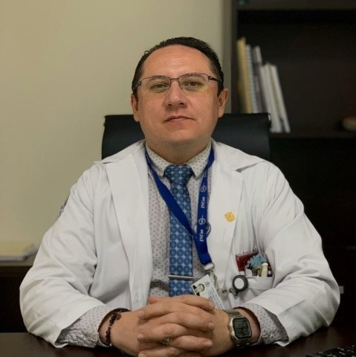

Mtro.Psic.Mascos Espinoza Bello

Valid, reliable information and how it can be used by the male population to take care of their health will always be an objective that every society should seek, specifically, before a pathology such as prostate cancer that currently represents an emerging public health problem.
Initially, let's consider health literacy, as the set of knowledge, skills and experiences in health matters that make an individual able to know their own state of health and how they should take care of themselves. (Navarro-Rubio et al., 2016). This concept has gained relevance since it is one of the most relevant predictors of a person's health status along with other social determinants such as age, income level, employment status or educational level even more in a male population that usually has little contact with the health system from a prevention approach.

Low health literacy can have adverse effects on the health of individuals, for example in patients with a low level of health literacy: 63% were not physically active, 68% had overweight and lower physical and mental health (Jayasinghe et al., 2016). In another study, it was identified that those patients newly diagnosed with localized prostate cancer with low literacy level had greater emotional distress (Song et al., 2012). In patients with the same cancer, those with higher literacy levels had a 59% lower risk of having a high prostate antigen level than those with low literacy (Jamieson et al., 2021).

According to the National Adult Literacy Survey, about 1 in 5 Americans in the general population may lack the literacy skills needed to function properly as patients.

(continued on page 7)

(comes from page 6)

These people are at a disadvantage because they do not have the ability to obtain, process, and understand the information and services about cancer needed to take health care decisions, because this limits oral or written communication in health (Davis et al., 2002), which can be magnified in people in prostate cancer risk representing an older age group and in some cases, with greater psychosocial adversity. What this tells us is that not having the information available, understanding it and taking action on one's own health can have even more negative consequences in countries with a low or medium income.

In this context, to implement health literacy programs it is necessary to evaluate what the population knows or knows about the disease, how it is detected and most common symptoms . Therefore, knowing how much men know about prostate cancer, myths and taboos such as the loss of masculinity, can be considered as a first link in the literacy process from a prevention perspective.

Qualitatively, some patients report ignorance about where the prostate is located, its function in reproduction or orgasm, have not heard about prostate cancer, and those cases in which they have heard it show shame, do not know what medical studies consist of (prostate antigen, digital rectal examination, biopsy, or even genetic tests),
at what age it is advisable to carry out the first analyzes, the information about their sexuality, all the above susceptible to be worked by the health team from prevention.

In conclusion, we can affirm that health literacy is a necessary component in the population according to the available evidence, since, without the necessary knowledge, the risks of not having adequate medical care increase, In addition to the physical and emotional aspects being put at risk, in that sense, it is important to continue researching in the Latin American population to incorporate it into health systems. The time has come to talk and incorporate men's health as a strategic issue on the agenda of everyone from prevention.

References
*Davis, T.C., Williams, M. V., Marin, E., Parker, R.M., & Glass, J. (2002). Health Literacy and Cancer Communication. CA: A Cancer Journal for Clinicians, 52(3), 134–149.

*Jayasinghe, U. W., Harris, M. F., Parker, S.M., Litt, J., Driel, M. van, Mazza, D., Mar, C.
Del, Lloyd, J., Smith, J., Zwar, N., Taylor, R., & Group, O. behalf of the P. E. into P. (PEP) P. (2016). The impact of health literacy and life style risk factors on health-related quality of life of Australian patients. Health and Quality of Life Outcomes, 14(1).

(continued on page 8)

(comes from page 7)

*Navarro-Rubio, M. D., Rudd, R., Rosenfeld, L., & Arrighi, E. (2016). Health literacy: involvement in the health system. Clinical Medicine, 147(4), 171–175.

*Song, L., Mishel, M., Bensen, J. T., Chen,
R. C., Knafl, G. J., Blackard, B., Farnan, L., Fontham, E., Su, L. J., Brennan, C. S., Mohler, J. L., & Godley, P. A. (2012). How does health literacy affect quality of life among men with newly diagnosed clinically localized prostate cancer? Cancer, 118(15), 3842–3851.

PROSTATE CANCER INFORMATIONAL VIDEOS

Dr. Tania Estapé

FEFOC has launched this month a collection of 14 videos on prostate cancer. They cover medical, psychological, rehabilitation, nutrition... We also talk about support groups and our book "Prostate Cancer in Straight,Gay and Bisexual".
The videos begin with one on Generalities in prostate cancer given by the scientific director of FEFOC, Prof. Jordi Estapé,followed by the main treatments ( prostatectomy, by Professor Antonio Alcaraz and radiotherapy by Professor Albert Biete).
In number 4, Professor Estapé, and FEFOC psycho-oncologist Dr. Tania Estapé, talk about active surveillance, as a less aggressive option but which, sometimes, in return, implies a high degree of anxiety and restlessness in the patient and his family.

Dr. Cristina Sans talks about a crucial issue, which is the role of genetic tests and Dr. Pilar Manchón on Parametric Nuclear Resonance in prostate cancer.

Next, Dr. Tania Estapé talks about the psychological repercussions of prostate cancer on the patient in video 7 and on his family in video 8. The two that follow are about a crucial topic in prostate cancer such as sexuality.

Dr. Isidro Bonet approaches it from the medical point of view, giving practical solutions (prostheses ...) and Dr. Estapé brings the psychological and relationship point of view, proposing a new approach to sexual life after prostatectomy.

Dr. Montserrat Folch and Ms. Herminia García tell us respectively about aspects such as nutrition and more suitable diets and pelvic floor rehabilitation.

Video 13 explains support groups, their importance, modalities and advantages. He also has a testimony from the FEFOC groups, with his partner (who always has a very relevant role). Finally, our book on prostate cancer "Prostate cancer in heteros,gays and bisexuals" ispresented, which is a good source of inclusive information.

(continued on page 9)

(comes from page 8)

These videos have been made thanks to the selfless collaboration of Mr. Fernando Rodríguez Domingo and all the professionals who participate. They can be seen at the following link:

https://www. youtube. com/channel/UCMOFY1FL cbVOCshefrj6mkQ/videos

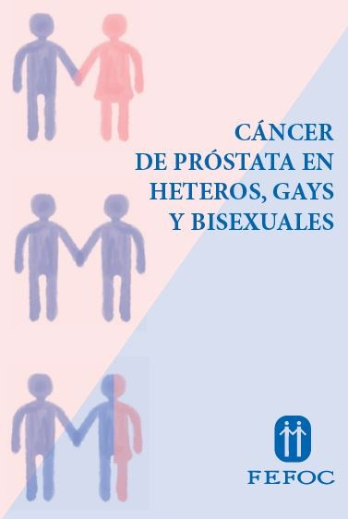

To purchase the book click here.

For more information
about donations click here.

Image from the collection of videos about prostate cancer
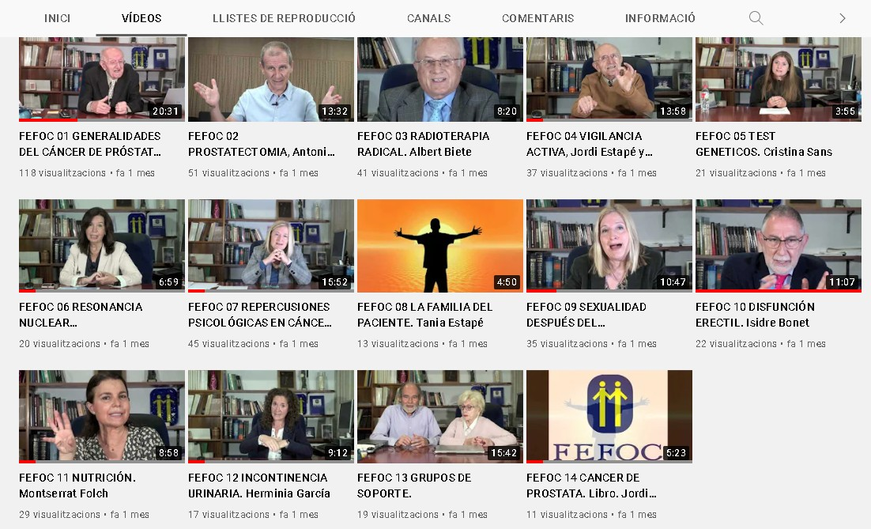

Directors: J.Estapé, T.Estapé Secretary: M.Soler

Marc Aureli, 14.
08006 - Barcelona
Tel. 93 217 21 82
Email: fefoc@fefoc.org www.fefoc.org

We appreciate the collaboration of:

