SCRIPT
EUomo's second online webinar on Active Surveillance:
"“Which are the needs of Active Surveillance patients during their patient journey?”
Thursday, May 20th, 2021 from 18:00 to 19:00 PM CET

Cosimo Pieri = CP
Ioannis Vanezos = IV
Prof. Valdagni = RV
Lara Bellardita = LB
Anja Vancauwenbergh = AV
Questioner Erik Briers = EB Q
Questioner Steve (USA) = S Q

Choosing Active Surveillance: What a patient could expect from the clinician?
Prof. Riccardo Valdagni, Radiation Oncologist, Italy

CP:
Now I'm very pleased to introduce to you professor Riccardo Valdagni. Riccardo Valdagni represents for us the real leader and innovator in the area of prostate cancer and active surveillance in Italy at least. Since 2003 he has been managing the Prostate Cancer Program in the National Cancer Institute in Milano. And in this period, he has promoted very effective new approaches like the multidisciplinarity to optimally manage prostate cancer patients from the first visit after diagnosis, helping the patient in the decision making phase to properly choose among different treatments or observational strategies as active surveillance, supporting patients from a psycho-emotional point of view during the the active surveillance journey. And all these based on a very accurate research and organisation activities on solid ground.
He is associate professor at University of Milan, director of the Prostate Program and director of Radiation Oncology Department at the National Cancer Institute in Milano. So a long experience that can help all of us. How are you Riccardo today?

RV:
Fine thanks. Well, first I want to thank you Cosimo and Hein Van Poppel for kindly inviting me to Europa Uomo. Hein knows very well that I love the Europa Uomo association and talked several times to the EAU meeting of Europa Uomo, so I'm really happy to be here with you.

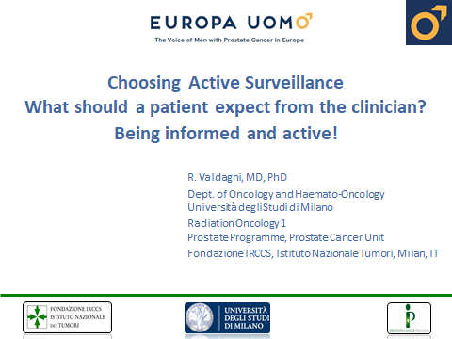

CP:
Thank you and so we have also a few questions for you. So the first question is: ‘Being presented the option of active surveillance can be initially confusing for the patient. What should a patient know and understand when facing this diagnosis’?

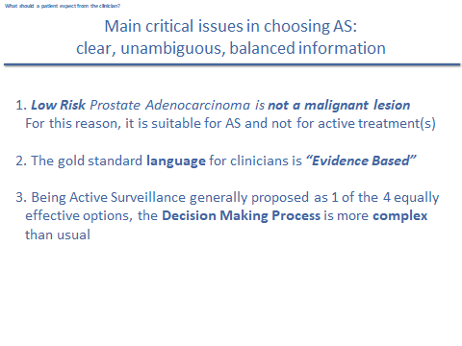
RV:
OK, this question is essentially about confusion. The answer, from my experience, is that the patient should receive clear, unambiguous, balanced information about three very critical points.
First, that low risk prostate adenocarcinoma is not a malignant disease. It is not a beast, as Ioannis said. And this is the true reason why active surveillance is proposed as one of the available options, alongside radical prostatectomy, radiotherapy and brachytherapy.
The second critical point regards our medical language, that should be evidence based: that means based on scientific truth as expressed by national or international guidelines.
And the third critical issue regards the decision of choosing active surveillance among the three treatment options, because this is more complex than the usual decision making process in medicine. As literature data teach us, radical therapies are equally effective in terms of oncological outcomes, but they are different when we consider the possible risks of side effects caused by surgery or radiotherapy.

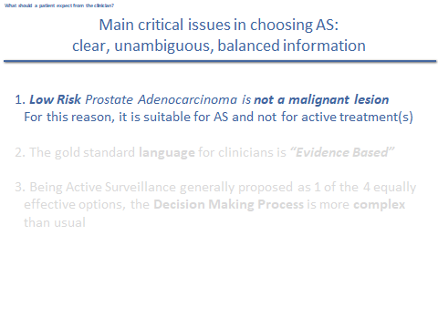
Before scientifically supporting the statement that “low risk prostate cancer is not a malignant lesion”, I want to underline that the word adenocarcinoma means cancer, malignant cancer. This is a really confusing and conflicting point for many patients!

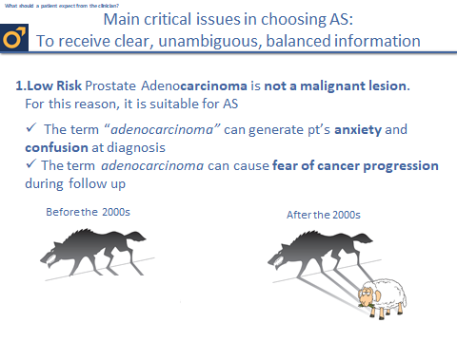
Such contradiction generates a lot of confusion in patients and relatives at diagnosis and in the decision making phase (“I have a malignant cancer. Why are clinicians are proposing that I should only be followed with active surveillance and not to be treated?”). And sometimes such confusion persists during the journey of active surveillance and at follow-up. Aome patients complain of fear of cancer progression, even if we, as clinicians, underline that grade grouping 1 or Gleason score 3+3 is not a malignant cancer.

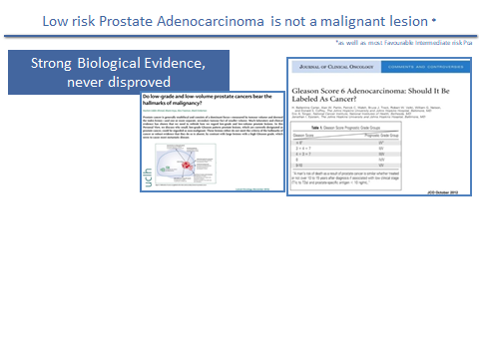
So let's briefly see the evidence based literature, “the scientific truth”. There is strong biological evidence, never disproved, that none of the six hallmarks of malignancy are present in the Gleason score 3+3 or grade grouping 1 cells.
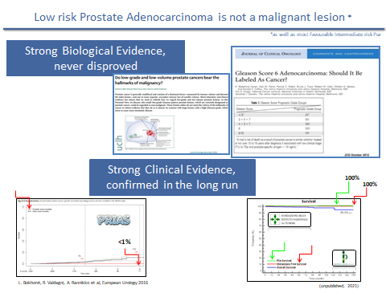

And then there is the clinical evidence derived from many active surveillance cohorts of patients: a very strong clinical proof, confirmed in the long run, as shown in the PRIAS study on the left side of the figure. It shows that prostate cancer mortality is less than 1% at 10 years. And on the right side figure, you can see our Milan experience on 1.260 patients: to date no patient on active surveillance has died of prostate cancer or developed distant metastases.
As you can see, a very solid scientific evidence that low risk adenocarcinoma is not a malignant lesion.
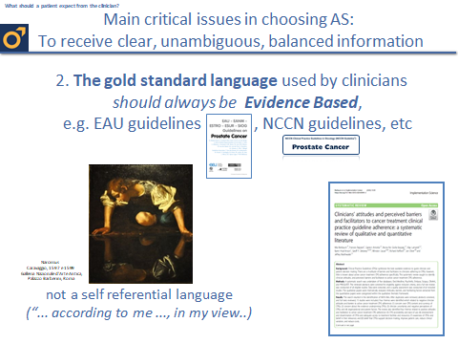

The second critical point regards the gold standard language used by clinicians: it should always be based on scientific evidence. A clear example of evidence based medicine is the declination of this evidence into guidelines, such as EAU guidelines in Europe and NCCN guidelines in US. I want to underline that too many times patients report a self-referential statement by our colleagues – and I mean they often say “according to me ...” or “according to my experience, it’s better you do ...”, or “... in my view, ...”. Self-referentiality, as opposed to evidence-based guidelines, is a well known and documented barrier to proposing and managing active surveillance patients.

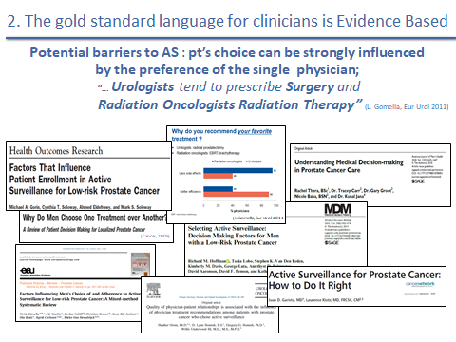

And still talking about barriers, and following what Ioannis said about his experience, I want to stress that probably the worst barrier to choosing active surveillance is the fact that patient choice can be highly influenced by the preference of a single physician. In 2011, Professor Gomella, a famous US urologist, published a paper supporting multidisciplinarity as the best way to manage prostate cancer patients. He wrote that urologists tend to prescribe surgery, and radiation oncologists tend to favour radiation therapy, meaning that the single physicians have a propensity to prescribe his or her personal speciality, despite what is suggested by guidelines. Unfortunately, we don't have a specialist in active surveillance!

CP:
OK, thank you very much for this. Now another question is: Referring to the previous testimonial, our friend Ioannis said that very simply every doctor, depending on his specialty, was recommending his solution. So what kind of approach should the doctor have instead of this?

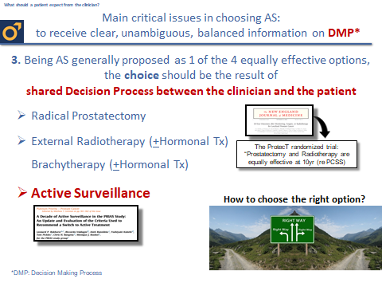

RV:
The answer is evident for a clinician who works in a multidisciplinary team in a prostate cancer centre or in a prostate cancer unit: to share the decision-making process with our patients. The choice should be the result of this shared decision process, because active surveillance is generally proposed as one of the four equally effective options for treating or observing low risk prostate cancer, next to radical prostatectomy, external radiotherapy and brachytherapy.

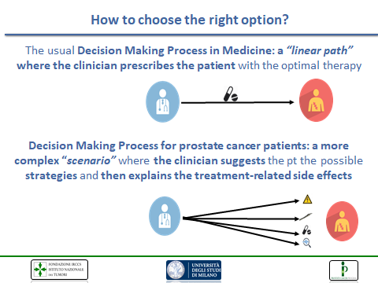

And let's talk a little bit about the decision making process in general. In medicine we know there is a linear path: the patient asks the clinician and in general the clinician prescribes the optimal therapy. Due to the availability of different options, the scenario in prostate cancer is more complex. I mean that clinicians should not prescribe – rather propose to the patient the possible therapies/observational strategies and then they should explain the possible treatment-related side-effects as well as the rough percentage of risk of that specific toxic event. It's clear that we don’t have a standard reference in terms of percentage of side-effects: these depend on many variables such as surgical/radiation oncology expertise, patient’s age and medical history, available technology, etc.

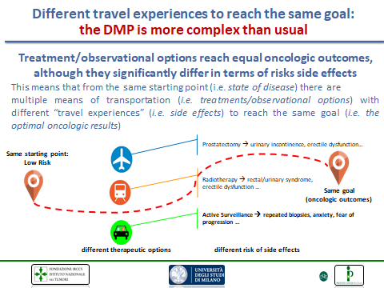

So going a little bit into details on the shared decision making process in prostate cancer. It is different because treatments and observational strategies reach equal oncological outcomes. But they significantly differ in terms of risk of side-effects. Using a metaphor, this means that from the same starting point – i.e. a low risk prostate cancer (grade 1 or Gleason score 3+3) – there are multiple means of transportation to reach the same goal: prostatectomy, radiotherapy or active surveillance. These means of transportation also imply different travel experiences – that is, potential side effects. With prostatectomy: urinary incontinence, erectile dysfunction. With radiotherapy: rectal or urinary syndrome, erectile dysfunction. With active surveillance: repeated biopsies, anxiety, fear of progression. So that's why the decision-making process in low risk prostate cancer is more complex than usual.

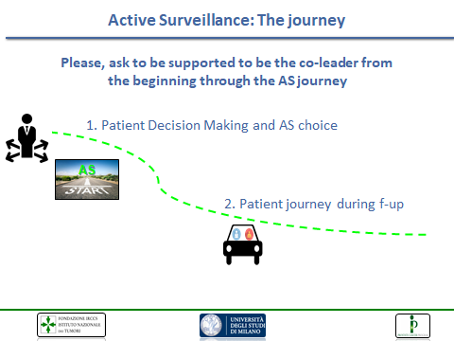

The logical consequences of such complexity is: patients, please ask to be supported, to be the co-leader, and not be passive in that doctor-patient relationship. And be a co-leader from the beginning, in the decision-making phase, and through all the active surveillance journey.

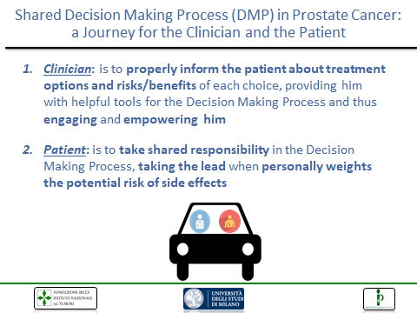

So going more into detail. What should we expect from the clinicians? I want to underline that this is my personal experience and my personal view of the problem. I think the clinician should properly inform the patient about treatment options and the risks/benefits of the choice. We should provide him with helpful tools for the decision-making process, and thus at this point, with a well-informed patient, we also have him engaged and empowered. That's another critical point, as we will see later. What I suggest to patients is that they should take shared responsibility in this decision-making process, and take the lead to personally weigh the potential risk of side effects. Because this decision can influence your quality of life and you are the only judge of your quality of life.

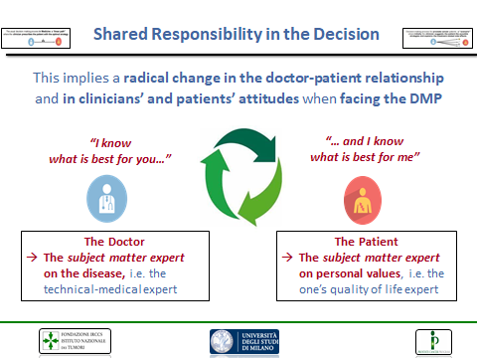

This implies, as I conclude this part on the shared decision-making process, a radical change in our position, our functional position in the doctor-patient relationship and a change in the clinician’s and patient’s attitude. Because the doctor, as we know, is the subject matter expert of disease, he is the technical medical expert. He says: “I know, as physician, what is best for you”. But when we talk about choices involving side effects, the subject matter expert on personal values, on quality of life, on deciding which side effects he does not want to risk, is the patient. Because he knows what is best for him.

CP:
OK, thank you very much and just to conclude, maybe you can give us an idea how the specialist can support the patient in the decision-making. You already told us many things, but maybe you can comment more.

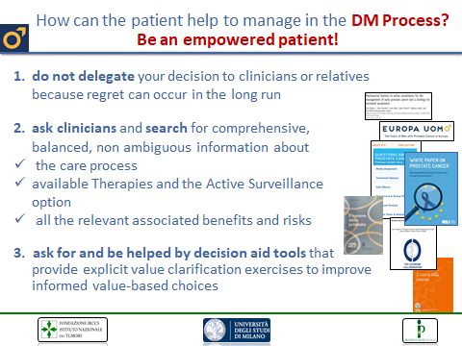

RV:
Trying to be synthetic, I think the message for patients is be an empowered patient. From a practical point of view, do not delegate your decision to clinicians or relatives – we physicians sometimes see the pressure on the relative to choose one or the other option. Very rarely, the relatives suggest or promote active surveillance. And I say this because the literature show us that if the decision is delegated to clinician or relatives, regret can occur in the long run. Ask clinicians and search for comprehensive balanced, non-ambiguous, information on the web about the care process, the available therapies and active surveillance options, and all the relevant associated benefits and risks. And also ask for and be helped by decision aid tools. We have been working for the past 12 years with aids in the decision-making phase and they are really helpful for patients and they provide the patients with an explicit value clarification exercise to improve value-based choices.

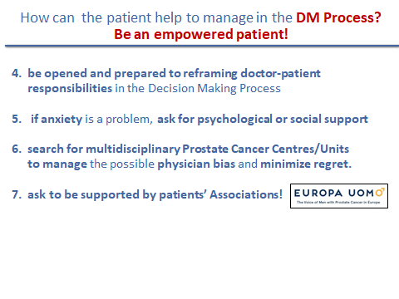

Be open and prepared to reframe doctor-patient responsibilities in the decision-making phase. Specifically, the patient should be an actor and should not be passive in the decision-making phase. Another important point, if anxiety is a problem for the reasons that we have seen: ask for psychological or social support. Search for multidisciplinary prostate cancer centres or units because this is the optimal way to manage the possible physician bias and minimize regret. And ask to be supported by patients’ associations like Europa Uomo. That is really fundamental.

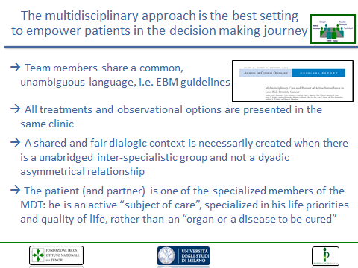

Just opening a parenthesis on the multidisciplinary approach. We know, and I know that Hein Van Poppel is a firm supporter, that the multidisciplinary approach is the best setting to empower patients in the decision-making journey. Team members share a common, unambiguous language and international guidelines. All treatments and observational options are proposed in the same clinic at the same time in general. A shared and fair dialogic context is necessarily created when there is an unabridged inter-specialist group and not a dyadic asymmetrical relationship between physician and patient. And last, in the decision making process, the patient and partner should be one of the specialist members of the multidisciplinary team because he is an active subject for care, specialized in his life priority and his quality of life – rather than an organ or a disease to be cured.

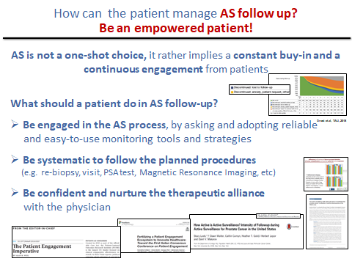

And what about active surveillance follow-up? Active surveillance is not a one-shot choice, rather implying a constant buy-in and a continuous engagement for patients. So what should a patient do in active surveillance follow-up, in the journey? Be engaged in the active surveillance process by asking and adopting reliable and easy to use monitoring tools and strategies. Be systematic, and follow the planned procedure – I’m referring to re-biopsy times, visits, PSA tests, MRI tests. And be confident and nurture the therapeutic alliance with your physician.

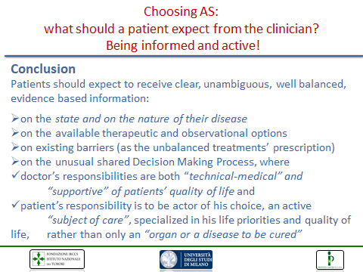

In conclusion, I would say that patients should again receive clear and ambiguous, well balanced, evidence-based information on the state and nature of their indolent disease; on the available therapeutic and observational options; on existing barriers, specifically the unbalanced treatment prescriptions that can occur in the daily routine; on the unusual shared decision-making process where doctor responsibilities are both technical-medical and supportive of patients’ quality of life; and the patients’ responsibility to be an actor of his choice, an active subject of care, specialized in his life priorities and quality of life, rather than only an organ or a disease to be cured.

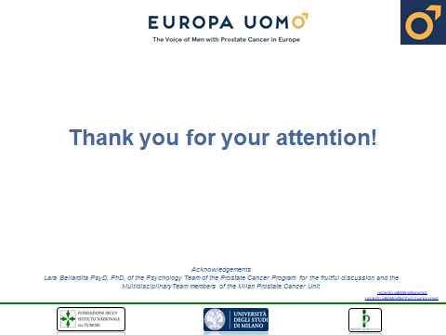

And I thank you for your attention.

CP:
I thank you very much Riccardo Valdagni. And we have now the opportunity to introduce Lara Bellardita. How are you, Lara?

Quality of Life and Life Style during Active Surveillance.
Dr. Lara Bellardita, Clinical and Health Psychologist, Psychotherapist, PhD - Italy

LB:
I'm doing very well. I'm very pleased to be part of this panel, so I'd like to thank you for this invitation Cosimo, Prof. Van Poppel and all Europa Uomo.

CP:
OK, thank you to you and just to say a few words. Lara is a clinical psychologist, psychotherapist and PhD with focus on health, psychology and behavioral medicine. Lara has a longstanding experience as she has been collaborating with the prostate cancer unit in Milano. Her research and clinical focus has been on psychological implications of prostate cancer and specifically on active surveillance. She has developed a specific interest in healthy lifestyle and health promotion, together with quality of life and of course psychological well-being. So now we have a question for you just on this subject. Specifically, how does active surveillance impact on quality of life from your experience? What are the psychological implications?

LB:
We can start by mentioning the functional aspects of quality of life; based on scientific literature, and on my clinical practice as well, I can say that, compared to patients that choose active treatment, patients on active surveillance are more likely to maintain health-related quality of life in terms of erectile and urinary functions. But when we talk about health-related quality of life, we're not talking only about functional aspects. We're also, of course, talking about mental health, about coping strategies, post traumatic growth; the concept of quality of life is very comprehensive and a lot of different factors fall under its umbrella. We have no evidence so far, and we've been studying the phenomenon for more than 10 years now, that men in active surveillance show high levels of anxiety and fear of disease progression. So, no high nor clinical levels. That doesn't mean that men do not experience anxiety at all, or that they do not experience fear of progression at all as Ioannis was very well explaining before when he was talking about, not only his experiences, his journey, but his current psychological state. We should mention that the base of anxiety is fear, and fear is good because it's a primary emotion that is related to survival; it allows us to survive. We need fear, so it's good to have a little bit of fear because that fear brings us to take things seriously. And being on active surveillance has to be taken seriously. Men have to be compliant in monitoring their disease. They have to be proactively involved in their journey as Professor Valdagni was saying before. So we shouldn't say that anxiety, a little bit of anxiety in active surveillance is evil. It can be useful. We need to know how to deal with anxiety and somehow monitor the psychological state just as clinical parameters of prostate cancer are measured and monitored throughout active surveillance. Of course, disease is a subjective experience, so it's important that each patient is approached with personalized care. So it's important that as Professor Valdagni was saying before, that multidisciplinary groups provide not only the balanced information, but also the opportunity for psychological aspects to be taken care of. We also know, and that was our particular interest in beginning when we started conducting research on psychological aspects of active surveillance, that there are protective factors in psychological well-being and mostly these protective factors have to do with support: support from spouses, from family members and from health care professionals. So it is important that a men do not to travel in the journey by themselves. Relationships are the cornerstone of psychological well-being, and that applies to active surveillance context as well. In my experience, as a matter of fact, most of the times that patients requested psychological support, it was because there were divergent opinions regarding active surveillance within the family and mostly when spouses were not supportive of active surveillance choice. So it is very important that the journey is a family journey from the beginning. The decision making process has to involve the partner because, once again, it is something that affects the psychological well-being of the entire family. In addition, those men who have an existing background of clinical anxiety or clinical depression or other mental health conditions should be particularly aware of their starting point. That doesn't mean, and I want to be very clear about this, that they should not opt for active surveillance. That's not the case. They should just be particularly aware and particularly engaged in monitoring their psychological state throughout the active surveillance path. I remember that at the beginning of my research on quality of life in active surveillance, when I was sharing our data in the medical community regarding the psychological aspects of active surveillance, a lot of clinicians and healthcare professionals were asking me whether active surveillance should not be offered to patients who are forms of mental health impairment. My answer was, and still is, “NO”. You need to talk to the patients and together find the right solution, find the right path. And again, if anxiety becomes a burden that you cannot carry by yourself ask for psychological support. Talk to your physician and explain that you'd like to be referred to a psychologist or psychotherapist.

CP:
Good, it was very clear, your presentation. Another subject that we cover sometimes is the lifestyle. So what is the importance of lifestyle for patients specific with active surveillance?

LB:
Acting surveillance can be considered in some way in a window of opportunity because men become patients but at the same time they are not sick and so it's a good time to become proactive in learning about overall health, learning about disease prevention. So if you're choosing active surveillance because you want to maintain your health-related quality of life, you should be thinking prospectively. And thinking about, you know, aging well, healthy aging and healthy aging has to do with stress, has to do with sleep, with exercise and diet. All these factors, this is very well known nowadays, impact the body ability to fight illness and promote health. The main underlying mechanism is the decrease of inflammation. So why should men on active surveillance bother about their lifestyle? I remember one patient many years ago - he was a candidate for active surveillance - saying that he wanted to be engaged in the decision making process and he was using this metaphor: when you take the car to a mechanic, you want to know what's going to happen to your car. You want the mechanics to explain to you what they're going to do, how much it is going to cost? Is the car going to perform better, not better, the same as before, not the same as before? So following this analogy, following this way of thinking, to keep the car performing well, you need to do maintenance, ordinary maintenance, and extraordinary maintenance. You need to fill in with the proper fuel. And you need to check tires and brakes and substitute tires and brakes when the right moment comes. You need to change the tires based on climate and environmental conditions. What I'm saying is, out of the metaphor, our body and mind need to be taken care of by adopting healthy habits and behaviors and men on active surveillance should really bother about their lifestyle. Also, it's a matter of coherence. Again, if you're choosing active surveillance because you care for your quality of life, do anything that you can do to promote your quality, your life, and your health.

CP:
In fact, I think you covered well the point and you already covered this in a certain way, the lifestyle. But coming to diet and active surveillance that’s a part of lifestyle. Do you have any indication to the families to maintain proper eating? What we should pay attention to?

LB:
Before I talk about diet, let me just briefly mention the importance of exercise. And when it comes to healthy behaviors, exercise is the bottom line. Everyone should keep moving, and that particularly applies for men with prostate cancer on active surveillance and generally for men with prostate cancer. The indication is exercise as much as you are physically able to do. This is, considering your baseline, considering where you are starting from, exercise as much as you can. Walking is a great way to start and then you can maybe approach other disciplines., other sports, fo example running or swimming. You need to engage in activities that increase heartbeat and makes you sweat a little bit, that's the idea. Sleep is very important too. We don't talk about sleep that much, but it has a very important part in terms of healthy lifestyles. Have you a sleeping routine? Go to bed and wake up more or less at the same time. Turn off your mobile phones and tablets at least two hours before you go to bed. A lot of times people that have a hard time falling asleep they think OK, I'm going to check my social accounts. Wrong solution because using our devices wakes us up, wakes the brain up, and that's not what we want at that particular time of the night. It's important to consider sleep as part of healthy habits. Psychological maintenance is very important too. How to stay positive? One very simple and very effective exercise is practicing gratitude. Keep a gratitude journal for two weeks, a month, each evening and write down three things that you are particularly grateful for. There is very strong evidence showing that it decreases stress, including its physiological markers, and it improves our ability to recognize the good things in our lives, and that's very helpful in managing stress and negative emotions. Those negative emotions, or anxiety, that may emerge when waiting for your test results or when your medical examination is approaching. This kind of practices, this kind of activities lower your physical arousal and have many benefits in terms of psycho-physiological well-being. Make plans, learn something new, learn to play an instrument, engage in those activities that trigger positive emotions; nurturing yourself with positive emotions by doing the things that you love and with the people that you love is good for your health. It doesn't have to be something big, it doesn't necessarily have to like your dream vacation. You can practice daily activities that bring a little bit of joy in your life. For example, dance is a great way of bringing together exercise, music and relationship with other people. There's a growing literature showing that dancing improves brain activity and protects against typical impairment related to aging, brain diseases related to aging. Coming to diet now. One of the most recent and most reliable studies is the MEAL study, published last January in JAMA. Researchers wanted to test whether behavioural intervention, promoting vegetable consumption and bringing men to eat more fibres, more vegetables, would decrease cancer progression in men with early stage prostate cancer on active surveillance. This is a very specific study. It was a randomized control trial, a well-designed study with almost 500 men enrolled and casually assigned to two different groups: an intervention group and a control group. Those in the intervention group were provide with sessions with a counsellor. Men were counselled to eat at least seven servings a day of fruits and vegetables. The men in the control group were simply given information material and referred to the Prostate Cancer Foundation website where they could read about healthy living, diet, healthy food and so on and so forth. Well, the findings showed that men in the treatment group in fact changed their diet and they increased their intake of fresh fruit and vegetables. Nonetheless, this change in their diet habits did not affect time to progression. So there was no specific impact on prostate cancer progression itself. But we do know that those changes improve overall health and prevent other diseases, obesity, diabetes, cardiovascular diseases. And we do know that obesity has being found in some studies related to prostate cancer. As for now, we can say that there is no direct association between diet and prostate cancer; nonetheless, a certain type of diet can help overall health. And if you're a man with prostate cancer on active surveillance, you should be bothered by your overall health. There's no evil or good food; simply follow the suggestions and directions of the World Cancer Research Fund. Suggestions on what food you should avoid, what food you should limit. Prostate Cancer Foundation, as well, has a lot of material. I personally have been working with the Italian Chapter of Europa Uomo on informing patients on healthy lifestyle. I believe that Europa Uomo, in the different local chapters, can have a great role in supporting men on learning about healthy living. There's a growing interest in caloric restriction. Preclinical studies have been showing that cutting calories down may have an impact on cells functioning, but these studies are still very limited and there's very, very little evidence in human studies. So we don't really know yet about caloric restriction. So again, NO “do it yourself" diet; talk to your physician: he/she may be able to provide information directly or may refer you to a nutritionist, a dietician. The best scenario will be that counselling on healthy lifestyle is provided within the multidisciplinary team, so with an healthcare professional that is continuously engaged with the work of the multidisciplinary team and is not unaware of the peculiarities of prostate cancer and of active surveillance. So that would be of course the best case/situation. My main message is healthy living, including healthy diet, is not a destination, it is a journey. And this journey is on a road that has several bumps above all when we face everyday stressors or a stress related to prostate cancer because it's very easy to turn into food in search of comfort, turning to alcohol, turning into smoking in search of comfort. Immediately you might have, a positive effect, you may feel more relaxed, you may feel happier that you had your favourite cake and your favourite burger. But there are both short and long term rebound effects. In the short term you may feel guilty or unhappy. Unhealthy eating may also impair mood and, in the long run, unhealthy habits may contribute to developing of conditions such as obesity, diabetes, cardiovascular disease, which of course do not help when you are in the path of trying to promoting your quality of life and your health. So consider what you eat, the quality of the food. Consider how much you eat, quantity matters. Consider how you eat, lot of times we eat mindlessly. We do something else while we're eating, we should be eating mindfully. There's an Italian fictional police detective Montalbano, created by the pen of Andrea Camilleri. He lives and works in Sicily and he does love his food very much. And when he's eating, he doesn't want to be talked to by anyone. So what I'm saying is: pay full attention to the food you are eating and enjoy it fully, because if you do so, you'll be more aware of the choices you make in terms of your diet and you'll feel when you start to be full, when the sense of satiety emerges. And you're more likely to eat better and eat less. And of course, sometimes do indulge in your favourite food. Have your favourite cake, have your favourite dessert, have your favourite burger, have fries. Sometimes do that with family, with friends, out on a trip, sometimes. Give yourself options. The idea here is not to tell yourself: OK, I should not eat this. Give yourself options; tell yourself I choose to eat food that I enjoy and that is good for my health.

CP:
Thank you very much. So a lot of good advices about our life and the only thing we hope is that we will be all vaccinated to start dancing. Dancing is at the moment difficult.

LB:
OK, you can start by yourself so you learn.

CP:
I think it was always very clear. I am looking from our secretary if there are questions, but I have already one from the past webinar which is probably been already answered, but I will propose it. So it's a UK patient who is on active surveillance for two years with low grade prostate cancer. So there is no increase in PSA or other symptoms. And his question is: Why some cancer grow but others don't over several years? And if some cancer cells actually die on their accord without any treatment. It is probably not an easy question, probably Prof. Valdagni already gave some indications about this. I don’t know if we can add something briefly or not.

RV:
To sum up, he talks about why some cancers grow and in which way. Will they grow locally, or grow locally and metastasize: that’s the question. So malignant cells grow and metastasize. But we are dealing, in active surveillance, with grade grouping 1 or Gleason 3+3. Lesions, indolent lesions, that are not malignant and can only grow locally. If we look at the active surveillance statistics worldwide, we see that between 10 and 20% of patients have a nodule, while 80-90% of patients entering into active surveillance have microscopic disease. But again, if we are talking of low risk prostate cancer, this can grow locally in one out of five cases but it does not tend to metastasize or cause death. This should be very clear. We're talking about two different settings, and that's the reason why patients, and also sometimes general practitioners, are really confused about it.

AV:
Cosimo, I have one question, I think for Prof. Valdagni also: Does this mean that 3+3 will never metastasize? And does 3+4 start as 4, does 3 never evolves to 4?

RV:
“Never”, in medicine, is an absolute word that should be considered in a complex way because medicine (and most of our life) is based on probabilities. So to the best of my knowledge, there is only one case published in the literature, in 2012 if I remember well. These authors followed a patient who started with the 3+3 and died from metastasis. And they analysed all the sequence of information and they thought that everything started from a 3+3 lesion. When I talked to one of the most eminent pathologists in the world, he told me, discussing this case, that it was an error in the definition of a small deposit of 3+4 and only the 3 component was defined and analysed at the biopsy. It’s the only one case. I remember another very important paper, published in the US, approximately 15.000 patients with low risk prostate cancer undergoing radical prostatectomy, and if I remember well, there were only 22 deaths among 15.000 people. And when they re-analysed the biopsy they found only 19 out of 22, and in these 19 cases there was a diagnostic error. So we have so many hints and scientific proofs in the literature suggesting that 3+3 or grade grouping 1 is not a malignant cancer. And if you look at the statistics in the world, they underline this finding. If I remember correctly, another incredible number, more than 22.000 people included in active surveillance in the Movember Gap3 study: they reported 56 deaths. And that is absolutely on line with diagnostic error at the beginning: 56 cases out of 22.000.

AV:
OK Cosimo, can I interrupt? We are not with so many, as the question came from Erik but Erik has another small comment on that question. So Eric can you repeat that what you have sent to me through the chat please?

EB Q:
Yes, because we always talk about natural history of prostate cancer and with what we are just saying that 3+3 is not cancer, I agree that we should not treat it as cancer, but this means that the natural history of cancer does not start with a low grade, it just jumps into 4 and then progresses into 5, 6 and metastasize, this seems odd because we all know that even high grade PIN is a precancerous state, so it's not cancer, it can go on into cancer, and it can -as in other cancers- it might regress and so not continue as high grade, it disappears and it can come back in other cells.

RV:
Hi Erik, good to see you again. So regarding high grade PIN: it would be fine to have Hein Van Poppel answering this question because it's his specialty. But I started studying oncology with the concept of high PIN as a precancerous lesion but since then, and I don’t want to say how many years ago, the concept has evolved and when I talk to urologists they don't consider high PIN in that way anymore. The first question is one of my favourite questions because I started studying oncology with the concept of upgrading: a progression from 3+3 to 3+4, 4+3 and so on till 5+5. So this was one concern when we started active surveillance, and when people ask me about this concept, I always refer to one study published by the John Hopkins Group. And the decisional premise is that we don't have any scientific proof that a 3+3 can become a 3+4. No way, until to my best knowledge to follow a 3+4 and really look if this 3+3 changes in time, in the long run. Nonetheless, they use three different statistical methods considering the upgrading and the natural history of a prostate cancer patient in active surveillance. And using these three different statistical systems, they found the same result. And the results are the following, if I remember well. If there is a progression, the risk is between 1 and 2% per year. So that's what we know. But we're talking about the risk of a 3+3 becoming a cancer.

EB Q:
So the risk is not evolution of 3+3 cells, but a multi clonality of prostate cancer because at the same time while this one tumour, our not tumour 3+3 cell group, is staying 3+3 at the left bottom, at the right top there could be creation of a cell group with a 4 who is another clone.

RV:
It's a new cancer. That’s the main understanding at the moment. If there is a progression from 3+3 cells, this is very rare.

EB Q:
So we shouldn't biopsy the same lesion because that will stay 3+3.

RV:
That’s almost impossible if you have microscopic lesions. As I was saying before, 80% of patients have no visible nodules or a clear definition of microscopic deposit at MRI.

CP:
Thank you, I think we recovered a lot of aspects and probably there will be other questions.

AV:
Cosimo, can I just leave the question for the American guy? He had a question. Maybe we can finish with his questions. Hey Steve, can you repeat the question that you have sent to me please?

S Q:
I had a conversation once through Us Too I believe, it was a chat with an emergency room surgeon. He was 70 years of age. And he said he went in after 10 years because of BHP. They have the organ removed. And they discovered, despite the fact that being an active surveillance and no reason to do anything, after 10 years, they discovered a low level 4, I believe 4+4. The question really is. The markers we use Doc and this is to all of us the tools we use are not absolute. They give us a good estimation or a good set of input to make a decision as a patient. But we can be harbouring higher grade cancer until we actually open ourselves up. So the question is, if we are told that we are 3+3, and Erik has trying to say this can concretely, and I think everyone's hearing the question. If we're trying to judge our life and our decisions as a patient says, where the final word. On a 3+3 and all the markers that indicate this is the best choice, active surveillance. Can we not be harbouring a higher grade cancer in point of fact, have you not found that yourself? And what does that say to a normal gentleman? That while he may think he is to live to be 80 years or 85 years of age, maybe being 100 or a lot longer, older, and if he's got a higher grade cancer and doesn't know it. What does that say to that individual as he ages? What choices should he be making? Is there in fact some -I'm trying to think of the right word- imaging that today shows more promise and telling that older gentleman that he has a higher percentage of choices down one path over another, for instance surgery. I'll stop there.

RV:
Cosimo, do you want me to answer?

CP:
If it is possible, yes.

RV:
OK, just a few words. That’s a good point. When patients exit from active surveillance and go to surgery, what is the situation? Can we find an upgrading? In general, yes, because the upgrading from grade 1 to grade 3 or 4 should be the base to exit active surveillance. That means that we found somewhere foci of a Gleason score not suitable or a grade grouping not suitable for active surveillance. The American guy was talking about a diagnosis at radical prostatectomy, if I understood well, of 4+4. Yes, that can happen. In general, from studies published in the literature, the frequency of this event is similar in patients not undergoing active surveillance. But starting from, I suppose, the Gleason 3+3 or grade grouping 1, they undergo radical prostatectomy and in general, we can have a percentage of what we call adverse pathology. Adverse pathology variables include 4+4. Does it mean that active surveillance is dangerous for the patient and most specifically the time spent in active surveillance is dangerous?. To the best knowledge, we can say no. We have literature and evidence that this is not the case. Obviously, as I said before, medicine is probabilistic and it could be that in some persons, the time spent in active surveillance can be dangerous. But we don't have any proof of this. And also we don't have any hints that staying in active surveillance we can miss information and not improve the life of our patient. That's what we know. Again, in active surveillance we see sometimes that the patient is totally negative at re-biopsy and MRI. And then one year after, very rarely, patients can develop a cancer. We think a new cancer, very aggressive. But I always say to my young colleagues and to patients that there is not one patient followed in such an optimal way as persons in active surveillance, if they are systematic with PSA tests, clinical examination, MRI and rebiopsy.

