THE CANCER GARDEN OF THEM
© FEFOC 2021

Directors: Professor Jordi Estapé and Doctor Tania Estapé.

editorial
We modestly believe that our book, posted on Amazon, "Prostate Cancer in Heteros, Gays and Bisexuals," is becoming increasingly topical. Apart from many other examples we will add to two: 1) The statements of Mr. Philippe Saman, founder of Ahora Donde-Le Refuge (non-profit association that accompanies and welcomes LGBTIQ young people rejected by their family) in the Contra de la Vanguardia, in which he says that there are still young homosexuals rejected by their parents, today in the XXI century. These children leave their homes, end up homeless and in the street and often prostitute themselves to survive 2) The attacks against the goalkeeper of the German football team, the great Manuel Neuer, because he played some matches of the current Euro 2021 wearing a bracelet with the colors of the flag

Because, says the venerable association, that this is giving a political tinge to the party and that UEFA is apolitical and does not want to offend Hungary whose Parliament has approved, driven by its prime minister, homophobic and transphobic legislation that prevents homosexuality from being addressed in educational programmes in schools. The latest news confirms UEFA's negative attitude.
It is clear that this is a global issue, involving significant minorities who are discriminated against. The same thing happens with gay and bisexual prostate cancer patients, as we explained in our book which, as we presumed, is of an extraordinary topicality and modernity. Neither in Spanish nor in North American hospitals is the condition usually asked
Sexual patients, essential in cancer
gay. But, in addition, before an upcoming game in
prostate.
Munich among the national teams of Germany and Hungary has proposed that the stadium be illuminated with these colors, which has led none other than UEFA to ban it.

(continued on page 2)

(from page 1)
Let us fight against all forms of discrimination. In our countries too. Also here and now. It is not a thing of underdeveloped countries. Gays and bisexuals suffer continued and diverse discrimination even in the cores of Western civilization.
We draw attention to other important contributions in this issue. Dr. Cristina Sans continues to enlighten us with her knowledge and genetic tests; we insist on the importance of the Mediterranean diet, this time no less than in relation to active surveillance, and the essential psychological support of patients who choose this option and, in the growing role of chemotherapy in prostate cancer.
Dr. Tania Estapé is the first elected member of the Uomo Board of Europe.
Astrid Vimena explains the importance in neuropsychology in the multidisciplinary care of patients.

TANIA ESTAPÉ, PSYCHO-ONCOLOGIST OF FEFOC ELECTED MEMBER OF THE BOARD OF DIRECTORS OF EUROPA UOMO
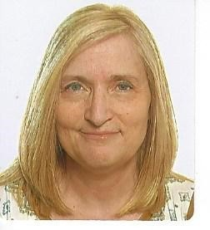
FEFOC has been a member of Europa Uomo since its inception. Europa Uomo is the European entity that brings together associations of patients with prostate cancer. FEFOC has a very solid line dedicated to this cancer that has been hidden for a long time. FEFOC has a specific website dedicated to this cancer (www.cancerdeprostata.org),individual and group psychological care and production of material, such as this magazine, a code, manuals, book and informative videos. With Europa Uomo it has been possible to share experiences from different countries, as well as common work.

After a while, FEFOC has taken another step in this organization, promoting its Psycho-Oncologist as a candidate for member of the Board of Directors.
Tania Estapé is a Doctor in Psychology and specialist in Clinical Psychology and dedicated to Psycho-oncology for many years.
In recent years he has attended the annual general assemblies of Europa Uomo as a Spanish representative. The last two General Assemblies of Europe Uomo were virtual due to the Coronavirus pandemic. This year's took place on june 19 in the morning. It proceeded to vote on the two vacant seats on the Board. Tania Estapé won in the voting and has a new role as a member of the Board of Directors of Europa Uomo. With her entry to the Board Tania Estapé proposes to promote attention to the psychological aspects in prostate cancer, highlighting the role of the patient's partner.

We hope that in this new journey new challenges can be met in the fight for the visibility of prostate cancer patients and their families.

20-YEAR STUDY LINKS ONCOTYPE DX®GPS TO RISK OF DISTANT METASTASIS AND DEATH FROM PROSTATE CANCER
Cristina Sans.

A new publication of the JCO Precision Oncology, referring to the Genomic Oncotype DX® Genomic Prostate Score (ODX GPS) genomic test, already mentioned in previous editions, concludes that genomic testing provides accurate information on the risk of distant metastasis and death from prostate cancer (long-term goals). This objective information can be used dichotomously (positive/negative) beyond clinical parameters.

(continued on page 3)

(from page 2)
Remember that this is molecular information, which complements the results of clinical tests performed in order to know the patient's prognosis.
The data from the study, from the U.S. group led by Dr. Klein(Cleaveland Clinic,USA), includes a cohort of 428 patients in follow-up during the years 1987 and 2004. According to Dr. Klein, "a patient with a GPS score of 29 may be a good candidate for active surveillance, while a higher score indicates an aggressive tumor that requires more intense monitoring (...) and according to their life expectancy an immediate treatment (surgery and/or radiotherapy)". This is the longest validation study with ODX® GPS and although it is necessary to confirm these findings with more studies, it is a very interesting fact when assessing active surveillance.
This study brings even more robustness to a genomic test that, despite its short time on the market, already accumulates more than 20 studies that demonstrate its validation and clinical utility.
The genomic test, ODX® GPS, distributed by Palex Medical and developed by Exact Sciences, is currently aimed at patients with localized prostate cancer of very low, low and intermediate clinical risk, but work is being done on its application to high-risk patients in the near future.
For more details of the study, you can access the attached press release in English or directly to the publication, from the link: https://ascopubs.org/doi/pdf/10.1200/PO.20.0 0325

NEUROPSYCHOLOGY IN ONCOLOGY:
Emerging discipline in the healthcare system for multidisciplinary care for the benefit of patients
Mtra. Astrid Ximena Romero Hernandez. Postgraduate in Psychology. National Autonomous University of Mexico. Psycho-oncology Service National Cancer Institute

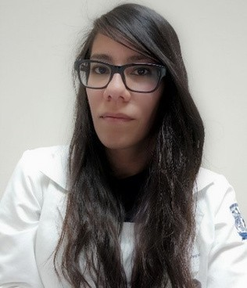
In clinical practice it is relatively common to attend cancer patients who have subjective complaints of cognitive impairment, which can range from loss of objects and forgetfulness of information, to work dysfunction and difficulty in making decisions. It is often common for patients to express sadness, irritability, anger and frustration at their current situation, as they no longer perform their daily activities as effectively as before.
These alterations consist of the deterioration or dysfunction of different neuropsychological processes such as attention, memory, language, among others. It is estimated that up to 75% of patients experience them during treatment, and in 35% of them the alterations may persist after the end of treatment.
One of the treatments associated with these disorders is hormone therapy, also called androgen suppressor therapy, which is used in patients with prostate cancer whose disease has not spread outside the prostate. This may be due to decreased blood levels of testosterone (a hormone associated with the functioning of memory and learning mechanisms), or cerebrovascular damage. Some alterations have been reported in the ability to make movements aimed at an end, in the ability to spatially locate stimuli in the immediate environment, in the organization, planning and solution to new situations, visual memory, concentration and immediate manipulation of information.
(continued on page 4) 3

(from page 3)
In contrast, breast cancer patients treated with hormone therapy have consistently demonstrated memory impairment of previously learned concepts and autobiographical memory.
If the patient does not have sufficient cognitive resources to mitigate these affectations, their functionality can be compromised and their quality of life decreased.
Neuropsychology allows to know the cognitive profile, something particularly complex in cancer patients, since some present risk factors that contribute to the appearance of neuropsychological alterations, such as advanced age, fatigue, sleep and mood disorders, diabetes and hypertension.
Based on the cognitive profile, recommendations are made for patients and their families, such as environmental modification programs, external aids (use of alarms, notebooks) and interconsultations with other health professionals. The objective of the neuropsychological approach is the reintegration of patients into their family, work and social environment.
In Latin America, the application of neuropsychology in oncology is an emerging field that allows both to understand the cognitive functioning of patients, and to provide them with tools and strategies that allow them to improve their quality of life. Despite the above, neuropsychology in oncology is still little known to some health professionals, limiting the possibilities of diagnosis, treatment and reintegration into the environment. In this sense, it is of vital importance that neuropsychologists in oncology consolidate the bases that allow the development of multidisciplinary teams, through evidence-based clinical practice, training of human resources and research, as well as the dissemination of this area among patients and families to access neuropsychology services in a timely manner.

References:

American Cancer Societand. (2020). Hormone therapy for prostate cancer. Retrieved from https://www.cancer.org/es/cancer/cancer-de-prostata /tratamiento/terapia-hormonal.html Lange,M., Joly,F. , Vardy, J., Ahles, T., Dubois, M., Tron, L., Winocur, G., De Ruiter, M. B., & Castel, H. (2019). Cancer-related cognitive impairment: an update on state of the art, detection, and management strategies in cancer survivors.
Annals of oncology : official journal of the European Society for Medical Oncology, 30(12), 1925–1940.
https://doi.org/10.1093/annonc/mdz410
Tae, B. S., Jeon, B. J., Shin, S. H., Choi, H., Bae, J. H.,
& Park, J. Y. (2019). Correlation of Androgen Deprivation Therapy with Cognitive Dysfunction in Patients with Prostate Cancer: A Nationwide Population-Based Study Using the National Health Insurance Service Database. Cancer research and treatment, 51(2), 593–602. https://doi.org/10.4143/crt.2018.119
Wu, L.M., & Amidi, A. (2017). Cognitive impairment following hormone therapy: current opinion of research in breast and prostate cancer patients. Current opinion in supportive and palliative care, 11(1), 38–45. https://doi.org/10.1097/SPC.00000000000000251

CHEMOTHERAPY IN PROSTATE CANCER

An obvious fact in prostate cancer (CP), is that many patients with extended cancer, who respond to hormone treatment at the outset, over time are resistant to it.
From 1950 began, in some of these patients, chemotherapy with alkylating (drugs widely used in chemotherapy of other tumors; in the tumor cell they create bridges between the two helical beams of DNA, thus preventing the partitioning of the cell or mitosis and its multiplication). But they were poorly documented studies.

(continued on page 5)

(from page 4)

It was not until 1972 that Dr. Gerald Murphy and collaborators led a project (the American Cancer Society National Prostate Cancer Detection Project) to scientifically assess the possible efficacy of chemotherapy. To do this they designed a comparative study between an alkylating agent (cyclophosphamide) and 5 fluoruracil (antimetabolyte that competes with an essential amino acid for DNA formation, pyrimidine). They saw some benefits, but the studies included few patients to really have value.
Later, other cytostatics were tested that not only decreased in many cases the level of PSA (marker of CP) and improved the survival of patients. Subsequently, some more effective drugs have emerged, highlighting the combination of docetaxel (semisynthetic derivative of yellish), which interferes with mitosis or cell division), associated with prednisone. In June 2010, the FDA approved cabazitaxel (another yesjo derivative) to be used, also associated with prednisone, for the treatment of patients who in turn were resistant to docetaxel plus prednisone.
We consider very important the potential progress of chemotherapy in CP. Hormone treatment is very effective but its consequences on patients' quality of life are, in our opinion, excessive. Chemical castration has, it is true, advantageously replaced surgical castration.
But patients continue to pay a severe price in terms of their quality of life. Chemotherapy, if it progresses, may perhaps in the future replace hormone treatment. Without paying the price of castration. Of course, with the adverse effects of chemotherapy that have the advantage, in general, of happening at a specific time and not castrating patients.
We also think that researchers should make progress in the field of hormone treatment, obtaining products that do not focus exclusively on the cancellation of testosterone.

Combining progress towards more effective and less toxic chemotherapy and hormone therapy is a challenge worth fighting for.

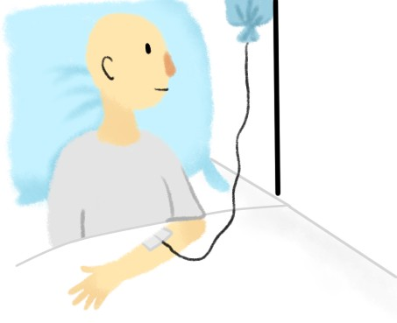
Q
uimiotherapy

ANXIETY ABOUT ACTIVE SURVEILLANCE IN PROSTATE CANCER
Tania Estapé

ACTIVE SURVEILLANCE = ANXIOUS SURVEILLANCE?

Active surveillance in prostate cancer is a "non-treatment" option that is a very interesting and important proposal: patients are candidates not to receive treatments and are monitored for possible changes in their tumor that at some point could indicate the start of active treatments. Active surveillance is a step forward in trying to treat cancer as aggressively as possible in terms of the impact on patients' quality of life. Thus, looking at the history of Oncology we have examples, such as the change from mastectomies in breast cancer to tumorectomies whenever possible. Of course the main objective is healing but it can be accompanied by quality of life or at least a maximum preservation of it, a more global cure of the patient will always be achieved.

(continued on page 6)

(from page 5)

So the "do not treat" that active surveillance entails is certainly a promising option because, as we know, in prostate cancer, the repercussions are often very harsh. Loss of erection and urinary incontinence are two great examples of how the patient's life can be profoundly altered. However, despite the advantages that seem very clear when reading it, there are some factors that make it difficult to choose this option. One of them is the difficulty in coping with having cancer and (apparently) not "doing anything." This first barrier is found in both patients and family members. For them, having their loved one diagnosed with cancer without eradicating it is something that goes against all logic. Our ancestors weigh heavily and provide us with the equation cancer=death, the sooner it is removed the better.
We believe that this is understandable, since until now we have been told how advisable it is to detect early in order to be able to act as soon as possible when there is the minimum of a tumor. At this point the barrier is twofold, if it is the case that the patient prefers it, but his family pressures him to have surgery. To the doubts and insecurities of the affected person himself is added the lack of support of the family in this decision. Moreover, daily life with the tumor can be difficult to manage. Patients wake up every morning knowing that they "carry the cancer inside," as one testimony explained. Despite not having the repercussions of treatments, this awareness that your cancer remains in your body and that, at any time it could spread, can generate a high degree of anxiety and fear that, in some cases, can interfere with your quality of life in another way. We refer to the fact that a high level of anxiety often conditions the enjoyment of life, concentration on activities such as reading, filming or social exchange, or work tasks, if the patient is still active.
In this sense, patients, despite having the advantage of saving themselves some harsh consequences of treatments, can see their social activities reduced, have insomnia and live with difficulties uncertainty. This is called the fear of progression. In patients already cured, free of disease, we often speak of the fear of relapse, in this case it is that it progresses and spreads. The patient goes into a spiral of doubt: What if it spreads and arrives too late? What if I have made a mistake? What if this is really very serious and that is why I am no longer being treated? This can be compounded by something very common in patients which is comparison. Both the patients themselves and their families will meet other affected patients and family members who have received treatment.
What's more, if the patient goes to a support group they are likely to feel alone because they will often hear the stories of others explaining their experience with prostatectomy, the radioterapia.....de again will be assailed by doubts about whether they have chosen correctly.
In summary, we consider that there are some channels of communication at different levels: on the one hand, doctors and health professionals report with data, they are based on evidence of how beneficial it can be for patients to opt for active surveillance. On the other hand, patients (and their families) receive with fear and insecurity an option not to be treated when since childhood they have been hearing that cancer is something that must be removed as soon as possible to be able to bet on the cure. It is essential to make a multidisciplinary approach to patient decision-making. Meetings without urgency, being able to give you all the information and the necessary time, will help to be calmer. It has been shown that regretting the decision taken can lead to worse psychological adaptation. Although it is logical that the patient lives with a certain fear, it is necessary to ensure that he can enjoy his life to the fullest.

(continued on p.7)

(comes from p.6)

On the other hand, psychological intervention programmes must be designed. Despite being able to make a multidisciplinary approach to decision-making, there are patients and family members who will not be able to avoid having their degree of anxiety. For this it is necessary to have psychological support tools.

MEDITERRANEAN DIET AND ACTIVE SURVEILLANCE

J. Gregg, D.D., and collaborators at the University of Texas' Anderson Cancer Center have studied the possible relationship between dietary type and prostate cancer (CP) progression in men who chose active surveillance. Those who followed a Mediterranean Diet (DM) style diet evolved better than those who did not.
Dr. Justin Gregg believes that men with CP are motivated to find something that positively impacts the progression of the disease and improves their quality of life. Well, DM is a non-invasive medium, good for global health and, as shown in your study, has a potential effect to modify the progression of CP. After taking into account known factors that can worsen cp progression (such as age, PSA level, and tumor volume), patients who follow DM decrease the risk that their tumor will grow or progress to a point where they may need treatment.
The study included 410 men who chose active surveillance, with localized CP and Gleason grade groups 1 or 2. The mean age of the patients was 64 years. They were passed a questionnaire on eating habits and, according to the results, were divided into three groups. High, medium and low adherence to this diet.
The results showed a significant reduction in the risk of tumor progression in relation to the adhesion group, with the most positive results in the degrees of greatest follow-up.

The authors wish to study this issue in other patient groups. The importance of this study lies not only in the better overall health of dm adherents but, what is the most remarkable thing about this trial, is that those who choose active surveillance and DM have a lower risk of CP progression. That those who choose active surveillance but are not adherents to DM.
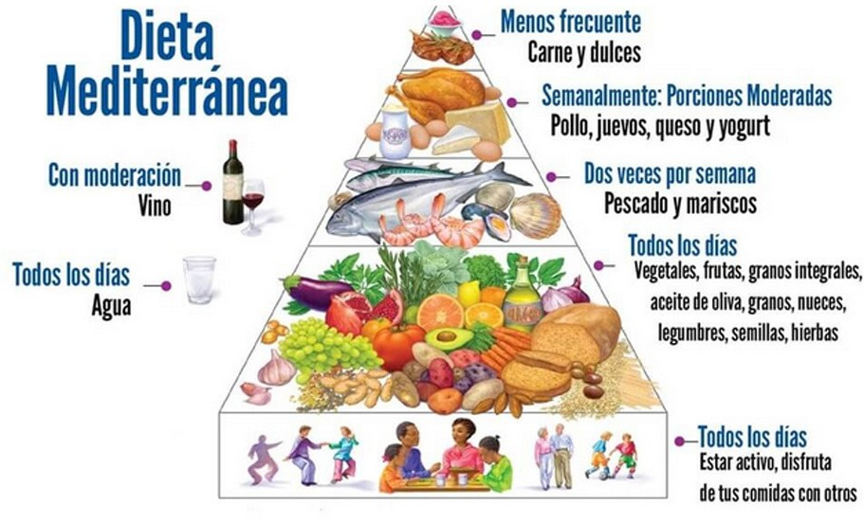

SUMMARY OF THE HISTORICAL BACKGROUND OF THE MEDITERRANEAN DIET

Some kind readers have been interested in this topic, so review the essential historical facts of the design of this diet. It is worth reviewing a little the origin of one of the greatest goods that our ancestors have bequeathed to us. It originated in the Mediterranean Sea, through the exchange of food culture between various civilizations.
Within that sea, it probably began in the eastern Mediterranean, by growing cereals and legumes in various countries. But it was the Greeks and Romans who cultivated the three basic ingredients of that diet: olives and subsequent oil, wheat bread and vines, from which the wine came. This culture spread to the western Mediterranean.

(continued on p.8)

(comes from p.7)

To the original basic ingredients, especially the Roman ones, they added vegetables (onion, lettuce, carrot, cabbage, celery, artichoke, etc.), fruits (figs, peaches, plums, apples, pears, cherries, etc.), nuts (almonds, walnuts, hazelnuts), cheese (with preference for sheep), and, in a very prominent way, original, almost great, fish, seafood and in any case, poultry, but almost without red meat.
We also recommend physical exercise.
Later, two fundamental aspects enriched the Mediterranean diet.

- Arab and Muslim contributions. Their influence was enormous in the lands where they settled (from 711 to 1492), specifically in the wide region called Al-Andalus (much of Spain for some or more widespread, also including Portugal and France).
Arabs and Muslims introduced rice, eggplants, spinach, oranges and lemons and also underline the importance of diet in overall health. They picked up the principles of Hippocrates.

- The same year they were expelled from Spain by the troops of Kings Isabella and Ferdinand (1492), Christopher Columbus arrived in America, which meant the addition to the Mediterranean diet of decisive products such as potatoes, tomatoes, corn, coffee and chocolate. It represents perhaps the most important exchange between civilizations and cultures in history. Particularly striking is the adoption of the tomato, the first red fruit in our diet and which was a symbol of this.

We see how the Mediterranean diet, after its birth in the eastern Mediterranean, incorporates essential elements from different villages and cultures.

Mediterranean diet

Since 1960, the decrease in coronary heart problems has been noted in Greece and Spain, when their incidence is compared with that of the United States. Several studies point to our diet as the basis of this difference. Several important organizations point to this, as well as the Dietary Guidelines for Americans,the WHO and the UN, which recognize its value in the prevention of chronic diseases.
As for cancer, it is observed that its incidence in the countries of the southern Mediterranean was low when our diet was followed and that it rose progressively when we were imitating the eating style of the countries of the North.
Current studies such as the one presented in this issue expand its indications and benefits. On the other hand, the Mediterranean diet is essentially ecological, with its vegetarian predominance and the minimization of animal meat intake. It combats cruelty to animals (our brothers) and the harmful consequences of intensive farms, while at the same time eliminating a food as dangerous to our health as red meat.

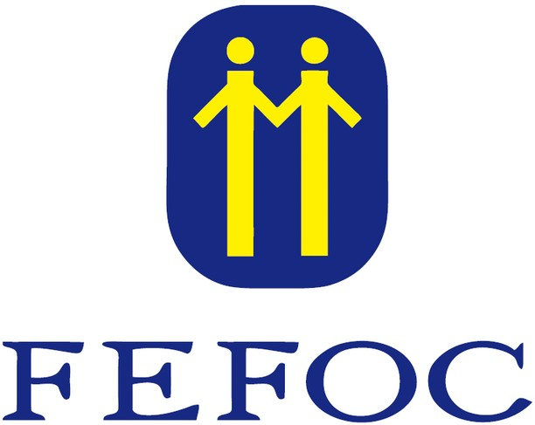

To acquire the book click here.

For more information
about donations click here.

We appreciate the collaboration of:

Directors: J.Estapé, T.Estapé Secretary: M.Soler Vaqué

Marc Aureli, 14.

08006 - Barcelona
Tel. 93 217 21 82

Email: fefoc@fefoc.org www.fefoc.org

