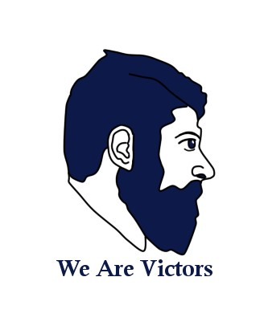
THE GARDEN OF THE

CANCER OF THEM
© FEFOC 2021
Directors: Professor Jordi Estapé and Doctor Tania Estapé.

EDITORIAL
In 1891 the German surgeon Max Wilms began to interest in and describe kidney cancer in children, which since then bears his surname. The same year an English painter, Luke Fildes,produced a wonderful canvas entitled "The Doctor", inspired by a terrible personal experience, the death from tuberculosis of his first child, then a year old. Aside from the terrible personal drama, both Fidles and his wife were tremendously impressed by the attitude of the doctor who treated them. And Fidles immortalized him.
In the painting, exhibited at the Tate Gallery in London, we are in a poor cabin. Lying between two chairs (of different origins), a girl agonizes. Behind, the mother is seen, collapsed, and, behind her, her partner tries to give her strength.
But what dominates the picture is the expression of the

Just four years earlier, Picasso produced, in Barcelona, another canvas of medical motif: "Science and charity", which is exhibited in the Museu Picasso of this city Here things are different: in fact, we see an adult woman dying. Near her is a doctor who does not even look at her, her attention is focused on taking her pulse, oblivious to the agony that is lived next to her. Science. On the other side of the bed is Charity. A nun carrying a girl in her arms and tending, the nun, a glass of water to the dying.
Both doctors represent, in our opinion, two fundamental trends in medicine. The second represents increasingly dehumanised technology; the first is the real doctor, for whom the patient first.
You will remember the famous phrase issued in usa with

doctor. You don't have an algno medical device in your
regarding the evaluation of doctors: "Publish a

hands, as a sign of their impotence. But the expression on his face is one of deep pain, of concentration, of insignificance. He is the doctor at his peak, bearing witness to his wounded humanity, watching death slip through his fingers the life of that being.
or perish", post or be fired. Faced with this challenge, many doctors in large hospitals are launching into a race in search of the dreamed "impact factor". And how is it measured? Through the weight of publications. Patient care and teaching have no impact factor.
(continued on page 2) 1

(from page 1)
Many patients suffer from this situation:"Hedidn't even look me in the face during the visit", more attentive to the computer and the telephone. Who actually visits patients?
Not long ago we experienced a case that may be an example a woman with breast cancer was given a catheter to facilitate chemotherapy. The operation took much longer than had been anticipated. After a few days the corresponding cervical region began to hurt. He went to the hospital. He had an ultrasound. normal. It's a contracture, they explained. After a few days when the pain persisted, he went to his gp, trusted by him. Other scans showed the presence of a considerable thrombus, an obvious cause of the pain. It has been fixed, fortunately.
We call for an impact factor for assistance; we demand that doctors should not be forced to compete forcibly and outside the healthcare field; we demand that they have time to be able to assist their patients.
It is very neat to care for a patient with prostate cancer. Explain the therapeutic options, give you the right support, be, in a word, authentic doctors.
All this comes from the second article by Dr. García-Restoy.

DISEASE-CENTERED MEDICINE VS. PERSON-CENTERED MEDICINE (Part 2)
One of the biggest healthcare challenges in recent years in developed countries is undoubtedly the care of patients with chronic diseases. To address this, it is crucial that health organizations adapt their organization and that the patient's relationship with the doctor and other professionals evolves so that the sick person is at the center of the system and participates in decision-making. Victor Montori, a diabetes doctor at the Mayo Clinic has denounced from many works and from the foundation The Patients Revolution,as well as from his book with the same title, how industrialized medicine has moved away from the care of people and proposes a "careful" and "gentle" care more focused on the person and less focused on the disease. This new look is based on the models of "cumulative complexity" and "minimally disruptive medicine" that seek to prioritize the vital and health goals of patients and minimize the negative impact that healthcare causes on their lives. This approach confronts the burdens derived from treatment, disease and the obligations of daily life with the patient's ability, which will depend on their personality, education, knowledge of their diseases, functional, cognitive limitations, socio-family support, economic situation, etc. Thus, for example, increasing the number of medicines or introducing drugs whose form of administration or dosage is more complicated can increase the burden of treatment and cause an effect contrary to that desired by hindering its compliance. The imbalance between the burdens and the capacity of the person determines the degree of complexity, that is, the difficulty of the individual to cope with the burdens of disease and many aspects of life.

(continued on page 3)

(from page 2)
Keep in mind that loads and capacity may vary over time depending on clinical factors and changes in social and personal circumstances. From joint deliberation with the patient, doctors should be able to make joint decisions and develop therapeutic plans that are not only effective, but also accepted and acceptable by the patient and his environment.
In short, it is necessary for professionals, patients and caregivers to be aware of the complexity derived from the burdens of the disease, treatments and the circumstances of life in the face of the capacities of the sick person, regardless of their condition as a patient. Patients must also assume, within their possibilities, the responsibility for self-care and the role that corresponds to them in decision-making. For their part, organizations and care devices must adapt to provide professionals with the necessary resources so that the care of chronic patients is carried out efficiently and with the utmost respect for the dignity of patients and professionals.

Enric Garcia Restoy Medical Internist.
Terrassa Hospital. Terrassa consorci Sanitari.

QUESTIONS ABOUT SIDENAFIL
On the Us Too International Hot Sheet, Dr. Jeffrey Albaugh answers a question asked by a prostate cancer survivor. The question is as follows:

I DON'T SEE MANY DIFFERENCES BETWEEN THE GENERIC SIDENAFIL AND VIAGRA.
IS THERE A DIFFERENCE? WHY CAN'T I TAKE MORE THAN 100 MLGS?
DR. ALBAUGH'S RESPONSE:
Thank you for your questions. Both sidenafil and Viagra contain the same chemical, sidenafil. And they must produce the same effects in most men. I have worked with many men who alternated both medications. They told me they found no difference between the two. Sometimes some different effect may occur, but not in terms of the basic drug, sidenafil,but due, in any case, to other components of the tablet. The essential results of these drugs are the same with any of them. And also with tadalafil (Cialis).
As for the dosage, if you increase above 100 mlgs., may also increase your side effects. One of these effects may be to cause a decrease in blood pressure, with increased heart rate. Precisely in the beginning these drugs were investigated as possible hypotensive, but then it was observed that they helped to have an acceptable erection. At the dose of 100 mlgs,the one recommended by the AmericanFDA, they produce a certain hypotensive effect, but this effect would increase with higher doses of these. These reflections are valid for both sidenafil and tadalafil). But remember that your dosages are different. Sidenafil,a maximum of 100 mlg,for tadalafil, a maximum of 20 mlgs. It is not advisable to mix alcohol intake with the use of any of them, since alcohol can also lower blood pressure.
It is important that, before starting sildenafil or taladafil,consult with your doctor if youtake other medications, to avoid interference between them.

CHEMOTHERAPY IN ADVANCED PROSTATE CANCER
An obvious fact in prostate cancer (CP) is that many patients who respond to hormone treatment from the outset, over time, are resistant to it.
From 1950 began, in patients resistant to hormone treatment, chemotherapy with alkylating agents (drugs widely used in chemotherapy of other tumors; in the tumor cell they create bridges between the two helical beams of DNA, thus preventing the partitioning of the cell or mitosis and its multiplication). But they were poorly documented studies.
It was not until 1972 that Dr. Gerald Murphy and collaborators led a project (the American Cancer Society National Prostate Cancer Detection Project) to scientifically assess the possible efficacy of chemotherapy. To do this they designed a comparative study between an alkylating agent (cyclophosphamide) and 5 fluoruracil (antimetabolyte that competes with an essential amino acid for DNA formation, pyramidine). They saw some benefits, but the studies included few patients to really have value.
Later, other cytostatics were tested that not only decreased in many cases the level of PSA (marker of CP) and improved the survival of patients. Subsequently, some more effective drugs have emerged, highlighting the combination of docetaxel with prednisone.
We consider very important the potential progress of chemotherapy in CP. Hormone treatment is very effective but its consequences on patients' quality of life are, in our opinion, excessive. Chemical castration has, it is true, advantageously replaced surgical castration.
But patients continue to pay a severe price in terms of their quality of life. Chemotherapy, if it progresses, may perhaps in the future replace hormone treatment. Without paying the price of castration. Of course, with the adverse effects of chemotherapy that have the advantage, in general, of happening at a specific time and not castrating patients.
We also think that researchers should make progress in the field of hormone treatment, obtaining products that do not focus exclusively on the cancellation of testosterone.
Combining progress towards more effective and less toxic chemotherapy and hormone therapy is a challenge worth fighting for.

PROSTATE CANCER AND OBESITY
In Oncology, diet is increasingly given importance both in the development of the tumor and in its progression. In addition, along with tobacco, alcohol, obesity, sedentary lifestyle and solar irradiation, diet is a factor that can be managed directly by the individual. However, although we found many suggestions, no specific and concrete diet has been detected objectively to prevent cancer or slow its growth.
We know that obese people have a higher risk of dying from prostate cancer (CP), developing aggressive CP more often and with a greater chance of recurrence of the disease after initial treatment.
Research on the subject, carried out by the Cancer Prevention Study, showed that patients with a body mass index greater than 32.5 kilograms per square meter were 35% more likely to die from CP than those affected with an index equal to or less than 25. It happens that a majority of patients with CP who die do so more from cardiovascular complications than from the disease itself. The great obese are, as we know, more prone to such problems.
(continued on page 5)

(from page 4)

Excessive consumption of fats in the diet is often accompanied by obesity. Its consumption is higher in the USA and in Western European countries, where precisely the percentage of deaths from CP is higher. Thus, in Japan where the incidence and mortality due to CP were low, they have been increasing with the introduction of the dietary model of usa and western Europe.
Obesity may be closely related to CP with an increased risk of aggressive disease. Fat cells secrete hormones that can stimulate prostate tumor growth and also, inflammation, which in turn can help the higher degree of aggressiveness of CP in obese people.

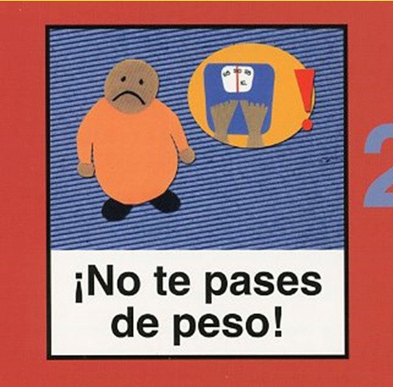
IN THE FACE OF CANCER, DO MEN HAVE LESS ANXIETY AND DEPRESSION THAN WOMEN?

Dr. Tania Estapé

Anxiety and depression are two consequences of cancer, the most common. Anxiety refers to fear, to the feeling of threat to the loss of control of the patient, while depression appears more cumulatively, in the medium and long term, when the treatment ends and in moments of reflection, of vital approaches, of the meaning of life. Although these two answers are general, if we compare for different differential variables between the different people, there are different aspects due to some characteristics of the patient profiles. Without a doubt sex is one. In general, women suffer more levels of anxiety and/or depression, if we talk about the general population. This is reflected in the face of cancer as well. There are significantly higher levels of both anxiety and depression in women with cancer than in men. That is the objective fact. However, we must consider some aspects because the results capture a photograph but perhaps not so much the processes that underlie it.
The tests we use in Psycho-oncology to evaluate the different psychological repercussions are usually what is called in psychology very obvious. What does this term refer to? Well, it is very clear to the subject who answers them, in which answers he is manifesting discomfort or fragility. That is, if a test includes the question "Are you sad?", it is very obvious that answering the maximum score offered is marking discomfort. The use of this type of questionnaire is undoubtedly due to a historical fact. In the first approaches in Psycho-oncology, questionnaires from the world of Psychopathology (discipline related to mental illness or disorder) were used.
(continued on p.6)

(comes from p.5)
The results were very poor, because, in general, the cancer patient does not suffer from a disorder but an adaptive psychological and emotional reaction to the situation. So scales are used as we said before more obvious.
What about this? Well, people who answer can modify their answers based on several factors. This can be both in one sense (presenting itself as worse than it really is), and in another (suppressing negative responses to appear well-being when there is none.
In men with cancer, there is a tendency to get lower scores. We hypothesize that this may be due to a male cultural pattern that is still in place. We see it in men, for example with prostate cancer, who are mostly in an age group where the role assigned to men to be strong still weighs heavily, and that crying or showing weakness or fear is not man's. Therefore, not infrequently, men with clear depressive or anxious traits in the clinic, obtain low scores in the tests administered. In the graph that we attach it is very clear what we explain. We do not want to say that these men are lying or manipulating the result, but that, in some cases, it is conditioned by cultural and self-esteem factors that may prevent them from being sincere or admitting these feelings that they interpret as unsoculine. Not surprisingly, if we look at the history of the support groups of cancer patients, the prostate have been among the last to be formed, because they have a hard time sharing their experiences and being emotionally honest. Even in FEFOC, with 21 continuous years of group, we remember that at the beginning, in 1996, when we raised with urologists and other doctors the possibility of making a group, we saw how most of the men who sent denied any suffering. We believe that we are on the right track by opening a way for men with prostate cancer to share their experiences and establish bonds of cohesion and solidarity in a frank way.

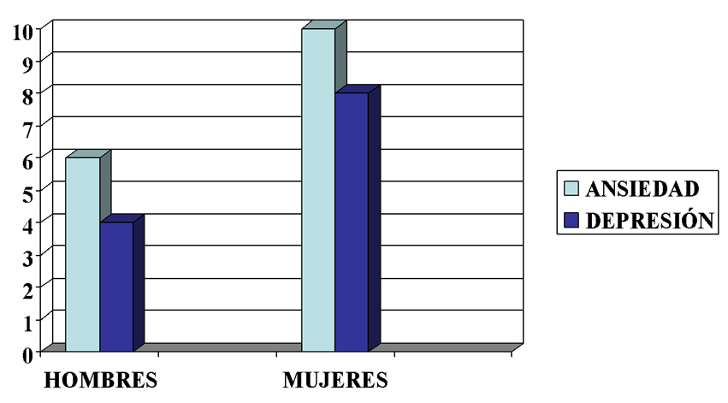
Anxiety and depression in men and women with cancer (©Dra. Tania Estapé)

MY LIFE IS IMPORTANT. DISCOVERING MY LEGACY IN THE LIGHT OF CANCER
Ana Marcela González Ling

Postgraduate in Psychology Universidad Nacional Autónoma de México UNAM / Servicio de Psicooncología INCan / OPCION Oncología

Few experiences in life confront us as directly with the finite nature of our existence as a cancer diagnosis. Although the prognosis of this dreaded disease has improved significantly with early detection methods and advances in oncology, it continues to be perceived as a fatal disease and this perception is transferred to our collective construction of what cancer is. Even with neoplasms of good prognosis, ideas about mortality are present in 30 to 80% of cancer patients and it is not uncommon for us to start asking ourselves what we have done with our lives.

(continued on p.7)

(comes from p.6)
What am I supposed to do with my life? Have I accomplished my mission? Have I wasted the time that now seems so valuable, or am I reassured by how I've lived? Profound questions to which there is no simple answer.
In addition, men have an added burden since historically expectations are high, among them are: forming a family, supporting it, being strong and successful, having assets, containing emotions, leaving their family protected for when they are no longer there and a long etcetera. All this adds a significant emotional burden to people and if we do not express and question these concerns, we may miss the opportunity to observe ourselves through the gaze of the other, to reconstruct and resignify our history.
Let's start by making it clear that every life trajectory is important. The wisdom of the country man is as valuable as that of the great businessman. Each person, with their life experience, the accumulation of their crises and their joys, builds a path full of learnings that for viewers is invaluable.
In the words of Lin Manuel Miranda in the famed Broadway play, Hamilton: "What is a legacy? It's planting seeds in a garden that you're never going to see." It is so curious the subject of legacy, that we live every day creating it, sowing those seeds that little by little are germinating. It is true that we may not get to see the garden in all its magnitude, but from the present we can begin to enjoy the process of sowing and seeing it germinate. Our legacy can be composed of both material things (goods, property, savings, business, etc.) as of that which is intangible (memories, experiences, life lessons, values, etc.) that is reflected in our daily actions, in our personal relationships and in everything we build day by day.

The legacy is transformed into something tangible that Dr. Breitbart and his collaborators have developed as part of Sense-Centered Therapy. This evidence-based therapy for cancer patients addresses legacy as an important element of life sense that can help people reconnect with the desire to continue living, maintain hope, and decrease symptoms of anxiety and depression. In one part of this therapy, patients can make a legacy project for their loved ones in the way they prefer (text, video, audio, collage, a song list, a presentation, etc.). They address legacy in three dimensions: past, present and future.
Let's go back to everything that precedes us. Our parents, grandparents, ancestors, their culture, their beliefs and their context were key to today being who we are and finding ourselves here, with the enormous privilege of living. The lives of our ancestors, whether we know them or not, have a great impact on our reality, we are part of their legacy and that gives us a responsibility to do something meaningful with our lives. What better example about the importance of understanding history than recognizing that the experiences of others inspire us, teach us and that in this way the past always guides the future. Their future is our present and eventually our present will be part of history.
The legacy that is built in the present is the great gift we can offer to our loved ones. That gift goes beyond the material that one can build with love for one's loved ones, it also involves the way we live, our values, our way of facing problems, our way of enjoying life, our jokes, our support in difficult times and everything that makes up the way we will be remembered by others.
Day by day we build our legacy and we can choose to act how we want to be remembered, choose to live on our own terms. No matter how advanced an illness may be, we always have the possibility to continue creating our legacy, it's never too late to share.
Even in adverse situations, where the physical state can be very deteriorated, we can express affection, share our learning and continue to contribute to the world.
(continued on p.8)

(comes from p.7)
The possibilities are endless, whatever our life experience, it is worth being told and listened to attentively. Valuing our life experience and feeling at peace with the life we have lived makes a big difference in how we live the disease process. There are psychological interventions such as Sense-Centered Therapy or Dignity Therapy that help patients to capture their legacy in a tangible way, with the help of a professional, so that they can share it with their loved ones.
Sharing your life experience, your memories, your learnings and what is most valuable to you is not only good for patients, it is an invaluable gift to your loved ones. Dare to share your life experience!
References
Simon, Steffen & Pralong, Anne & Hallek, Michael & Scheid, Christoph & Holtick, Udo & Herling, Marco. (2021). What is known about palliative care in adult patients with allogeneic stem cell transplantation (allo-SCT)?. Annals of Hematology. 100. 1-13. 10.1007/s00277-021-
04538-4.
Miranda, Lin-Manuel. "The world was wide enough" Hamilton: An American Musical, original recording with Broadway cast, Atlantic Recording, 2015, disc 2, track 22.
Breitbart, W., Rosenfeld, B., Pessin, H., Applebaum, A., Kulikowski, J., & Lichtenthal, W. G. (2015). Meaning-Centered Group Psychotherapy: An Effective Intervention for Improving Psychological Well-Being in Patients With Advanced Cancer. Journal of Clinical Oncology, 33(7), 749–754.
Chochinov, H.M., Hack, T., Hassard, T., Kristjanson, L. J., McClement, S., & Harlos, M. (2005). Dignity Therapy: A Novel Psychotherapeutic Intervention for Patients Near the End of Life. Journal of Clinical Oncology, 23(24), 5520–5525.

To acquire the book click here.

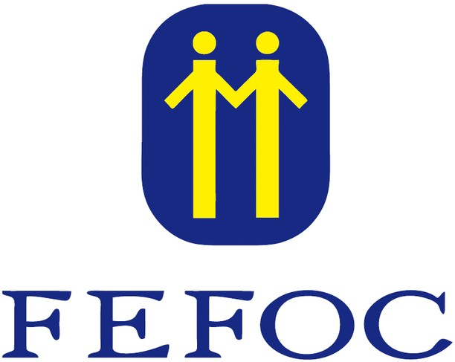
For more information
about donations click here.

Directors: J.Estapé, T.Estapé Secretary: M.Soler Vaqué

Marc Aureli, 14.
08006 - Barcelona
Tel. 93 217 21 82
Email: fefoc@fefoc.org www.fefoc.org

We appreciate the collaboration of:

